English test for grade 7
test yourself 1
I. Find the word which has a different sound in underlined part.
1. A. came B. lake C. station D. start
2. A. ancient B. radio C. village D. nature
3. A. break B. head C. bread D. heavy
4. A. wait B. said C. maid D. sail
5. A. train B. wait C. said D. paid
6. A. sailing B. railway C. brainstorm D. captain
7. A. safety B. chat C. taste D. waste
8. A. centre B. let C. belt D. security
9. A. safety B. traffic C. station D. plane
II. Choose the correct answer by circling A, B, C or D.
1. Linda used to morning exercise when she got up early.
A. did B. does C. doing D. do
2. My mum the bus to work every day, but I cycle.
A. catches B. drives C. goes D. runs
3. You should look right and left when you go the road.
A. down B. across C. up D. along
4. Bus is the main public in Viet Nam.
A.travel B. tricycle C. transport D. vehicle
5. The play was so boring. , An saw it from beginning to end.
A. Therefore B. Despite C. However D. Although
6. She’s sure that they will find the film .
A. entertaining B. entertain C. entertainment D. entertained
7. - “Do you like seeing a film?” - “ ”
A. No, I don’t like it at all B. Sure. What film shall we see?
C. Who is in it? D. I’m sorry, I can’t.
8. being frightened by the images, Lan still liked the film so much.
A. In spite B. Despite C. Although D. Nevertheless
9. is La Tomatina celebrated? - Every August.
A. Where B. Why C. When D. Which
10. My father liked the of that singer.
A. perform B. performer C. performance D. performing
11. Does your bike ever down on the way to school?
A. break B. take C. do D. turn
12. I go on foot when I was in primary school.
A. used to B. break C. can D. may
13. Give a before you turn left or right.
A. sign B. turn C. sound D. signal
14. A lot of dancers go to Rio de Janeiro to the Carnival.
A. attend B. join C. perform D. appear
15. the film was gripping, Tom slept from beginning to end.
A. Therefore B. Despite C. However D. Although
III. Read the text and fill in the blanks with correct words. Use the words in the box.
in live their with from
sleep are and or gets
The streets are crowded (1) the traffic. Taxis are bringing tired people (2) the airport and the train stations to the hotels. They hope to (3) a few hours before their busy day in the big city. Trucks (4) bringing fresh fruits and vegetables into the city. Ships are bringing food (5) fuel to the harbour.
By seven o’clock (6) the morning, the streets are filled again with people. Millions of people (7) in the big city, and millions of people who work in the big city live in the suburbs, the commuters, are hurrying to get to (8) offices. Everyone is in a hurry. Some stop only to drink a cup of coffee. Others stop to buy the morning paper (9) to have breakfast.
The noise of traffic (10) louder. The policemen blow their whistles to stop the traffic or to hurry it along.
IV. Read the text and then choose the best answer A, B, C or D.
Yesterday, on the way home from school, I saw an accident. A boy was run over by a taxi when he was riding his bicycle. The boy’s leg was broken and it was bleeding badly. Someone there tried to stop the bleeding. They put pressure on it and held it tight. A man used his mobile phone to call the emergency service. Some minutes later, an ambulance arrived and sent the boy to the hospital. Two policemen came to the scene immediately. Some people told the police that the taxi driver was driving at a very high speed when the accident happened. Some others began talking about the traffic accidents these days and blamed the increasing number of accidents on the roads for careless driving and drunk drivers.
1. What did the writer see yesterday?
A. An accident B. A fire C. A fighting D. A crash
2. The accident happened between a taxi and .
A. a bus B. a bicycle C. a car D. motorbike
3. The boy was sent to the hospital by .
A. a police B. a car C. a passenger D. an ambulance
4. What part of his body was hurt? – His .
A. arm B. head C. leg D. shoulder
5. How was the driver driving when the accident happened? – Very .
A. fast B. slowly C. carefully D. well
V. Choose the sentence that has the same meaning as the first.
1. As soon as I receive my result, I will phone you.
A. I will ring you the moment I receive my result.
B. Sooner or later after I receive my result, I will give you a ring.
C. After receiving my result, I will call you.
D. I will make a phone call to you when I get my result.
2. When I was a young girl, chocolate was one of my favourites.
A. When very young, I like eating chocolate cakes.
B. Chocolate used to be a favorite of mine when I was a young girl.
C. My favourite was chocolate as was a little girl.
D. Being a little girl, I like chocolate.
3. I haven’t seen my aunt for years.
A. I haven’t meet my aunt for long ago.
B. The last time I met my aunt was since years ago.
C. I last saw my aunt years ago.
D. I didn’t see my aunt years ago.
4. I think it’s necessary to tell Tim about it at once.
A. Tim may be told about it at once.
B. Tim might be told about it at once.
C. Tim must be told about it at once.
D. Tim should be told about it at once.
5. It is essential that we meet him at the airport.
A. He must be met at the airport. B. He might be met at the airport.
C. He should be met at the airport. D. He may be met at the airport.
VI. Put the words and phrases in the right order to make meaningful sentences.
1. takes/ art/ half/ gallery/ only/ hour/ to/ an/ the/ It/ to/ get.

2. mine/ book/ Her/ from/ is/ different.

3. playing/ young/ brother/ the/ very/ piano/ My/ when/ was/ enjoyed/ he.

4. are/ I/ as/ as/ not/ thought/ These/ expensive/ clothes.

5. new/ is/ next/ A/ to be/ going/ school/ built/ year/ here.

VII. Rewrite the following sentences in the way that their original meanings do not change.
1. Van Cao composed Viet Nam's anthem Tien Quan Ca.
→ Viet Nam’s anthem Tien Quan Ca
2. Be careful or you’ll hurt yourself.
→ If you are
3. What is the price of the bicycle?
→ How much ?
4. The market does not have any carrots
→ There
5. You’re the best guitarist in the school.
→ No one
VIII. Circle the mistake (A or B), then correct it.
1. Laura was taking off her coat and sat down.
A B
2. While we were on holiday, we were spending most of our time sightseeing.
A B
3. Paul listened to his iPod, so he didn’t hear the doorbell ring.
A B
4. While we were having a picnic, it was starting to rain.
A B
5. Helen was painting a picture when her mum was cooking.
A B
test yourself 2
I. Choose the word whose underlined part in pronounced differently from the rest.
1. a. breaking b. great c. steak d. healthy
2. a. cycle b. bicycle c. fly d. skyscraper
3. a. cycle b. licence c. vehicle d. centre
4. a. reversed b. walked c. stopped d. obeyed
5. a. park b. pavement c. plane d. safety
II. Match the road signs with their meanings.
No Overtaking No Left Turn Pedestrian Crossing
Slippery Road Crossroads No Parking Go Ahead Only Turn Right Railway Crossing Hospital Ahead

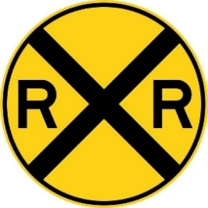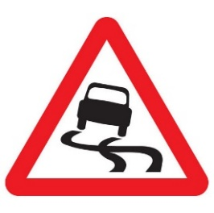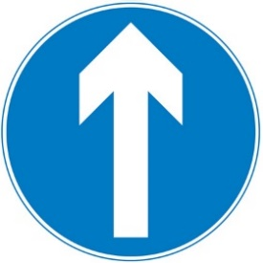
1.______________ 2._____________ 3._____________ 4._____________
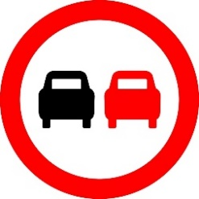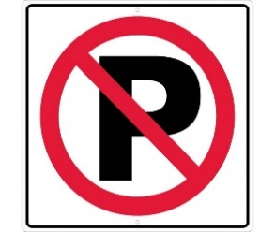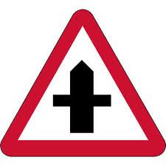
5.____________ 6._____________ 7.______________
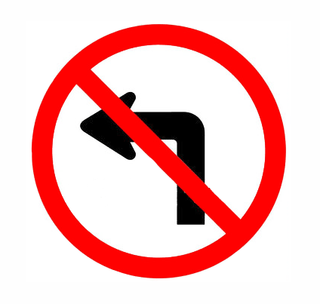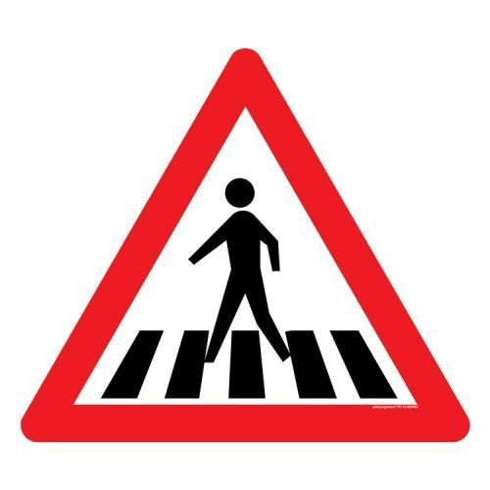
8.____________ 9. ______________ 10._____________
III. Choose the best answer a, b, c or d to complete the sentence.
1. You should walk across the street ______ the zebra crossing.
a. on b. at c. in d. from
2. My house is not far from my school, so I usually go ______.
a. on foot b. by foot c. by car d. by boat
3. This morning, I was ______ in a traffic jam and got to school fifteen minutes late.
a. catch b. block c. struck d. stuck
4. Turn on the left turn ______ before you make the turn and slow down.
a. sign b. direction c. signal d. crossing
5. It is ______ to use a hand-held mobile phone while driving or riding.
a. safe b. important c. illegal d. careful
6. ______ does it take you to ride to school? – About 30 minutes.
a. How long b. How far c. How often d. How much
7. A ______ is a part of a road that only bicycles are allowed to use.
a. cycle cross b. cycle lane c. cycle line d. cycle race
8. You ______ cross the street when the light is red.
a. should b. don’t have to c. can d. mustn’t
9. People ______ produce as much rubbish as we do now.
a. use to b. used to c. used to not d. didn’t use to
10. “How far is Vung Tau from Ho Chi Minh City”-“_______”
A. It’s not very far b. it takes about two hours or more.
c. It’s about 120km d. You can get to Vung Tau by boat or bus.
IV. Write the correct from or tense of verbs in brackets.
1. ____________________ (you/ ever/ drive) on the wrong side of the road?
2. My family ______________ (fly) back from our Hong Kong holiday two days ago.
3. Right now, the students _______________ (learn) road signs in the schoolyard.
4. Usually Lan ______________ (walk) to school, but this week she _____________ (ride) her bike.
5. The driver was so drunk that he ______________ (lose) control of his car.
6. If I have enough money, I _________________ (buy) a racing car.
7. My father ________________ (teach) me to ride a bike when I was seven.
8. Transport used ______________ (be) much slower three hundred years ago.
9. Saudi women weren’t allowed ______________ (drive) a car until recently.
10. In South Africa, you have to let animals ________________ (go) first.
V. Supply the correct form of the words in brackets
1. Young children are expected to show _____________ to their parents. (obey)
2. When cycling on the roads, remember: _____________ first. (safe)
3. Children should avoid _____________ foods such as hamburger and chips. (health)
4. Most road accidents happen because the motorists drive _____________. (care)
5. It is unsafe and _____________ to pass another vehicle on the left. (legal)
6. My _____________ was delayed for over two hours due to bad weather. (fly)
7. Everyone should _____________ obey traffic rules for their own safety. (strict)
8. The policeman _____________ the car to stop with a flashlight. (sign)
9. Signs with red circles are mostly _____________ - that means you can’t do something. (prohibit)
10. This _____________ sign indicates that traffic lights are ahead. (warn)
VI. There is one mistake in each sentence. Find and correct it.
1. I love Thai food now, but I didn’t used to like spicy food.
2. He can drive a bicycle with his hands off the handlebars.
3. We use to walk miles to school every day due to lack of public transport.
4. You are not allowed to drive faster than the number on a limit speed sign.
5. It about 1137 kilometres from Hanoi to Ho Chi Minh City.
6. Bicycles are a cheap and efficient mean of transport.
7. A sign within a red triangle will warn people for something.
8. Be careful when you are on roads. You must drive fast or carelessly!
VII. Match the questions with the correct answers.
1. How does your father travel to word?  2. May I see your driving license, please.  3. Sir, did I do anything wrong?  4. What took you so long?  5. What is the fastest means of transport?  6. How far is it from here to the railway station?  7. Could you tell me how to get to the nearest bus stop, please?  8. How long will it take to get there? | a. Oh, sorry sir, I don’t have it on me.  b. was stuck in a traffic jam.  c. Not very far. Just about 2 km.  d. Go straight ahead, then turn right at the crossroads.  e. Yes, sir, You ran through the stop sign.  f. By motorbike.  g. Twenty minutes.  h. The plane, I think.
VIII. Choose the which word best fits each gap.
Staying safe on foot and bike
Look out for yourself and your friends when out (1) ________ foot and bike. Choose the (2) ________ routes you can like quieter, slower roads, with pavements if you’re
walking or (3) ________ if you’re going by bike.
It’s easy to get distracted by your phone or by friends, but you need to be (4)________ to traffic. Put your phone away and take your earphones (5) ________ when crossing the road. Don’t trust that drivers (6)_______ spot you and be able to stop in time – many drivers go too fast and don’t (7) ________ enough attention, (8)________ anything you can do to protect yourself is a good thing.
1. a. on b. in c. by d. with
2. a. safe b. safer c. safest d. safely
3. a. zebra crossings b. cycle paths c. footpaths d. bumpy roads
4. a. risky b. warning c. serious d. alert
5. a. off b. over c. out d. down
6. a. must b. will c. could d. should
7. a. pay b. make c. turn d. take
8. a. but b. so c. though d. because
IX. Read the text carefully, then do the tasks.
Large cities often have problems that small towns and rural areas do not have. Two of the biggest problems are heavy traffic and the pollution that cars create. Of course. Traffic problems and pollution are not only found in big cities. However, the higher populations and larger number of cars on the roads in cities can make the problems happen more often and with more noticeable effects.
One of the most common traffic problems the large cities have is congestion. As the population of a city increases, so does the number of cars on the road. Cities cannot always improve the number and size of their roads and highways to keep up with the number of cars. The result is traffic congestion, or traffic jams. When traffic jams happen, cars that are stuck in the congestion continue to run their engines. This creates pollution and is a big problem. Pollution causes health problems for the people in cities and also hurts the environment.
A. Match the words with their meanings.
1. rural a. being too crowded or too full
2. noticeable b. unable to move
3. congestion c. easy to see or recognize
4. traffic jam d. in the countryside, not in the city
5. stuck e. too many vehicles in one place prevents
B. Choose the correct answers.
1. Where do traffic problems and pollution frequently happen?
a. small towns b. rural areas c. big cities d. remote villages
2. According to the passage, what causes traffic congestion in big cities?
a. A lot of city dwellers b. Too many cars on the roads
c. Careless drivers d. Less traffic signs on the streets
3. The high number of cars is caused by_________
a. urban planning b. traffic congestion
c. environmental pollution d. the population
4. The highway and road network is ________ of meeting the requirement of increasing number of vehicles.
a. full b. aware c. incapable d. uncertain
5. Which of the followings is NOT true? 5.
a. Only big cities have the problem of pollution.
b. Traffic jams cause pollution
c. Pollution is a major problem in big cities.
d. Pollution causes health and environmental problems.
test yourself 3
I. Put the words into the correct column depending on how the ending –ed is pronounced.
Pulled, opened, closed, featured, decided, showed, danced, saved, suggested, walked, enjoyed, needed, watched, attended, waited, finished, hated, painted, stopped, ended, engaged, laughed, performed, wanted, looked, cried, directed, relaxed, described, increased, brushed, touched
/t/ | /d/ | /id/
II. Choose the word that has the ending pronounced differently.
1. a. escaped b. liked c. decided d. washed.
2. a. moved b. gripped c. remembered d. encouraged
3. a. matched b. dressed c. started d. decreased
4. a. excited b. annoyed c. bored d. terrified
5. a. borrowed b. explained c. tried d. succeeded
I. Complete the sentences with the types of film in the box
honor animation thriller science-fiction (sci-fi) adventure
action romantic comedies documentary comedies romance
1. A __________ is an exciting film, especially about murder or serious crimes
2. ___________ film features lots of monsters such as Frankenstein, or Dracula that make you scream and be afraid, very afraid!
3. __________ are sweet films that include romance, but also lots of funny moments as well
4. In general, _______________ make you laugh – a lot!
5. ________________ films are about imaginary events in the future or in outer space
6. A _______________ is a film that investigate some real – life story
7. In ____________ film the heroes have lots of battles, do incredible stunts and drive fast
8. ______________ films use computer graphics to make elaborate stories
9. ______________ films have a main character who’s usually either on a conquest or exploration
10. ______________ films are stories of people finding each other and falling in love.

II. Underline the correct types of film
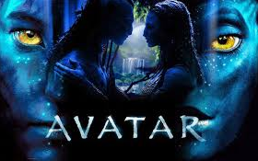 | - “Avatar” ís a science fiction/ comedy film written and directed by James Cameron.
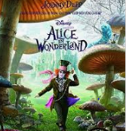 | - “Alice in Wonderland” is a fantasy/ horror film with Johnny Depp.
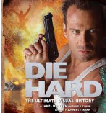 | - “Die hard” is a popular action film/ musical with plenty of guns, explosions and high – speed car chases
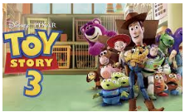 | - “Toy story 3” is a successful animation/ war film
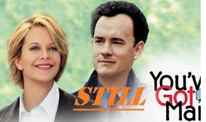 | - “You’ve got Mail” is a romantic comedy/ thriller that’s full of laugh and love
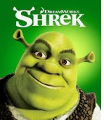 | - “Shrek” is a very funny film that makes people laugh. “Shrek”’ is a romance/ comedy
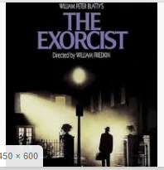 | - “The Exorcist” is probably one of the scariest cartoons/ horror films of all time
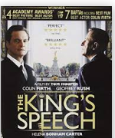 | - “The King’s speed” is a historical drama/ war film based on the true story of British King George VI and his speech defect.

III. Match the words to their definitions.
- gripping a. funny and interesting
- scary b. extremely good
- violent c. causing strong feelings of sadness or sympathy
- boring d. very surprising, and difficult to believe
- moving e. not surprising
- entertaining f. frightening
- predictable g. using or involving force to hurt or attack
- hilarious h, very exciting
- shocking i. not interesting
- incredible j. extremely funny
IV. Complete the sentences with the correct adjectives above
1. The film was so ___________ that Mrs. Brown cried at the end
2. Romance move plots have become so __________________ that you can tell exactly what’s coming
3. My mother can’t stand war film because they’re too ___________________.
4. It was an action film, but it was so __________________ that I fell asleep in the middle
5. We laughed all the way through the film. It was so ______________________.
6. That thriller was so ______________. I couldn’t take my eyes off the screen for a second.
7. Sam always has nightmares after watching ____________ movies
8. The ending of The Sixth Sense was really _____________. It surprised me a lot.
9. The Meyerowitz Stories is getting some ______________ reviews and should be one to add your watch list.
10. Most historical movies are both educational and __________________.
V. Underline the correct form
Alice: That was a very (1) excited/ exciting movie. What did you think?
Jake: To be honest, I found It kind of (2) bored/ boring. I’m not (3) interested/ interesting in science fiction
Alice: Really? I find it (4) fascinated/ fascinating. What kind of movies do you enjoy?
Jake: Mostly comedies. Have you seen Home Again?
Alice: Yes, but I wasn’t (5) amused/ amusing at all. In fact, I thought it was horrified/ horrifying. The story line was (7) confused/ confusing, and I couldn’t find any humor in the character’s problem. When I left the theatre, I feel rather (8) depressed/ depressing.
Jake: I’m (9) amazed/ amazing that you felt that way! I thought it was very (10) amused/ amusing.
Alice: Well, I guess it’s a matter of taste.
VI. Join the two sentences using the word in brackets.
1. Glennie Close hasn’t won a single Oscar. She has been nominated six times, (although)
_________________________________________________________________________
2. Brian Stone is a famous singer. He can’t sing folk song. (despite)
_________________________________________________________________________
3. Some people said the film was terrible. I found it quite gripping. (Though)
_________________________________________________________________________
4. It was a horror film. It wasn’t frightening at all. (in spite of)
_________________________________________________________________________
5. The movie was a box-office failure. It had an all-star cast. (even though)
_________________________________________________________________________
6. The film had good reviews. It was entirely ignored by awards bodies, (despite)
_________________________________________________________________________
7. People criticized the movie for being too violent. The movie was a commercial success
(in spite 0f)
_________________________________________________________________________
8. I liked it a great deal. I will likely never watch it again, (although)
_________________________________________________________________________
9. The film had largely negative reception. Penn was nominated for Best Actor. (despite)
_________________________________________________________________________
10. Critic reviews were favorable. The film was pulled early from theaters due to low ticket sales. (although)
_________________________________________________________________________

