Planning date:14/1/2023
Teaching date:17,18/1/2023
PERIOD 55
UNIT 7: TRAFFIC
LESSON 1: GETTING STARTED –
MEETING IN THE SCHOOL YARD

I. OBJECTIVES: By the end of this unit, students will be able to gain the following things:
1. Knowledge:
- An overview about the topic Traffic
- Vocabulary to talk about means of transport
+ Pronunciation:
+ Vocabulary: Use the words about means of transport.
- cycle (v) /ˈsaɪkl/: đạp xe
- traffic jam (n.phr.) /ˈtræfɪk dʒæm/: tắc đường
- cross the road (v.phr.) /krɒs ðə rəʊd/: băng qua đường
- rush hour (n.phr.) /ˈrʌʃ aʊə(r)/: giờ cao điểm
+ Grammar:
2. Competence:
a) General competencies:
- Students will be able to know more words and phrases about means of transport.
- Develop communication skills and cultural awareness
- Be collaborative and supportive in pair work and teamwork
- Actively join in class activities
b) Specific competencies:
- Group work and independent working, pair work, linguistic competence, cooperative learning and communicative competence.
- Sts can introduce themselves or one another fluently.
3. Qualities: The love of traffic; The awareness about importance of trafffic; Be ready to talk about means of transport; Know some daily activities in the street.
- Develop self-study skills.
II. PREPARATIONS
Teacher: Grade 7 text book, laptop, TV, pictures and realia, Computer connected to the Internet, Sach mem.vn
Students: Text books, pencils, pics, blank papers, realia,….
III. PROCEDURE:
In each activity, each step will be represented as following:
* Task delivering
** Task performance
*** Report and discussion
**** Judgement
Activity 1. WARM UP (5’-IW, GW)
Teacher’s & Student’s activities | Content
Miming game
* Teacher gives instructions
** In groups, Ss
- One of the students in the group go to the board.
- Teacher secretly show 1 picture of a mean of transport to that student. He/She has to mime the picture and the other has to guess. Of course the other groups will also be allowed to guess.
- take turns go to the board until finish all the pictures.
**** Teacher checks and corrects if Ss pronounce the words incorrectly.
Activity 2. KNOWLEDGE FORMATION (15'- PW, IW)
* Aim:
- To help students use key language more appropriately before they read and listen.
- To get students interested in the topic
- To set the context
- To help Ss understand the main idea of the text
* Content: Teach some new words, some action verbs go with nouns.
* Product: Ss learn how to use them.
* Implementation: Teacher’s instructions…
Teacher’s & Student’s activities | Content
Task 1. Listen and read.  * T asks Ss to look at the photos and answer the question  1. What is he doing?  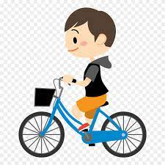  2. What is this?  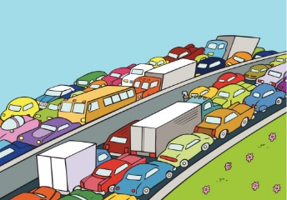  3. What are they doing?  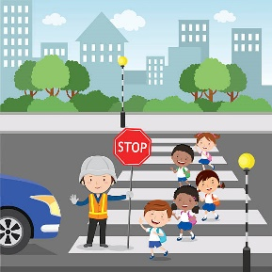  4. Which time of the day usually has traffic jam?    ** Ss say the words.  **** Teacher shows and says the words aloud and asks Ss to repeat them.  * Teacher asks Ss to translate the word into Vietnamese.  Concept check: Slap the board  Task 1. Exercise 2 (p.74):  * Teacher asks Ss to look at the picture (p.73), answer the question:  + Where are they?  Read the conversation again and choose the correct answer:  1. How does Lan often go to school?  A. By bicycle.  B. By motorbike.  C. On foot.  2. It normally takes Lan ___ to get to school.  A. two minutes  B. ten minutes  C. twenty minutes  3. Lan and Mark agree to go cycling ______.  A. tomorrow  B. every day  C. at the weekend  ** Ss work out and answer questions in pairs.  *** Ss share their answers as a whole class.  **** T asks them to read and listen to the conversation to check their answers. T encourages students to explain where they have found the answers from the conversation. | Task 1. Listen and read.  Vocabulary:  - cycle (v) /ˈsaɪkl/: đạp xe  - traffic jam (n.phr.) /ˈtræfɪk dʒæm/: tắc đường  - cross the road (v.phr.) /krɒs ðə rəʊd/: băng qua đường  - rush hour (n.phr.) /ˈrʌʃ aʊə(r)/: giờ cao điểm  Task 1. Exercise 2 (p.74):  1. How does Lan often go to school?  A. By bicycle.  B. By motorbike.  C. On foot.  2. It normally takes Lan ___ to get to school.  A. two minutes  B. ten minutes  C. twenty minutes  3. Lan and Mark agree to go cycling ______.  A. tomorrow  B. every day  C. at the weekend
Activity 3. PRACTICE (15’-IW, PW, GW)
Teacher’s Student’s activities | Content
Task 2: Exercise 3 (p.74): Write one word from the conversation to complete each sentence.  1. Last Sunday afternoon, Lan ______ round the lake near her home.  2. Mark says to Lan: “You ______ be careful, especially when you cross  the road.  3. Traffic ______ are a problem in big cities.  4. – ______ does your mum go shopping?  – She often walks.  5. This road is very ______ during the rush hours.  * Teacher asks Ss to work individually to read and listen to the conversation and find the words and phrases and then share their answers with their partners who sit next to them. (peer check)  ** Ss do exercise 3 individually  *** Ss share and discuss with their partners to write all words/ phrases down on the notebooks.  **** Teacher corrects their answers as a class. | Task 2: Exercise 3 (p.74): Write one word from the conversation to complete each sentence.  1. Last Sunday afternoon, Lan ______ round the lake near her home.  2. Mark says to Lan: “You ______ be careful, especially when you cross  the road.  3. Traffic ______ are a problem in big cities.  4. – ______ does your mum go shopping?  – She often walks.  5. This road is very ______ during the rush hours.  Answers  1. cycled 2. should 3. jams 4. How 5. crowded
Task 4: Look at the pictures and write a word under each.  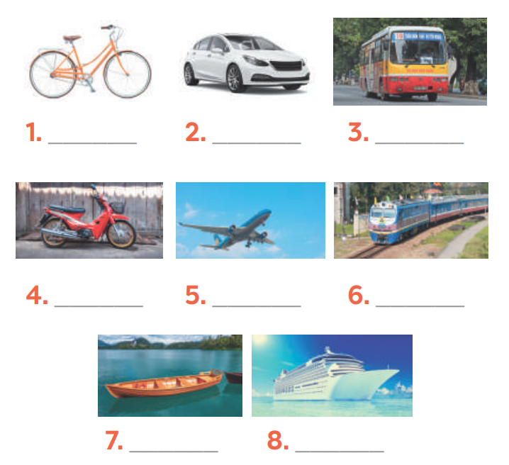  *** Teacher nominates Ss to read the words aloud and  **** Teacher checks and gives the correct answers. | Task 4: Look at the pictures and write a word under each.  Suggested answers:  1. bicycle  2. car  3. bus  4. motorbike  5. plane/air-plane  6. train  7. boat  8. ship
Activity 4. APPLICATION (7’-IW, PW, GW)
Task 5: Find someone who … Write your friends’ names in the blanks. Then report to the class  * Teacher gives Ss clear instructions in order to make sure Ss can do the survey effectively.  - ask students to look at the survey and think of the needed structures to ask their friends.  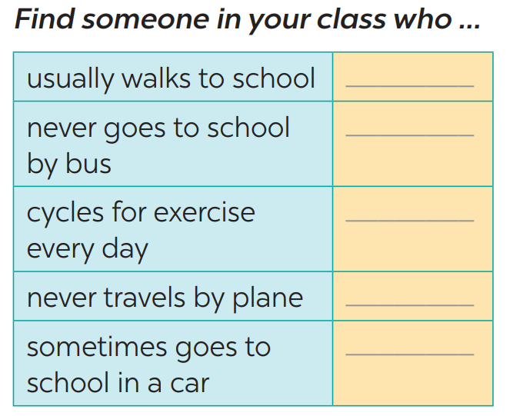  + Students goes around the class and ask at least 20 classmates and ask them (Do you usually walk to school? Have you ever gone to school by bus?…)  - observer Ss while they are role playing, note their language errors  ** Ss do as instructed  **** Teacher gives Ss feedback.  - choose some useful or excellent words/ phrases/ expressions/ word choices Ss have used to suggest other students use them  - choose some typical errors and correct as a whole class without nominating the students’ names | Task 5: Find someone who … Write your friends’ names in the blanks. Then report to the class  * Suggested answer:  1. Me: Do you never go to school by bus?  Lan: Yes, I do.  2. Me: Do you usually walk to school?  Minh: Yes, I do.  3. Me: Do you never travel by plane?  Mark: Yes, I do.  4. Me: Do you sometimes goes to school in a car?  An: Yes, I do.  5. Me: Do you cycles for exercise every day?  Peter: Yes, I do.
  usually walks to school | Minh
  never goes to school by bus | Lan
  cycles for exercise every day | Peter
  never travels by plane | Mark
  sometimes goes to school in a car | An
* Wrap up  To help Ss memorise the target language and skills that they have learned.  * Homework:  -Ttalk about the traffic in your neighbourhood  - Exercises in the workbook | * Wrap up  - Vocabulary of traffic and means of transport.  - Reading for specific information and details  - Scanning  * Homework:  -Ttalk about the traffic in your neighbourhood  - Exercises in the workbook

Planning date:14/1/2023
Teaching date:18/1/2023
PERIOD 56
UNIT 7: TRAFFIC
LESSON 2: A CLOSER LOOK 1

I. OBJECTIVES: By the end of this unit, students will be able to gain the following things:
1. Knowledge:
- Vocabulary about the verbs to use means of transport
- Vocabulary to read the road signs.
- Pronunciation: /aɪ/ and /eɪ/
+ Pronunciation: - Pronunciation: /aɪ/ and /eɪ/
+ Vocabulary: Use the words about means of transport.
- road sign (n.phr.) /ˈrəʊd saɪn/: biển báo giao thông
- cycle lane (n.phr.) /ˈsaɪkl leɪn/: đường đi riêng cho xe đạp
- traffic light (n.phr.) /ˈtræfɪk laɪt/: đèn giao thông
+ Grammar:
2. Competence:
a) General competencies:
- Students will be able to know more words and phrases about means of transport.
- Develop communication skills and cultural awareness
- Be collaborative and supportive in pair work and teamwork
- Actively join in class activities
b) Specific competencies:
- Group work and independent working, pair work, linguistic competence, cooperative learning and communicative competence.
- Sts can introduce themselves or one another fluently.
3. Qualities: The love of traffic; The awareness about importance of trafffic; Be ready to talk about means of transport; Know some daily activities in the street.
- Develop self-study skills.
II. PREPARATIONS
Teacher: Grade 7 text book, laptop, TV, pictures and realia, Computer connected to the Internet, Sach mem.vn
Students: Text books, pencils, pics, blank papers, realia,….
III. PROCEDURE:
In each activity, each step will be represented as following:
* Task delivering
** Task performance
*** Report and discussion
**** Judgement
Activity 1. WARM UP (5’-IW, GW)
* Content: JUMBLED WORDS
* Product: Having a chance to speak English and focus on the topic of the lesson.
* Implementation: Teacher’s instructions…
Teacher’s & Student’s activities | Content
JUMBLED WORDS  * Teacher gives instructions  ** In groups of 5, Ss will be given a small white board and marker.  - Teacher show the jumbled words onto the screen one by one  - Students work in groups to make the correct words and write down onto the small boards. When they finish, they hold it up to show their answers to teacher.  - take turns to write until finish all the words.  1- otba ->  2- itanr ->  3- npeilapra ->  4- rsotrpca ->  5- otmiroekb ->  **** Teacher checks and corrects if Ss write the words incorrectly. | JUMBLED WORDS  Answers:  1- otba -> boat  2- itanr -> train  3- npeilapra -> airplane  4- rsotrpca -> sport car  5- otmiroekb -> motorbike
Activity 2. KNOWLEDGE FORMATION (15'- PW, IW)
Teacher’s & Student’s activities | Content
Vocabulary  * T asks Ss to look at the photos and answer the question  1. What are they?  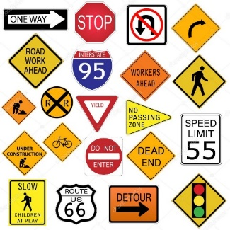  2. What is this?  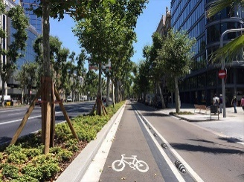  3. What is this?  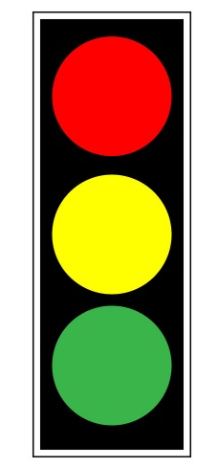  ** Ss say the words.  *** Other Ss correct if the previous answers are incorrect.  **** Teacher shows and says the words aloud and asks Ss to repeat them.  * Teacher asks Ss to translate the word into English  ** Ss says the word | Vocabulary  - road sign (n.phr.) /ˈrəʊd saɪn/: biển báo giao thông  - cycle lane (n.phr.) /ˈsaɪkl leɪn/: đường đi riêng cho xe đạ  - traffic light (n.phr.) /ˈtræfɪk laɪt/: đèn giao thông
Activity 3. PRACTICE (15’-IW, PW, GW)
Teacher’s Student’s activities | Content
Task 2: Exercise 3 (p.74): Look at these road signs. Then write the correct phrases under the signs.  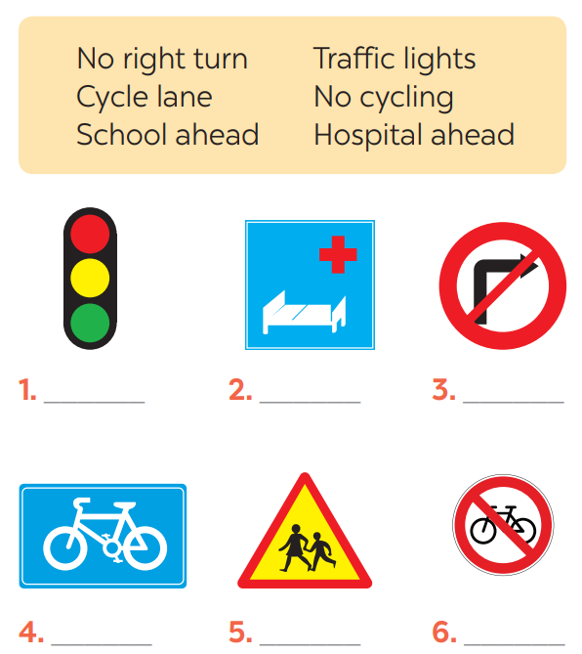  * Teacher asks Ss to look at the road signs and guess their meanings. Then work and share their answers with their partners who sit next to them. (peer check)  ** Ss do exercise 3 in pairs.  *** Ss share and discuss with their partners to write all words/ phrases down on the books.  **** Teacher corrects their answers as a class. | Task 2: Exercise 3 (p.74): Look at these road signs. Then write the correct phrases under the signs.  Answers  1. traffic lights 2. Hospital ahead 3. No right turn  4. cycle lane 5. School ahead 6. No cycling
Task 3: Work in pairs. Take turns to say which of the signs in 2 you see on the way to school.  * Teacher gives suggestions and asks students to share their sentences.  *** Teacher nominates Ss to say the sentences aloud  **** Teacher checks and gives the corrections if they have mistakes. | Task 3: Work in pairs. Take turns to say which of the signs in 2 you see on the way to school.  A: On the way to school, there are many bicycles on the roads, so I see a “Cycle lane” sign.  B: On the way to school, I see a “school ahead” sign.  A: On the way to school, there is no bicycle on the road, so I see a “No cycling” sign.  B: On the way to school, I see in a traffic light a “not turn right” sign.
Activity 4. APPLICATION (7’-IW, PW, GW)
Task 4: Listen and repeat. Pay attention to the sounds /aɪ/ and /eɪ/.  * Teacher gives Ss time to listen and practice pronouncing the sounds individually and words.  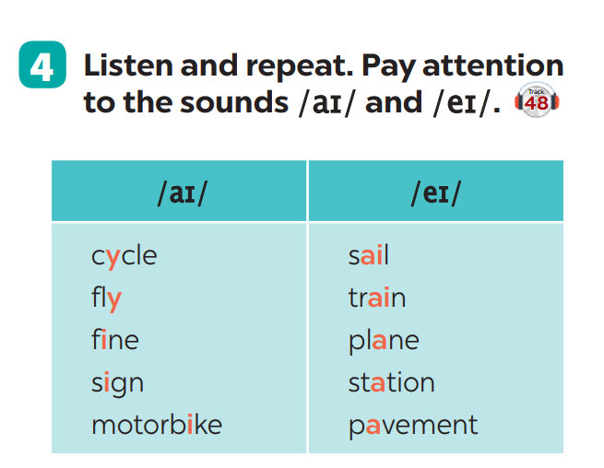  Task 5: Underline the words with the sound /aɪ/ and circle the words with the sound /eɪ/. Then listen, check and repeat  ** Ss do as instructed  **** Teacher gives Ss feedback.  - choose some common mispronounced words that contain the sounds and suggest students practise using them.  - choose some typical errors and correct as a whole class. | Task 4: Listen and repeat. Pay attention to the sounds /aɪ/ and /eɪ/.  Task 5: Underline the words with the sound /aɪ/ and circle the words with the sound /eɪ/. Then listen, check and repeat  Lời giải chi tiết:  1. The bus station is far from my house  2. Remember to ride your bike carefully.  3. We must obey traffic rules for our safety.  4. You have to get there in time for the train.  5. Don't ride on the pavement.
  /aɪ/ | /eɪ/
  cycle /ˈsaɪ.kəl/  fly /flaɪ/  fine /faɪn/  sign /saɪn/  motorbike /ˈməʊ.tə.baɪk/ | sail /seɪl/  train /treɪn/  plane /pleɪn/  station /ˈsteɪ.ʃən/  pavement /ˈpeɪv.mənt/
  /aɪ/ | /eɪ/
  my /maɪ/  ride /raɪd/  bike /baɪk/  time /taɪm/ | obey /əʊˈbeɪ/  station /ˈsteɪ.ʃən/  pavement /ˈpeɪv.mənt/
* Wrap up  To help Ss memorise the target language and skills that they have learned  * Homework:  - Exercises in the workbook | * Wrap up  - Vocabulary of verbs and road signs  - Pronuciation : /aɪ/ and /eɪ/  - Scanning  * Homework:  - Exercises in the workbook

Planning date:19/1/2023
Teaching date:28/1/2023
PERIOD 57
UNIT 7: TRAFFIC
LESSON 3: A CLOSER LOOK 2

I. OBJECTIVES: By the end of this unit, students will be able to gain the following things:
1. Knowledge:
Know how to use:
- It to indicate distance
- should and shouldn’t
+ Pronunciation:
+ Vocabulary: Use the words about means of transport.
+ Grammar:
Structure | Examples
1. It to indicate distance | It is 4 kilometers from my house to school.
2. should | We should eat more vegetables and fruits.
3. shouldn’t | You shouldn’t stay up late everyday.
2. Competence:
a) General competencies:
- Students will be able to know more words and phrases about means of transport.
- Develop communication skills and cultural awareness
- Be collaborative and supportive in pair work and teamwork
- Actively join in class activities
b) Specific competencies:
- Group work and independent working, pair work, linguistic competence, cooperative learning and communicative competence.
- Sts can introduce themselves or one another fluently.
3. Qualities: The love of traffic; The awareness about importance of trafffic; Be ready to talk about means of transport; Know some daily activities in the street.
- Develop self-study skills.
II. PREPARATIONS
Teacher: Grade 7 text book, laptop, TV, pictures and realia, Computer connected to the Internet, Sach mem.vn
Students: Text books, pencils, pics, blank papers, realia,….
III. PROCEDURE:
In each activity, each step will be represented as following:
* Task delivering
** Task performance
*** Report and discussion
**** Judgement
Activity 1. WARM UP (5’-IW, GW)
Teacher’s & Student’s activities | Content
SLAP THE BOARD  * Teacher gives instructions and sticks some road signs pictures onto the board.  ** In 2 group, Ss will choose 1 student in each group to go to the board.  - Teacher says a road sign message.  - Student quickly run and slap onto the correct road signs.  - Students take turns until finish all of the signs.  **** Teacher checks and corrects if Ss pronounce the signs incorrectly. | SLAP THE BOARD  Answers:  1- Cycle lane  2- School ahead  3- No cycling  4- No right turn  5- Schools ahead
Activity 2. KNOWLEDGE FORMATION (15'- PW, IW)
Teacher’s & Student’s activities | Content
IT INDICATING DISTANCE  - Teacher says: “This lesson today is going to tell you about “it indicating distance”  * Teacher draws students’ attention to the grammar point and the example  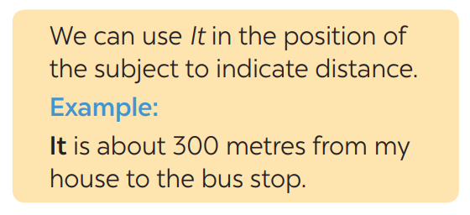  * Teacher asks Ss:  - What does the sentences tell us about?  Answer: Distance from his/her house to the bus stop  - What is the structure using in the sentence?  Answer: It be (about) + distance from A to B.  ** Ss read the grammar explicit and study the example.  *** Ss may discuss within groups/pairs before answering.  **** Teacher shows and says the sentences aloud and asks Ss to make similar sentences. | IT INDICATING DISTANCE  - What does the sentences tell us about?  Answer: Distance from his/her house to the bus stop  - What is the structure using in the sentence?  Answer: It be (about) + distance from A to B.
Activity 3. PRACTICE (15’-IW, PW, GW)
* Aim:
- To get students interested in the topic
- To set the context
- To help Ss understand the main idea of the text
- To practise asking and answering about distance.
- To practise the using should and shouldn’t.
* Product: Students’ answers.
* Implementation:
Teacher’s Student’s activities | Content
Task 1. Ex 1: Write sentences with It. Use these cues.  * Teacher asks Ss to look at the example and the task.  ** Ss work out and answer questions individually.  *** Ss share their answers in pairs.  **** T asks them to to check their answers.  * Then tell share them to share their sentences as a whole in class and correct for them. | Task 1. Ex 1: Write sentences with It. Use these cues.  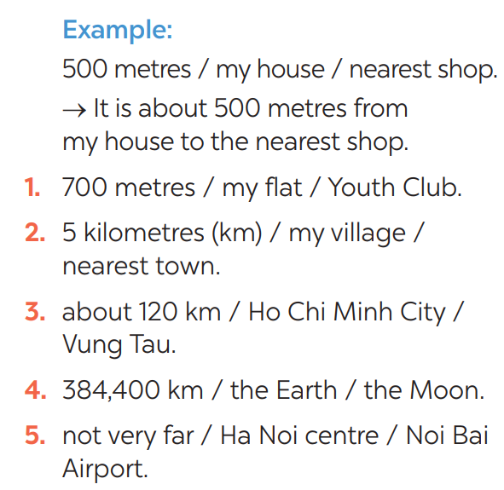
Task 2: Exercise 2: Work in pairs. Ask and answer questions about distances in your neighbourhood  * Teacher asks Ss to look at the example and identify the structure of the question: How far is it from … to …?  Then work with their partners who sit next to them to make similar conversations.  ** Ss do exercise 2 in pairs.  *** Ss write all conversations down on the notebooks.  **** Teacher corrects their answers as a class.  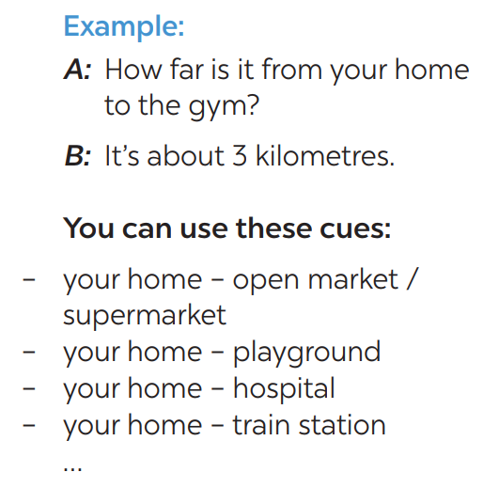 | Task 2: Exercise 2: Work in pairs. Ask and answer questions about distances in your neighbourhood
Task 3: Choose the correct option in brackets.  * Teacher draws students attention to the remember box. Teacher asks them to study the examples and identify the structure: S + should/shouldn’t + Vinf  * Teacher gives suggestions and asks students to make some similar sentences using the structures.  *** Teacher nominates Ss to read aloud the sentences.  **** Teacher checks and gives the corrections if they have mistakes. | Task 3: Choose the correct option in brackets.  Structure: S + should/shouldn’t + Vinf  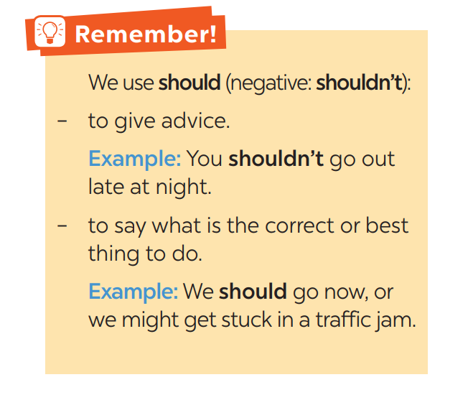
Task 4: Complete each sentence, using should / shouldn’t.  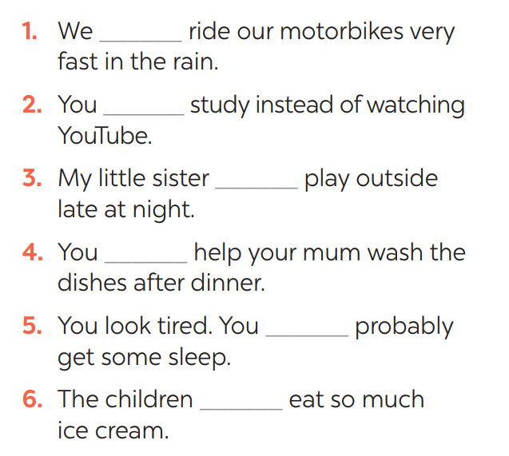  * Teacher gives Ss time to do the exercise individually and peer check with their partner.  *** Teacher nominates Ss to read aloud the sentences.  **** Teacher checks and gives the corrections if they have mistakes. | Task 4: Complete each sentence, using should / shouldn’t.
Activity 4. APPLICATION (7’-IW, PW, GW)
Task 5: Look at the pictures. Make sentences, using should / shouldn’t and the cues  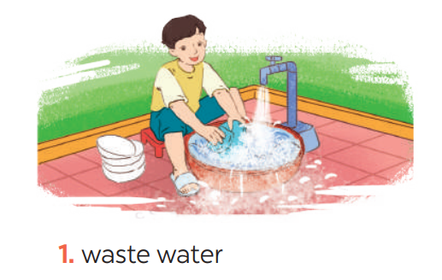  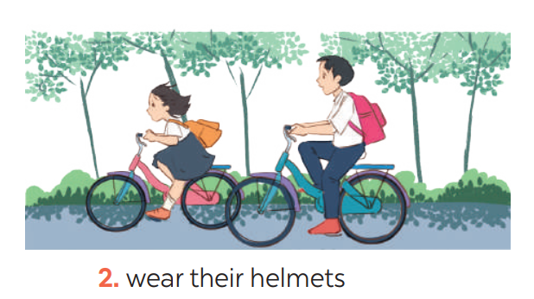  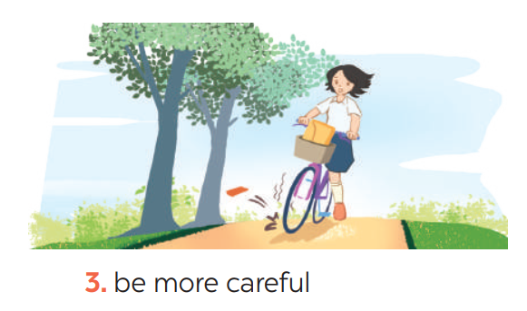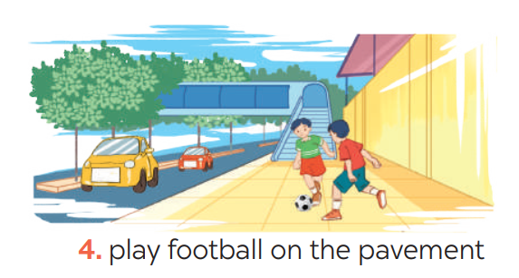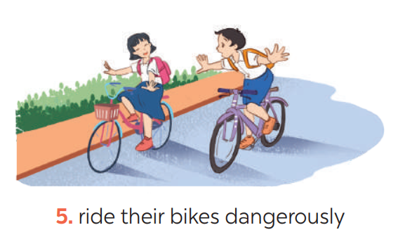  ** Ss do as instructed  **** Teacher gives Ss feedback.  - choose some common mistakes and suggest students how to avoid them.  - choose some typical errors and correct as a whole class | Task 5: Look at the pictures. Make sentences, using should / shouldn’t and the cues
* Wrap up  To help Ss memorise the target language and skills that they have learned  * Homework:  - Exercises in the workbook | * Wrap up  - It indicating distance  - Should/shouldn’t  - Scanning  * Homework:  - Exercises in the workbook

Planning date:22/1/2023
Teaching date:30/1/2023
PERIOD 58
UNIT 7: TRAFFIC
LESSON 4: COMMUNICATION

I. OBJECTIVES: By the end of this unit, students will be able to gain the following things:
1. Knowledge:
- Learn how to ask and answer about means of transport and some strange traffic rules.
- Practise using some grammar points and vocabulary related to the topic.
+ Pronunciation:
+ Vocabulary: Use the words about means of transport.
+ Grammar:
2. Competence:
a) General competencies:
- Students will be able to know more words and phrases about means of transport.
- Develop communication skills and cultural awareness
- Be collaborative and supportive in pair work and teamwork
- Actively join in class activities
b) Specific competencies:
- Group work and independent working, pair work, linguistic competence, cooperative learning and communicative competence.
- Sts can introduce themselves or one another fluently.
3. Qualities: The love of traffic; The awareness about importance of trafffic; Be ready to talk about means of transport; Know some daily activities in the street.
- Develop self-study skills.
II. PREPARATIONS
Teacher: Grade 7 text book, laptop, TV, pictures and realia, Computer connected to the Internet, Sach mem.vn
Students: Text books, pencils, pics, blank papers, realia,….
III. PROCEDURE:
In each activity, each step will be represented as following:
* Task delivering
** Task performance
*** Report and discussion
**** Judgement
Activity 1. WARM UP (5’-IW, GW)
Teacher’s & Student’s activities | Content
Game: BRAINSTORMING  HOW DO YOU GO TO SCHOOL?  * Teacher divides class into 2 teams and asks them to think of “MEANS OF TRANSPORTS” (even the strangest ones).  ** Ss have 1 min to think of the words related to the topic or they can discuss with their partners.  *** Each member from each team turn by turn run to the board and write one word.  **** Teacher corrects their answers.  - The team which has more correct words will be the winner.  - Teacher leads students into the lesson by telling what they are going to learn: “We are going to learn how to ask and answer about means of transport and some strange traffic rules”. | Suggested answers:  Motorbike, bicycle, train, bus, plane, helicopter,…
Activity 2. KNOWLEDGE FORMATION (15'- PW, IW)
Teacher’s & Student’s activities | Content
Task 1: Listen and read the conversation, paying attention to the highlighted parts.  * Teacher plays the record for SS to listen and read the conversation about means of transport. .  ** Ss listen and practice saying with their partners.  *** Teacher calls some pairs to read aloud.  **** Teacher corrects pronunciation if needed.  * Teacher asks Ss to pay attention to the highlighted parts and asks them some questions to elicit the new structure:  - Which tense do we use to ask and answer?  - Which question word do we use?  - …..  ** Ss answer teacher’s questions to find out new structure to ask anad answer about means of transport to travel to places  *** Some students give the new structure to the teacher.  **** Teacher corrects and writes on the board. | Task 1: Listen and read the conversation, paying attention to the highlighted parts.  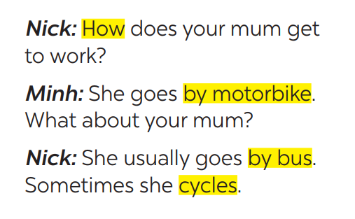  - Structure:  to ask:  - How do/does + S + go to …?  to answer:  - S + go/goes by …  - S + V
Activity 3. PRACTICE (15’-IW, PW, GW)
Teacher’s Student’s activities | Content
Task 2: Work in pairs. Take turns to ask and answer about the means of transport your family members use every day.  * Teacher has SS look at the situation in Ex 2 to make similar dialogue:  ** Ss work in pairs to make similar dialogue.  *** Teacher calls some pairs to present it in front of the class.  **** Teacher gives feedback and some comments. | Task 2: Work in pairs. Take turns to ask and answer about the means of transport your family members use every day.  Suggested answers:  A: How does your father go to school?  B: He usually drives his car but sometimes he goes by bus. How about your father?  A: He walks because we live near his office.
* STRANGE TRAFFIC RULES  Task 3: Which countries below keep to the left? Tick the correct answers.  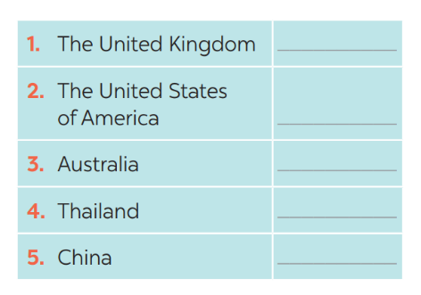  * Teacher asks Ss to discuss in pairs and tick.  ** Ss so the task in pairs  Task 4: Listen and check your answers in 3. Then listen again and complete the sentence with no more than THREE words.  * Teacher plays the recording twice.  *** Teacher calls some Ss to give their answer and explain it.  **** Teacher let Ss listen and confirms the correct answers.  Answer key: - United Kingdom, Australia  - same traffic rules/regulations | * STRANGE TRAFFIC RULES  Task 3: Which countries below keep to the left? Tick the correct answers.  Task 4: Listen and check your answers in 3. Then listen again and complete the sentence with no more than THREE words.  Answer key:  - United Kingdom, Australia  - same traffic rules/regulations
  1. The United Kingdom | v
  2. The United States of America
  3. Australia | v
  4. Thailand | v
  5. China
Activity 4. APPLICATION (7’-IW, PW, GW)
Task 5: Read, discuss which one do is the strangest rule?  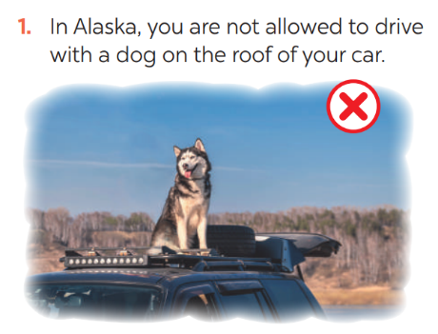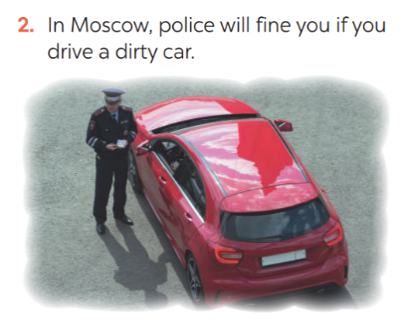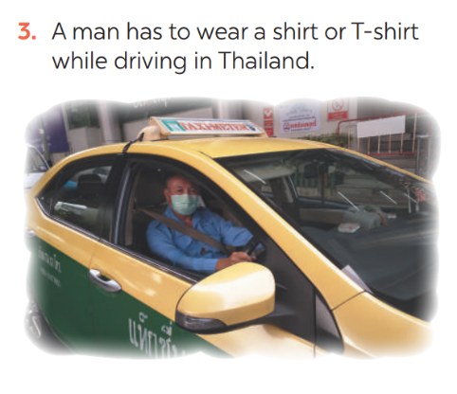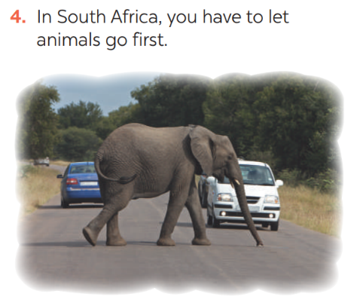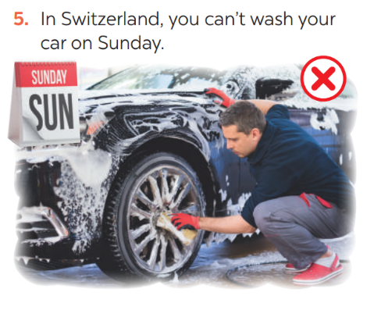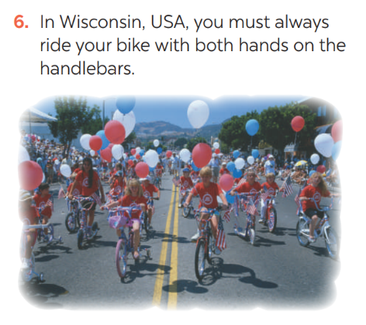  * Teacher has students work in groups to discuss which one they find strangest.  ** Ss work in groups.  *** 2-3 groups share their ides  **** Teacher encourages students to add more if they know. | Task 5: Read, discuss which one do is the strangest rule?  In my opinion, the strangest traffic rule is a man in Thailand has to wear a shirt or T-shirt while driving I just can't figure out why people have set that rule.  I know another strange traffic rule which prevents you from driving on Mondays if your number plate ends in a 1 or 2 in Manila, Philippines.
* Wrap up  - To consolidate what students have learnt in the lesson.  * Homework:  - Exercises in the workbook.  - To prepare for the next lesson:  Skills 1. | * Wrap up  Teacher asks students to talk about what they have learnt in the lesson.  * Homework:  - Exercises in the workbook  - To prepare for the next lesson:  Skills 1.

Planning date:22/1/2023
Teaching date:1,2/02/2023
PERIOD 59
UNIT 7: TRAFFIC
LESSON 5: SKILLS 1
I. OBJECTIVES: By the end of this unit, students will be able to gain the following things:
1. Knowledge:
+ Reading:
- Read for specific information about some rules about road safety
+ Speaking:
- Talk about how to avoid traffic accidents.
+ Pronunciation:
+ Grammar:
2. Competence:
a) General competencies:
- Students will be able to know more words and phrases about means of transport.
- Develop communication skills and cultural awareness
- Be collaborative and supportive in pair work and teamwork
- Actively join in class activities
b) Specific competencies:
- Group work and independent working, pair work, linguistic competence, cooperative learning and communicative competence.
- Sts can introduce themselves or one another fluently.
3. Qualities: The love of traffic; The awareness about importance of trafffic; Be ready to talk about means of transport; Know some daily activities in the street.
- Develop self-study skills.
II. PREPARATIONS
Teacher: Grade 7 text book, laptop, TV, pictures and realia, Computer connected to the Internet, Sach mem.vn
Students: Text books, pencils, pics, blank papers, realia,….
III. PROCEDURE:
Activity 1. WARM UP (5’-IW, GW)
* Aim:
To introduce the lesson.
To lead in the lesson.
* Content: Hangman
* Product: Having a chance to speak English and focus on the topic of the lesson.
* Implementation: Teacher’s instructions…
Teacher’s & Student’s activities | Content
Game: Hangman  * Teacher divides class into 2 teams and asks them to think of the word which has 9 letters in it related the topic “ON THE ROAD”.  ** Ss have 1 min to think of the words related to the topic or they can discuss with their partners.  *** Each member from each team turn by turn guesses the letter in the secret word.  **** Teacher corrects their answers.  - The team which can find or guess the secret first will be the winner.  READING  Teacher leads students into the lesson by telling what they are going to learn: “We are going to read a passage about some rules about road safety.” | Game: Hangman  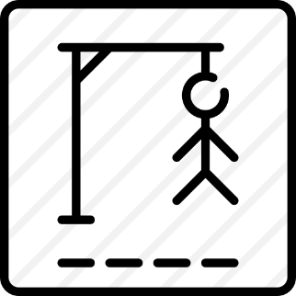  D A N G E R O U S
Activity 2. KNOWLEDGE FORMATION (15'- PW, IW)
* Aim:
To provide students with some lexical items before reading the text.
To introduce words related to skin conditions to Ss and help Ss have a general idea of what they are going to read.
* Content:
* Product: Ss learn how to use them.
* Implementation: Teacher’s instructions…
Teacher’s & Student’s activities | Content
Vocabulary  - Teacher introduces the vocabulary by:  + Providing the synonym or antonym of the words.  + Providing the pictures of the words.  + Providing the definition of the words.  Concept check: Rub out and Remember  DISCUSSION  * Teacher asks Ss to work in pairs to look at the Picture in Ex1 and discuss on what they see that is dangerous?  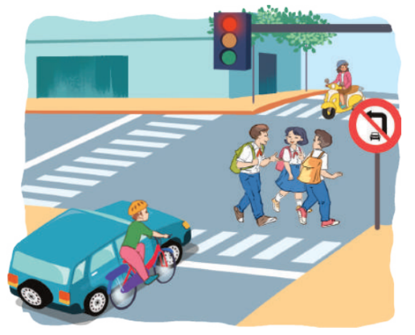  ** Ss work in pairs.  *** Teacher calls some Ss to check what they have discussed.  **** Teacher corrects. | Vocabulary  - pedestrian (n) /pəˈdestrēən/: người đi bộ  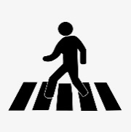  - passenger (n) /ˈpasinjər/: hanh khách    - (to) obey / ōˈbā/: tuân thủ  - seatbelt (n) / ˈsēt ˌbelt/: dây an toàn  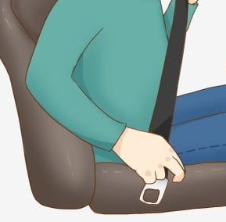  Concept check: Rub out and Remember  DISCUSSION  Answer keys:  The students who are crossing the road  Because they do not walk on the right place and they are not careful.
Activity 3. PRACTICE (15’-IW, PW, GW)
* Aim:
To help Ss develop their reading skill for main ideas and specific information (scanning) and help them focus on the road safety rules.
To help Ss further develop their reading skill for specific information (scanning).
To check students’ reading comprehension.
To help Ss talk about how they apply the rules in the reading to themselves.
To provide Ss an opportunity to practise giving advices on dangerous situations on the road.
* Product: Students’ answers.
* Implementation:
Teacher’s Student’s activities | Content
Task 1: Read the following text and choose the correct answer.  This text is about ______.  A. rules for pedestrians  B. traffic lights  C. traffic rules  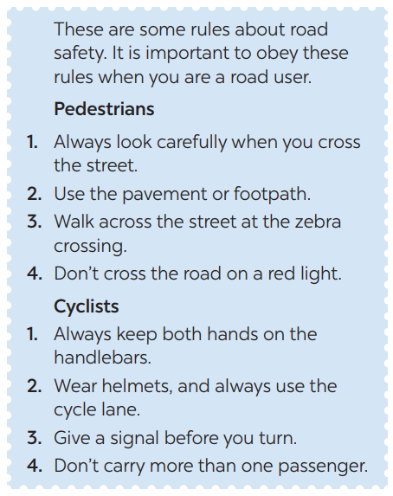  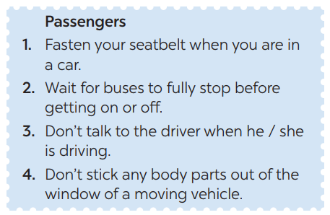  * Teacher has Ss read the first sentence of the text in detail to do the exercise and asks them how to do this kind of exercise.  ** Ss do the task independently  *** Teacher tells Ss to compare their answers in pairs before calling some of them to check.  **** Teacher confirms the correct answer and explains if needed.  Task 2: Read the text again and answer  the questions:  * Teacher asks Ss: reading each question, locating where the information appears in the text, reading that part carefully and circling the correct answer.  ** Ss do the task independently.  *** Teachers has Ss compare their answers in pairs and call some Ss to give their ideas.  **** Teacher checks and confirms the correct answers. | Task 1: Read the following text and choose the correct answer.  This text is about ______.  A. rules for pedestrians  B. traffic lights  C. traffic rules  Answer key: C  Task 2: Read the text again and answer  the questions:
Task 3: Work in groups. Ask and answer  the following question:  “When you are a road user, what should you NOT do?”  Make a list in groups. Compare  your list with other groups’.  * Teacher asks Ss to work in groups and tells them to focus on the rules for road users in the text to talk about which one they have to obey everyday.  ** Ss work in groups. Teacher goes around and listens and gives help if needed.  *** Teacher calls on some Ss to share their answers with the class.  **** Teacher listens and gives comment. | Task 3: Work in groups. Ask and answer  the following question:  When being a road user, we had better not:  - Cross the road on a red light.  - Cycle in the pavement or footpath.  - Lose cocentration when driving.  - Stick any body parts out of the window of a moving vehicle.
Task 4: Read the following sentences  about these people. Then work in groups. Discuss who is being safe, and who isn’t  * Teacher has Ss work in groups and asks them to take turns to discuss the situations.  ** Ss work in groups to do the task. Teacher goes around, listens and gives help if needed.  *** Teacher calls on some groups to share their answers with the class.  **** Teacher comments | Task 4: Read the following sentences  about these people. Then work in groups. Discuss who is being safe, and who isn’t  1. Hoang is riding a bike, and he is wearing a helmet.  => Hoang is being safe when being a road user because he wearing a helmet when ride a bike.  2. It is raining hard, but Mr Long is driving quickly.  => Mr Long is not safe because when it rains hard, the road is very slippery causing danger if he drives quickly.  3. The students are standing in a line to get on the school bus.  => The students is being safe because they standing in a line to get on the school bus.  4. Mr Binh is taking his daughter to school on his motorbike. She is sitting in front of him.  => Mr Binh is not safe because his daughter is sitting in front of him.  5. Michelle is cycling to school and she is waving and shouting to her friends.  => Michelle is not safe because she loses concentration when cycling.
Activity 4. APPLICATION (7’-IW, PW, GW)
Task 5: Give the advices on dangerous situations on the road.
Structure: S + should/shouldn’t + Vinf
* Teacher has students give advices on how to avoid the dangerous situations on the road.
*** Teacher calls on some groups to share their answers with the class.
**** Teacher comments and corrects if needed.
* Wrap up  - To consolidate what students have learnt in the lesson.  * Homework:  - Exercises in the workbook.  - To prepare for the next lesson:  Skills 2. | * Wrap up  Teacher asks students to talk about what they have learnt in the lesson.  * Homework:  - Exercises in the workbook  - To prepare for the next lesson:  Skills 2.

Planning date:2/2/2023
Teaching date:4,7/02/2023
PERIOD 60
UNIT 7: TRAFFIC
LESSON 6: SKILLS 2
I. OBJECTIVES: By the end of this unit, students will be able to gain the following things:
1. Knowledge:
+ Listening
- use the lexical items related to the topic Traffic
- listen for main ideas and specific information about traffic problems in Mumbai.
+ Writing: write about traffic problems in your area.
+ Pronunciation:
+ Vocabulary: Use the words about means of transport.
+ Grammar:
2. Competence:
a) General competencies:
- Students will be able to know more words and phrases about means of transport.
- Develop communication skills and cultural awareness
- Be collaborative and supportive in pair work and teamwork
- Actively join in class activities
b) Specific competencies:
- Group work and independent working, pair work, linguistic competence, cooperative learning and communicative competence.
- Sts can introduce themselves or one another fluently.
3. Qualities: The love of traffic; The awareness about importance of trafffic; Be ready to talk about means of transport; Know some daily activities in the street.
- Develop self-study skills.
II. PREPARATIONS
Teacher: Grade 7 text book, laptop, TV, pictures and realia, Computer connected to the Internet, Sach mem.vn
Students: Text books, pencils, pics, blank papers, realia,….
III. PROCEDURE:

Activity 1. WARM UP (5’-IW, GW)
* Aim:
To activate students’ prior knowledge and vocabulary related to the lesson.
To lead in the lesson.
* Content: BRAIN STORMING:
* Product: Having a chance to speak English and focus on the topic of the lesson.
* Implementation: Teacher’s instructions…
Teacher’s & Student’s activities | Content
BRAIN STORMING:
* Teacher writes on the board the word “Traffic problems” and asks Ss some questions:
+ What does this word mean?
+ What do we have to suffer from these problems?
+ Can you name some traffic problems?
** Ss think of these questions and discuss with their partners if needed.
*** Teacher calls some students to give their answers.
**** Teacher listens and give comments.
Teacher introduces students the content of the lesson: “In the lesson today, we are going to listen to a person talking about traffic problems in his city - Mumbai.”
Activity 2. KNOWLEDGE FORMATION (15'- PW, IW)
Teacher’s & Student’s activities | Content
Task 1: What can you see in this picture? What is special about it?  * Teacher asks Ss to work in pairs to the problems they can find in the picture.  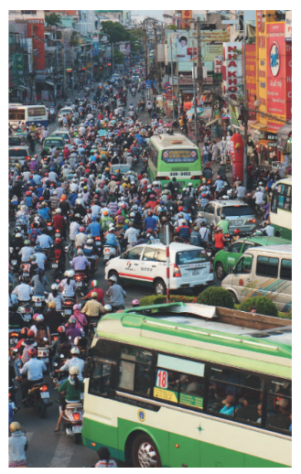  ** Ss work with their partner to do the task.  *** Teacher calls on some Ss to answer.  **** Teacher gives comments and leads Ss to task  Task 2: Listen to the recording and choose the correct answer A, B, or C  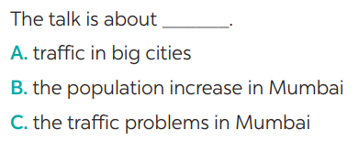  * Teacher asks Ss to read and underline the key words.  ** Ss work independently to guess then listen to the recording once to check their guess.  *** Teacher calls on some students to give the answers the have listened. | Task 1: What can you see in this picture? What is special about it?  Suggested answers:  In the picture, there are numerous vehicles running on the road: motorbikes, cars, and buses. They seem to be caught up the a traffic jam.  Task 2: Listen to the recording and choose the correct answer A, B, or C  * Aswer: C
Activity 3. PRACTICE (15’-IW, PW, GW)
* Product: Students’ answers.
* Implementation:
Teacher’s Student’s activities | Content
Task 3: Listen again and write ONE word or number in each gap  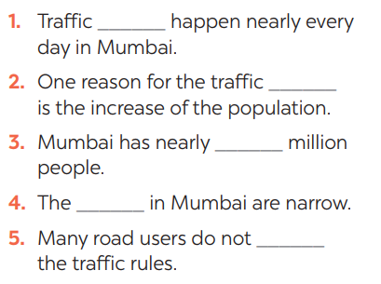  **** Teacher plays the recording again and confirms the correct answers for their prediction. | Task 3: Listen again and write ONE word or number in each gap  Answer key:
Task 4: Discuss: Compare traffic problems in Mumbai to the traffic problems in Hanoi.  * Teacher tells Ss to work in groups to discuss and compare traffic problems in Mumbai to the traffic problems in Hanoi. Write down onto the notebooks in full sentences  ** Ss work in groups. Teacher moves around and offers help if needed.  *** Teacher invites some Ss to share their answers.  **** Teacher corrects if needed. | Task 4: Discuss: Compare traffic problems in Mumbai to the traffic problems in Hanoi.  E.g. The traffic jams in Hanoi is as serious and frequent as they are in Mumbai.
Task 5: Tick the traffic problems in big cities in Viet Nam  * Teacher writes on the board “Your city’s Traffic Problems” and asks Ss to Tick the traffic problems in big cities in Viet Nam and asks them to give out more problems that they see in their city.  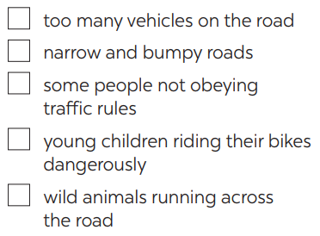  ** Ss think of it and can discuss with their partners.  *** Teacher calls on some Ss to raise their ideas.  **** Teacher listens and confirms. | Task 5: Tick the traffic problems in big cities in Viet Nam  Suggested answers:  Too many vehicles  Narrow roads  People’s awareness
Activity 4. APPLICATION (7’-IW, PW, GW)
Task 6: Write a paragraph of about 70 words about the traffic problems in your town / city.  * Teacher tells Ss that they are going to write a passage about the traffic problems in your town / city.  ** Teacher reminds Ss of the structure of a passage and steps to make an outline for the passage.  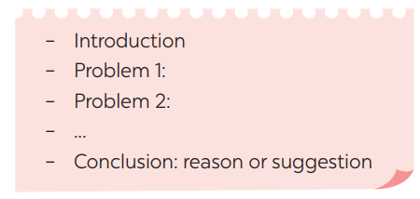  ** Ss work independently to do the task and try to use the notes from the previous tasks.  Teacher goes around and help if necessary.  Peer check and cross check  *** Teacher asks Ss to share their writing with their partners. Then, call on some Ss to show their writing in front of the class.  **** Teacher checks ideas, grammar, vocabulary and gives comments. | Task 6: Write a paragraph of about 70 words about the traffic problems in your town / city.  Suggested answers:  The most serious traffic problem in our city – Hanoi is the traffic jams. Although the public transport system in Hanoi is quite modern and covenient, many people prefer using their own motorbikes. The reason for that is because most roads and streets in Hanoi are quite smalls and include many tiny lanes. Therefore, using private vehicles allows them to get there without walking long distance. The situation usually gets worse at rush hours when people all go to work or return home from work and schools. In conclusion, people should try to use public transport more often to reduce the traffic jams and exhaust.
* Wrap up  - To consolidate what students have learnt in the lesson.  * Homework:  To allow students finalize their passage after being checked by friends and the teacher.  - To prepare for the next lesson:  Looking back. | * Wrap up  Teacher asks students to talk about what they have learnt in the lesson.  * Homework:  - Exercises in the workbook  - To prepare for the next lesson:  Looking back.

Planning date:4/2/2023
Teaching date:8,9/02/2023
PERIOD 61
UNIT 7: TRAFFIC
LESSON 7: LOOKING BACK & PROJECT
I. OBJECTIVES: By the end of this unit, students will be able to gain the following things:
1. Knowledge:
- Review the vocabulary and grammar of Unit 7
- Apply what they have learnt (vocabulary and grammar) into practice through a project
+ Pronunciation:
+ Vocabulary: Use the words about means of transport.
+ Grammar:
2. Competence:
a) General competencies:
- Students will be able to know more words and phrases about means of transport.
- Develop communication skills and cultural awareness
- Be collaborative and supportive in pair work and teamwork
- Actively join in class activities
b) Specific competencies:
- Group work and independent working, pair work, linguistic competence, cooperative learning and communicative competence.
- Sts can introduce themselves or one another fluently.
3. Qualities: The love of traffic; The awareness about importance of trafffic; Be ready to talk about means of transport; Know some daily activities in the street.
- Develop self-study skills.
II. PREPARATIONS
Teacher: Grade 7 text book, laptop, TV, pictures and realia, Computer connected to the Internet, Sach mem.vn
Students: Text books, pencils, pics, blank papers, realia,….
III. PROCEDURE:
In each activity, each step will be represented as following:
* Task delivering
** Task performance
*** Report and discussion
**** Judgement
Activity 1. WARM UP (5’-IW, GW)
* Aim:
To help students revise the vocabulary items they have learnt in the unit.
To enhance students’ skills of cooperating with team mates.
* Content: BRAIN STORMING:
* Product: Having a chance to speak English and focus on the topic of the lesson.
* Implementation: Teacher’s instructions…
Teacher’s & Student’s activities | Content
Quick revision check
* Teacher asks Ss to think of what they have learnt already in Unit 7.
** Ss work in pairs to do the task.
***Teacher calls some students to retell.
**** Teacher confirms and leads them to do all the exercises in books.
Activity 2. KNOWLEDGE FORMATION (15'- PW, IW)
* Aim:
To help Ss revise the vocabulary items (verbs) they have learnt in the unit.
* Content: Listening
* Product: Ss learn how to use them.
* Implementation: Teacher’s instructions…
Teacher’s & Student’s activities | Content
Task 1: Label each sign. Work in pairs. What does each sign tell us to do?  * Teacher has Ss work individually.  ** Ss do this activity individually, then compare their answers with their partners.  *** Teacher asks for Ss’ answers. **** Teacher confirms the correct ones  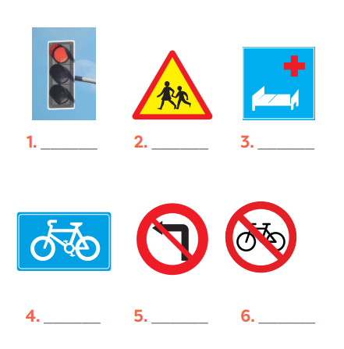 | Task 1: Label each sign. Work in pairs. What does each sign tell us to do?  Answer keys:  1. traffic light  2. school ahead  3. hospital ahead  4. cycle lane  5. No left turn  6. Do not cycle
Activity 3. PRACTICE (15’-IW, PW, GW)
* Aim:
To help Ss revise the vocabulary items (adjectives) they have learnt in the unit
To help Ss revise grammar points.
To help Ss revise the grammar points of the unit
* Product: Students’ answers.
* Implementation:
Teacher’s Student’s activities | Content
Task 2: Fill in each gap with one word to complete the sentences.  * Teacher has Ss work individually.  ** Ss do this activity individually, then compare their answers with their partners.  *** Teacher asks for Ss’ answers. **** Teacher confirms the correct ones  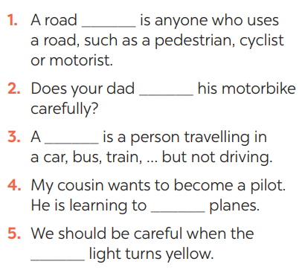  Task 3: Write complete sentences, using these cues.  * Teacher asks Ss to recall the structures of asking and answering about distance, and tell them to do Ex 3 in the book.  ** Ss do the exercise individually and swap with their partners.  *** Teacher calls some Ss to check their answer.  **** Teacher confirms the correct answer.  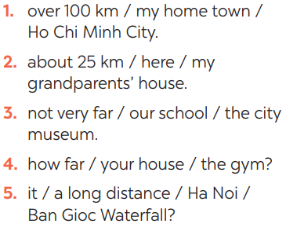  Task 4: Choose A, B, or C to complete the sentences.  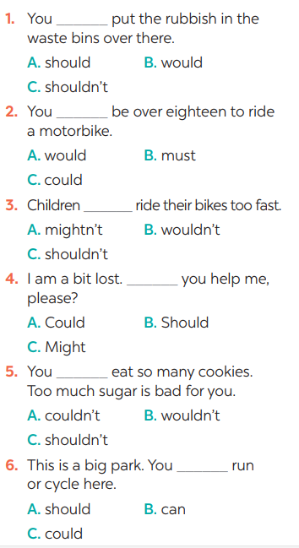  * Teacher asks Ss to do the task.  ** Ss work individually to do the task.  *** Teacher calls Ss to give out their answers.  **** Teacher checks and confirms their answer. | Task 2: Fill in each gap with one word to complete the sentences.  Answer keys:  1. user  2. ride  3. passenger  4. drive  5. see/notice  Task 3: Write complete sentences, using these cues.  Answer keys:  1- It’s over 100km from my hometown to Ho Chi Minh city.  2- It’s about 25 km from here to my grandparents’ house.  3- It’s not very far from our school to the city museum.  4- How far is it from your house to the gym?  5- Is it a long distance from Ha Noi to Ban Gioc Waterfall?  Task 4: Choose A, B, or C to complete the sentences.  Answer keys:  1. C 2. B 3. C  4. A 5. C 6. B
Activity 4. APPLICATION (7’-IW, PW, GW)
Task 5: Show the prepared signs. Make your own sign.    * Teacher asks Ss to show the signs they have prepared and identify the messages in each of the sign.  * Teacher also has Ss spend some time to make their own signs and practise presenting within their groups.  ** Ss discuss with their partners.  *** Some students raise their ideas and explain their answers.  **** Teacher listens and confirms.  Task 6: Traffic signs exhibition  * Teacher asks Ss to work in groups of 4 – 6 to stick their traffic signs onto the classroom’s wall and present about them.  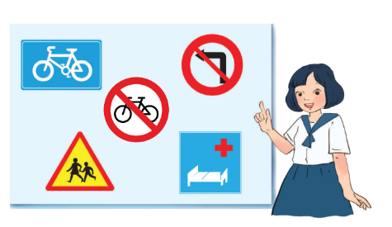  ** Ss work in group to do the task.  *** Teacher calls some groups to present their signs to the class  **** Teacher confirms and corrects. | Task 5: Show the prepared signs. Make your own sign.  I saw some traffic signs on my way from home to school:  1. Red light  => I see a red light on a traffic light when going through a crossroads. A "red light" sign means you have to stop.  2. School ahead>On my way to school, so I see a “school ahead sign”. A "school ahead" sign means there is a school ahead.  3. Not turn right  =>On the way to school, I see in a traffic light a “not turn right” sign.A "not turn right" sign means we must not turn right here.  5. No cycling  =>A "no cycling" sign means we are not allowed to cycle.  Task 6: Traffic signs exhibition
* Wrap up  - To consolidate what students have learnt in the lesson.  * Homework:  - To prepare for the next lesson:  Unit 8: Getting started. | * Wrap up  - Teacher asks students to talk about what they have learnt in the lesson.  * Homework:  - Exercises in the workbook  - To prepare for the next lesson:  Unit 8: Getting started.

Planning date:2/2/2023
Teaching date:9,11/02/2023
PERIOD 62
UNIT 8: FILMS
LESSON 1: GETTING STARTED

I. OBJECTIVES: By the end of this lesson, students will be able to gain:
1. Knowledge: - An overview about the topic “Films”
- Lexical items related to the topic “Films”:
+ types of films;
+ adjectives describing films.
2. Competence:
a) General competencies:
- Ss are interested in practicing language function
- Ss are interested in doing exercises
b) Specific competencies:
- Develop communication skills and cultural awareness
- Be collaborative and supportive in pair work and teamwork
- Actively join in class activities.
- Qualities:
- Develop self-study skills
II. PREPARATIONS
Teacher: Grade 8 text book, laptop, TV, pictures and realia, Computer connected to the Internet. Sach mem.vn
Students: Text books, pencils, pics, blank papers, realia,….
III. PROCEDURE:
In each activity, each step will be represented as following:
* Deliver the task
** Implement the task
*** Discuss
**** Giving comments or feedback

Activity 1. WARM UP (5’-IW, PW)
Teacher’s & Student’s activities | Content
Chatting and describing the picture.  -Teacher asks students some questions related to the topic:  - Ask Ss to look at the pictures and guess them what they are. | T: What did you do last night after finishing your homework?  Ss: …………..  T: Do you like watching film?  Ss: ……..  T: Look at the pictures and tell me what they are.  Ss: ………( They are the titles of films)  T: Do you think watching films is interesting?  Ss: ………
Activity 1. VOCABULARY (PRE-TEACH) (7'- PW, IW)
Teacher’s & Student’s activities | Content
Vocabulary:  * Teacher introduces the vocabulary asking students to brainstorm the types of films they like to see.  ** Teacher writes all students’ answers on the board.  *** Teacher circles or highlights the following words and discuss the meanings of these words:  **** Teacher checks students’ pronunciation and gives feedback. Teacher reveals that these four words will appear in the reading text and asks students to open their textbook to discover further. | Vocabulary:  1. fantasy (n)  2. horror film (n)  3. documentary (n)  4. comedy (n)
Activity 2. PRACTICE (23’-IW, PW, GW)
TASK 2: READ THE CONVERSATION AGAIN AND CHOOSE THE CORRECT ANSWER TO EACH QUESTION. (p. 83)  * Teacher tells students to read the conversation again and work independently to find the answers.  ** Students do the task individually.  *** Teacher allows students to share their answers before discussing it as a class and encourages them to give evidence.  **** Teacher calls some students to give the answers and gives feedback. | 2. READ THE CONVERSATION AGAIN AND CHOOSE THE CORRECT ANSWER TO EACH QUESTION. (p. 83)  Answer key:  1. b  2. a  3. a  4. c
Activity 3. PRACTICE (23’-IW, PW, GW)
TASK 3: CHOOSE THE CORRECT WORD OR PHRASE TO COMPLETE EACH OF THE FOLLOWING SENTENCES. (p. 83)  Game: Who is faster?  * Teacher divides the class into 2 teams. Each team will send a leader to play the game on the board.  - Teacher explains instructions of the game:  - Teacher reads the features of any types of film in the Vocabulary part.  - The two leaders of the teams will have to slap the board at the correct types of film.  - Who can slap the correct types of films faster will earn points for the teams.  ** Students play the games in team mode.  *** Teacher has students write down the correct answer on the notebook.  **** Teacher confirms the answers and gives feedback. | 3. CHOOSE THE CORRECT WORD OR PHRASE TO COMPLETE EACH OF THE FOLLOWING SENTENCES. (p. 83)  Answer key:  1. comedy  2. fantasy  3. documentary  4. science fiction film  5. horror film
TASK 4: COMPLETE THE FOLLOWING SENTENCES WITH THE WORDS IN THE BOX. (p. 83)  * Teacher asks students to work individually to complete the task.  ** Students fill in the blanks with the most suitable preposition.  *** Teacher allows students to share answers before discussing it as a class. | - COMPLETE THE FOLLOWING SENTENCES WITH THE WORDS IN THE BOX. (p. 83)  Answer key:  1. frightening  2. funny  3. moving  4. boring  5. interesting
Activity 5. PRACTICE (10’-IW, PW, GW)
* Aim:To check students’ vocabulary about types of films and adjectives describing films as well as improve pair work skill.
* Content: Ss ask and answer about a type of film.
* Product:Ss can use adjectives to describe about film.
* Implementation:
Teacher’s & Student’s activities | Content
TASK 5: WORK IN PAIRS. ASK AND ANSWER ABOUT A TYPE OF FILM. USE SOME OF THE ADJECTIVES IN TASK 4. (p. 83)  * Teacher models this activity with a more able student first.  ** Teacher asks students to work in pairs.  *** Teacher can go around to help weaker students.  **** Teacher calls on some pairs to practise in front of the class. | - WORK IN PAIRS. ASK AND ANSWER ABOUT A TYPE OF FILM. USE SOME OF THE ADJECTIVES IN TASK 4. (p. 83)  Example:  A: Do you like documentaries?  B: No, I don’t.  A: Why not?  B: I think they’re boring.
5. WRAP-UP & HOME WORK (2’)
To consolidate what students have learnt in the lesson.
* HOME WORK
To prepare vocabulary for the next lesson: A closer look 1.
Prepare at least 3 adjectives describing the types of films you like.

Planning date:
Teaching date:
PERIOD 63
UNIT 8: FILMS
LESSON 2: A CLOSER LOOK 1

I. OBJECTIVES: By the end of this lesson, students will be able to gain the following things
1. Knowledge:
- Vocabulary: adjectives to describe films
- Pronunciation: Correctly pronounce words that contain the sounds: /ɪə/ and /eə
2. Competence:
a) General competencies:
- Develop communication skills and creativity
b) Specific competencies:
- Be collaborative and supportive in pair work and teamwork
- Actively join in class activities
- Qualities:
- Develop self-study skills
II. PREPARATIONS
Teacher: Grade 8 text book, laptop, TV, pictures and realia, Computer connected to the Internet. Sach mem.vn
Students: Text books, pencils, pics, blank papers, realia,….
III. PROCEDURE:
In each activity, each step will be represented as following:
* Deliver the task
** Implement the task
*** Discuss
**** Giving comments or feedback

Activity 1. WARM UP (5’-IW, PW)
* Aims: To review on types of films, recall students’ vocabulary on adjectives to describe film.
* Content: Help Ss remember types of films and distinguish them.
* Product: Having a chance to speak English and focus on the topic of the lesson..
* Implementation:Teacher’s instructions…

Teacher’s & Student’s activities | Content
Game: Mime game:  * Teacher explains the game rules:  ** One student goes to the board and turns his/her back to the board. The teacher shows the poster of a film. Other students have to show the expressions to help him/her guess the type of the film.  *** Teacher and students discuss the answers.  **** Teacher confirms the answers and gives feedback. | Mime game:  poster – types of films
Activity 1. VOCABULARY (PRE-TEACH) (7'- PW, IW)
* Aim: To lead in the topic and introduce the new words.
* Content: Help Ss think about the meaning of the words by guessing.
* Product: Match the adjectives with their meanings.
* Implementation:Teacher’s instructions…
Teacher’s & Student’s activities | Content
* Teacher introduces the vocabulary.  ** Teacher introduces the vocabulary by:  - providing the pictures;  - providing the definition of the words.  TASK 1: WORK IN PAIRS AND MATCH THE ADJECTIVES WITH THE DEFINITIONS. (Exercise 1, p. 84)  * Teacher asks students how they think about different types of film.  ** Teacher asks students to work in pairs and quickly do the task.  *** Teacher allows students to peer check first.  **** Teacher confirms the answers and gives feedback. | Vocabulary:  - dull (adj)  - violent (adj)  - confusing (adj)  - shocking (adj)  - enjoyable (adj)  1. Match the following adjectives with their meanings. (Ex 1, P84 )  Answer key:  1. b  2. d  3. a  4. e  5. c
Activity 2. PRACTICE (23’-IW, PW, GW)
* Aim: To practice the targeted language (adjectives) and activate the background knowledge.
* Content: To help students practice using the adjectives to describe films.
* Product: Ss can understand and apply them to complete the sentences

* Implementation:
TASK 2: COMPLETE, UNDERLINE KEYWORDS, LISTEN TO THE RECORDINGS AND CHECK THE ANSWER. (Exercise 2, p. 84)  * Teacher asks students what KEYWORD is and to pay attention to the KEYWORDS in Ex. 2.  ** Teacher asks students to do Ex. 2. Have students do the task individually.  *** Ask them to share their answers in pairs before checking the answers as a class.  **** Teacher then encourages students to explain their answers. Correct if necessary. | 2. Complete the following sentences, using the adjectives in 1.(Ex 2, P84)  Answer key:  1. shocking  2. dull  3. enjoyable  4. violent  5. confusing
Activity 3. PRACTICE (23’-IW, PW, GW)
* Aim: To help students practice using the adjectives to describe films.
* Content: Students practice using the adjectives to describe films.
* Product: Ss can understand and practice speaking English with their friends

* Implementation:
TASK 3: ROLE-PLAY: REPORTER – FILM CRITIC. (Exercise 3, p. 84)  Pair work: Role-play: Reporter – Film Critic  * Teacher sets the scene. Ask some students to explain to each student to check their understanding of their roles and the situations.  ** Then let some pairs role-play the conversations in front of the class.  *** Teacher allows students to cross check first.  **** Teacher then checks pronunciation, if necessary. | 3. Work in pairs. Ask and answer the questions about a film you saw recently.(Ex 3, P84)
Activity 3. PRONUNCIATION (23’-IW, PW, GW)
* Aim: To let students listen and notice the targeted sounds in individual words.
* Content: Students listen and practice pronunciation of /ɪə/ and /eə/.
* Product: Ss can distinguish pronunciation of /ɪə/ and /eə/.
* Implementation:
TASK 4: LISTEN AND REPEAT, PRACTICE PRONOUNCING. (Exercise 4, p. 84)  Pronunciation: /ɪə/ and /eə/  * Teacher shows a list of words on the screen and asks students to listen to the recording.  - Teacher asks them to note down the words they hear. Give students a few minutes to look at the words and ask some students to repeat.  ** Teacher explains the difference between the sounds: /ɪə/ and /eə/. Then asks students to practice pronouncing words in Ex. 4.  - Teacher plays the recording several times, if necessary, for students to listen and repeat the words.  *** Teacher allows students to cross check first.  **** Teacher then checks pronunciation and gives feedback, if necessary. | 4. Listen and reapeat the words. Pay attention to the sounds /ɪə/ and /eə/.(Ex 4, P84)
Activity 5. PRONUNCIATION (10’-IW, PW, GW)
* Aim: To let students practice pronouncing the targeted sounds in sentences.

* Content: Ss listen and reapeat the sentences then practice them.
* Product:Ss can pronoun the words contained the sounds: /ɪə/ and /eə/.
* Implementation:
Teacher’s & Student’s activities | Content
TASK 5: LISTEN AND PRACTICE THE SENTENCES. (Exercise 5, p. 84)  * Teacher asks students to practise saying the sentences in pairs or groups.  ** Students practice saying the sentences in pairs or groups.  *** Teacher goes around to offer help or correct pronunciation, if necessary.  **** Teacher calls some students to say the sentences in front of the class. Check their pronunciation if necessary.  * Home assignment  To prepare vocabulary for the next lesson: A closer look 2. | - Listen and repeat, pay attention to the underlined words Then practice the  sentences.(Exercise 5, p. 84)  * Home assignment  Write some sentences to describe at least 3 classmates
5. WRAP-UP & HOME WORK (2’)
To consolidate what students have learnt in the lesson.
* HOME WORK
- Do more exercises in workbook.
- Teacher asks students to talk about what they have learnt in the lesson.

Planning date:
Teaching date:
PERIOD 64
UNIT 8: FILMS
A CLOSER LOOK 2
- OBJECTIVES: By the end of this lesson, Ss will be able to
  - Knowledge:
- Understand the use of the connectors: although/ though and however
- Practice using the connectors: although/ though and however in contexts
  - Competence:
- General competencies:
    - Be collaborative and supportive in pair work and teamwork;
    - Actively join in class activities
- Specific competencies:
    - Have ability to express contrasting idea.
    - Develop communication skills and creativity
    - Be collaborative and supportive in pair work and teamwork
  - Qualities:
    - Develop self-study skills
- PREPARATIONS
Teacher: Grade 7 text book, laptop, TV, pictures and realia, Computer connected to the Internet, sachmem.vn
Students: Text books, pencils, pics, blank papers, realia,….
- PROCEDURE:

In each activity, each step will be represented as following:
* Task delivering
** Task performance
*** Report and discussion
**** Judgement

Activity 1. WARM UP (5’-IW, GW)
* Aims:
- To activate students’ prior knowledge related to the targeted grammar: connectors of contrast.
- To increase students’ interest.
- To enhance students’ skills of cooperating with team mates.
* Content: Jumpled sentences
- Product: Having a chance to speak English.
- Implementation: Teacher’s instructions….
Teacher’s & Student’s activities |  | Content
Game: Sentence puzzling  * Teacher divides the class into 4 groups.  - Teacher delivers different sets of word cards to 4 groups.  - Each group will have to arrange the word cards to make a meaningful sentence.  - The group with a correct sentence will get 1 point  ** Students play the game in groups.  *** Teacher and students discuss the answers.  **** Teacher confirms the answers and gives feedback.  - Teacher draws students’ attention to the connectors used to create the sentences.  Teacher introduces the target of the lesson: connectors of contrast – although/ though and however. |  | Set 1:  He goes out although it is raining.  Set 2:  She gets good marks though she is lazy.  Set 3:  He is an amateur actor. However, he acts very well.  Set 4:  He studied hard. However, he failed the exam.
Activity 2. KNOWLEDGE FORMATION (15'- IW)
- Aim:
- To have students get to know about the connectors: although/ though and however.
- To help students understand the use of the connectors: although/though and however.
- Content: the grammar box
- Product: SS get to know connectors in examples
Implementation: Teacher’s instructions…...

Teacher’s & Student’s activities |  | Content
* Teacher asks students to study the Grammar box.  - Teacher draws students’ attention to the meaning and use of although/ though and however.  ** Teacher then asks some good students to give some more examples.  *** Teacher and students discuss the answers.  **** Teacher confirms the answers and gives feedback. |  | Although/ though  We use although/ though before a clause to connect two contrasting ideas in the same sentence.  Examples:  - Although/ Though John Peters is an amateur actor, he gave a great performance in his latest film.  - John Peters gave a great performance in his latest film although/ though he is an amateur actor.  However  We use however to contrast ideas in two sentences. We normally use a comma after it.  Example:  John Peters is an amateur actor. However, he gave a great performance in his latest film
Activity 3. PRACTICE (15’-IW, PW, GW)
* Aim: To check students’ understanding of the connectors although/though or however.
* Content: 1, 2 / page 85 4/ page 86
* Product:Ss ask and answer
* Implementation: Teacher’s instructions…...

TASK 1: COMBINE THE TWO SENTENCES, USING ALTHOUGH/ THOUGH.  (p. 85)  * Teacher has students work individually.  ** Students work individually to combine the sentences.  *** Teacher lets students work in pairs and exchange the answers before checking with the whole class (explain each sentence if necessary).  **** Teacher confirms the answers and gives feedback.  TASK 2: COMPLETE THE SENTENCES, USING ALTHOUGH/ THOUGH OR HOWEVER. (2 / p. 85)  * Teacher has students work individually.  ** Students work individually to complete the sentences.  *** Teacher lets students work in pairs and exchange the answers before checking with the whole class (explain each sentence if necessary).  **** Teacher confirms the answers and gives feedback.  TASK 4: CHOOSE THE CORRECT ANSWER (A, B, OR C) TO COMPLETE EACH SENTENCE. (p. 86)  * Teacher has students work independently.  ** Teacher asks students to do the exercise individually.  *** Teacher lets students work in pairs and exchange the answers before checking with the whole class (explain each sentence if necessary).  **** Teacher confirms the answers and gives feedback. | Answer key: 1/p85  1. Although the questions were very difficult, he solved them easily.  2. Although he was a great actor, he never played a leading role in a film.  3. Although they spent a lot of money on the film, it wasn’t a big success.  4. Although the film was a comedy, I didn’t find it funny at all.  5. Although We played well, we couldn’t win the match.  Answer key:  1. Although/ Though  2. However  3. although/ though  4. However  5. although/ though  Answer key:  1. A  2. C  3. A  4. C  5. A
Activity 4. APPLICATION (7’-IW, PW)
- Aim:
- To help Ss create half new sentences, using connectors.
- To help students practise using the connectors although/though or however
* Content: Write complete sentences with half of the complex sentence starting with a connector
- Product: Complete sentences with though / although / however.
* Implementation: Teacher’s instructions…...

Teacher’s & Student’s activities |  | Content
TASK 3: USE YOUR OWN IDEAS TO COMPLETE THE FOLLOWING SENTENCES. THEN COMPARE YOUR SENTENCES WITH A PARTNER’S. (p. 85)  * Teacher asks students to read the instruction.  ** Teacher asks students to do the exercise individually, using their own ideas to write sentences.  *** Teacher then has them work in pairs, comparing their sentences. Teacher can go around to help students.  **** Teacher confirms the answers and gives feedback.  TASK 5: GAME – CHAIN STORY WITH ALTHOUGH/ THOUGH. (p.86)  * Teacher has students work in groups.  ** Students write a story beginning with the clause, using the second part of the previous sentence with although / though as the first part of the next sentence.  - The group with the longest story wins.  *** Teacher lets students work in groups and cross check their answers before checking with the whole class (explain each sentence if necessary).  **** Teacher confirms the answers and gives feedback. |  | - I don’t really like the film though it is so interesting.  - He felt very well. However, he should not go to the office.  - The film was a great success. However, only teenagers like watching it.  - Although it rained all day, people enjoyed the festival.  - The music in the film was terrible. However, the story was great.  Example:  Although it rained yesterday, we went shopping.  Although / Though we went shopping, we didn’t buy anything….  …
Activity 5. WRAP-UP & HOME WORK (2’-IW)
- Aim: To consolidate what students have learnt in the lesson; To prepare vocabulary for the next lesson.
- Content: Home assignment
- Product: Take note Home assignment
- Implementation:
* Teacher asks students to talk about what they have learnt in the lesson .
- Write the exercise again in WB
- Ask Ss what they have learnt so far.

Planning date:
Teaching date:
PERIOD 65
UNIT 8: FILMS
Lesson 5: Skills 1
I. OBJECTIVE: By the end of this lesson, students will be able to
1. Knowledge:
By the end of this lesson, students will be able to:
- Develop reading skill about one’s favourite film
- Develop speaking skill: Talking about a film
2. Competence:
a) General competencies:
Students will be able to
- Develop listening and writing skills and creativity.
- Actively join in class activities.
b) Specific competencies:
- Group work and independent working, pair work, linguistic competence, cooperative learning and communicative competence.
- Sts can introduce themselves or one another fluently.
3. Qualities:
II. PREPARATIONS
Teacher: Grade 7 text book, laptop, TV, pictures and realia, Computer connected to the Internet. Sach mem.vn
Students: Text books, pencils, pics, blank papers, realia,….
III. PROCEDURE:
In each activity, each step will be represented as following:
* Deliver the task.
** Implement the task.
*** Discuss.
* Give comments or feedback.

1. WARM-UP (5’- GW/PW/IW)
+ Aim:
- To introduce the topic of reading.
- To enhance students’ skills of cooperating with team mates.
+ Content: Review the previous lesson.
+ Products: Having a chance to speak English and focus on the topic of the lesson..
+ Implementation: Teacher’s instructions…
Teacher’s & Student’s activities | Content
* Teacher divides the class into 2 teams.  - Each team will have to run in a relay to the board to write the correct types of films under the posters.  - The team with more correct answers will be the winner.  **Teacher and students discuss the answers.  ***Teacher confirms the answers and gives feedback.  *Students play the game in team mode. | Game: Who is faster?    Animation horror film  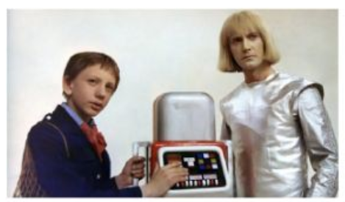  Science fiction film action film    Music fantasy
ACTIVITY 2: KNOWLEDGE FORMATION (10'- PW/IW)
+ Aim : To lead in the reading skills.
+ Content: Ss discuss what they like or dislike
+ Products: Ss learn how to use them.
+ Implementation:
Teacher’s & Student’s activities | Content
* Teacher has students work in pairs, ask and answer the following questions:  ** Teacher and students discuss the questions and answers.  ***Teacher accepts all students’ questions.  * Students work in pairs. | TASK 1: WORK IN PAIRS. DISCUSS THE FOLLOWING QUESTIONS. (p. 87)  - Do you like fantasies?  - Why or why not?
ACTIVITY 3. PRACTICE (10’-IW, PW, GW)
+ Aim: - To provide students with some lexical items before reading the text.
- To develop reading skill for specific information.
- To develop reading skill for specific information.
+ Content:
+ Products:
+ Implementation:
Teacher’s Student’s activities | Content
* T.teaches Voc.  - Translation  - Picture  - Translation  - Example  Give the stress  Ss copy down | Unit 8 FILMS  Lesson 5: Skills 1 (P.87-88)  * Vocabulary:  - series (n): chuỗi, loạt (phim, chương trình)  - wizard (n): phù thủy, người có tài phi thường  - must-see (n): đáng xem  - gripping (a): lôi cuốn, hấp dẫn
* Teacher asks students to open the book, read through the text and do the task.  ** Teacher allows students to share their answers before discussing it as a class and encourages them to give evidence.  *** Teacher calls some students to give the answer and explains which sentences give them the information.  * Students read the text and do the task. | TASK 2: READ THE FILM REVIEW OF HARRY POTTER AND THE SORCERER’S STONE ON MARK’S BLOG. MATCH THE WORDS OR PHRASES WITH THEIR MEANINGS. (p. 87)  Answer key:  1. b  2. d  3. a  4. c
* Teacher can set a longer time limit for students to read the text again and answer the questions.  - Teacher asks students to read the questions and underline key words, then reminds them to focus on the types of information they have to find.  - Teacher asks students to note where they found the information that helped them to answer the questions.  ** Teacher asks students to work in pairs and find the answer. Students can compare answers before discussing them as a class.  *** Teacher allows students to share their answers before discussing it as a class and encourages them to give evidence.  **** Teacher calls a student to write his/ her answer on the board, then checks sentence by sentence with the class.  Pair work | TASK 3: READ MARK’S BLOG AGAIN AND ANSWER THE QUESTIONS. (p. 88)  Answer key:  1. Harry Potter and the Sorcerer’s Stone is a fantasy.  2. Daniel Radcliffe is one of the stars in the film.  3. The film tells the story of Harry Potter. He’s a powerful wizard. He is a student at a school for wizards and learns about himself, his family, and the bad things happening around him.  4. People say it’s a must-see for teens.
ACTIVITY 4: WRITING (10' - IW)
1. Aim: - To help students form the ideas for their speaking.
- To help students use what they practice to give a long talk about the film Kungfu Boy.
- To help students improve next time.
- To help some students enhance their presentation skill.
2. Content: Teach ss how to write a film review.
3. Products:
Ss learn how to write a paragraph.
4. Implementation: Teacher’s instructions…
* Teacher models this activity with a more able student first.  ** Teacher asks students to work in pairs.  *** Teacher can go around to help weaker students.  **** Teacher calls on some pairs to practise in front of the class.  Pair work | TASK 4: LOOK AT THE TABLE. WORK IN PAIRS. ASK AND ANSWER QUESTIONS ABOUT THE FILM KUNGFU BOY. (p. 88)  Example:  A: How about seeing a film this evening?  B: That’s a great idea. What film shall we see?  A: Kungfu Boy.  B: What kind of film is it?
* Teacher allows students to give comments for their friends and vote for the most interesting and informative presentation.
** Teacher and students discuss the presentations.
***Teacher gives feedback and comments.
* Students give comments for their friends and vote for the most interesting and informative presentation.

WRAP-UP(2’)  To consolidate what students have learnt in the lesson. | Teacher asks students to talk about what they have learnt in the lesson.  Ss retell the content of the lesson
HOMEWORK(3’)  Prepare for the next lesson. | T. asks Ss to do at home  Ss copy down  - Learn Voc. By heart.  - Prepare Unit 8: Lesson 6: Skills 2(P.89)  - Do the task in this part

Planning date:
Teaching date:
PERIOD 66
UNIT 8: FILMS
LESSON 6: SKILLS 2

I. OBJECTIVE: By the end of this lesson, students will be able to
1. Knowledge:
- Listen for special information about a comedy.
- Write a short paragraph about your favorite film.
+ Language: use of like/love/enjoy/hate + V-_{ing}; talking about likes and dislikes.
+ Pronunciation: Correctly pronounce words that contain the sounds /ə/ and /ɜ:/
2. Competence:
a) General competencies:
Students will be able to
- Develop listening and writing skills and creativity.
- Actively join in class activities.
b) Specific competencies:
- Group work and independent working, pair work, linguistic competence, cooperative learning and communicative competence.
- Sts can introduce themselves or one another fluently.
3. Qualities:
II. PREPARATIONS
Teacher: Grade 7 text book, laptop, TV, pictures and realia, Computer connected to the Internet. Sach mem.vn
Students: Text books, pencils, pics, blank papers, realia,….
III. PROCEDURE:
In each activity, each step will be represented as following:
* Deliver the task.
** Implement the task.
*** Discuss.
* Give comments or feedback.

1. WARM-UP (5’- GW/PW/IW)
+ Aim:
- To waken up students’ interest.
+ Content: Review the previous lesson.
+ Products: Having a chance to speak English and focus on the topic of the lesson..
+ Implementation: Teacher’s instructions…
Teacher’s & Student’s activities | Content
+ Watch the video and write down the types of films.  + Asking questions:  - T asks ss watch video clip  - Ss write down the types of the films.  - T calls some ss give their answer.  - Check and correct | + Watch the video and write down the types of films.  + Asking questions:  - Which types of films can you see the most in the video?  “COMEDY”
ACTIVITY 2: KNOWLEDGE FORMATION (10'- PW/IW)
+ Aim : To help ss understand and activate their knoledge of the topic.
+ Content: Ss discuss what they like or dislike
+ Products: Ss learn how to use them.
+ Implementation:
Teacher’s & Student’s activities | Content
1. Work in pairs. Discuss the follwing question.  * Pre- listening:  - Asks ss to work in pairs and discuss question about what they like or dislike about a comedy.  - asks some ss to say their answers in front of the class. | 1. Work in pairs. Discuss the follwing question.  * pre-listeing:    Make people laugh  Helps people relax  Reduces stress    Mostly not educational  Some are not suitable for children
ACTIVITY 3. PRACTICE (10’-IW, PW, GW)
+ Aim: To help ss have the ideas of what the conversation is about; to help develop their skill of listening for specific information.
+ Content: Listen to the film Naughty Twins.
+ Products: Ss can learm how to use verbs of liking and disliking; Ss can make sentences correctly.
+ Implementation:
Teacher’s Student’s activities | Content
2. Mark and Hoa are talking about the film Naughty Twins. Listen to their conversation. Who stars in the film?  - Play the recording and ask ss to identify the names of the film stars they hear from the conversation.  - Aks two or three ss to write their answers on the board.  - Play the recording again for ss to check the answers. If time is limited, T may only play once. T may pause at the sentences that include the words or phrases ss need for their answer. | 2. 2. Mark and Hoa are talking about the film Naughty Twins. Listen to their conversation. Who stars in the film?  AK: Linda Brown and Susan Smith
3. Listen to the conversation again. Choose the best answer to each question below.  - Have Ss look at the questions in this activity. Ask them how to do it. Give them some strategies to do the exercise.  - Listening to the text paying attention to the key words, deciding what options to choose.  - Play the recording twice for ss to answer the questions. For stronger classes, ask ss take notes of the information to explain why they choose the answers.  - Invite Ss to share their answers. Confirm the correct answers.  - Have ss share their answer in pairs. Invite some pairs to answer and confirm the correct ones. Play the recording again if needed, stopping at the places where ss find difficut.  - For stronger classes, askss to explain their answer choices.  - T and other Ss give comments. | 3. Listen to the conversation again. Choose the best answer to each question below.  1. A 2. C 3. A 4. A
ACTIVITY 4: WRITING (10' - IW)
1. Aim: To help Ss prepare ideas for their writing.
2. Content: Teach ss how to write a film review.
3. Products:
Ss learn how to write a paragraph.
4. Implementation: Teacher’s instructions…
4. Make notes about one of your favorite film.  - Ask ss to make notes about one of their favorite films. Remind them that they do not have to write full sentences and they can use abbreviations.  - Ask ss to share their notes with their partners. T may read out the notes from some more able ss to the whole class. | 4. Make notes about one of your favorite film.  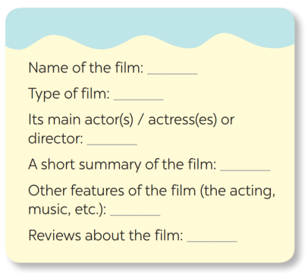
5. Write a paragraph of about 70 words about your favorite film, using the information in 4.  - T reminds ss to always think about what they are going to write.  - Ss can use the ideas they have prepared in 4.  - T asks ss to brainstorm the ideas and necessary language for the writing.  - T may ask ss to refer back to the reading for useful language and ideas and write some useful expression and language on the board.  - Ask ss to write the first dreaft individually.  - If time is limited, T may ask ss to write the final version at home | 5. Write a paragraph of about 70 words about your favorite film, using the information in 4.  Sample:  My favourite film is the Harry Potter series. It is based on one of the best selling novels. They are fantasy and fiction films about the wizard named Harry Potter and his friends: Ron and Hermione. Daniel Radcliffe, Emma Watson, Rupert Grint starred in this film. I like this film and I find it gripping, moving and funny, too. The scenes were set in the beautiful spots in the UK and the acting was really great.

Planning date:
Teaching date:
PERIOD 68
UNIT 8: FILMS
LESSON 7: LOOKING BACK & PROJECT

I. OBJECTIVES
By the end of this lesson, students will be able to gain:
1. Knowledge
- Review the vocabulary and grammar of Unit 8
- Apply what they have learnt (vocabulary and grammar) into practice through a project
2. Core competence
- Develop communication skills and creativity
- Develop presentation skill
- Develop critical thinking skill
- Be collaborative and supportive in pair work and team work
- Actively join in class activities
3. Personal qualities
- Be more creative when doing the project
- Develop self-study skills
II. PREPARATIONS
Teacher: - Grade 7 textbook, Unit 8, Getting Started
- Computer connected to the Internet
- Projector/ TV/ pictures and cards
- sachmem.vn
Students: Text books, pencils, pics, blank papers, realia,….
III. PROCEDURE:
In each activity, each step will be represented as following:
* Deliver the task.
** Implement the task.
*** Discuss.
* Give comments or feedback.

1. WARM-UP (5’- GW/PW/IW)
+ Aim:
- To create an active atmosphere in the class before the lesson
- To lead into the new lesson.
+ Content: playing games: Brainstorming
+ Products: revising the vocabulary related to the topic and lead in the next part of the lesson and enhancing students’ skills of cooperating with team mates.
+ Implementation: Teacher’s instructions…
Teacher’s & Student’s activities |  | Content
+ Greeting  + Asking questions:  Teacher divides the board, and divides the class into 2 teams.  ** Members of each team take turns and write as many types of films as possible in 2 minutes.  *** Students cross check their answers first.  **** Teacher confirms the answers and gives feedback. The group having more correct answers is the winner. |  | + Greeting  + Asking questions:  Team A Team B  - cartoon - comedy....  T-Ss  Team work  Ss  T-Ss  - Students (Ss) listen and learn how to do.  - Open their book and write .
ACTIVITY 2: KNOWLEDGE FORMATION (25'- PW/IW)
- + Aim : To help students revise types of films.
To encourage students to give examples for types of films.
To help students revise adjectives describing films.
To help students revise the connectors: although/ though and however.
+ Content: review types of films; adjectives describing films; the connectors: although/ though and however.
+ Products: Ss match the column A with column B;
+ Implementation:
Teacher’s & Student’s activities |  | Content
* Teacher encourages students to complete the task individually.  ** Students do the task individually.  *** Students exchange their textbooks with their partners.  **** Teacher gives feedback as a class discussion.  * Teacher asks students to think of as many examples of different types of films as possible.  ** Students think of as many examples of different types of films as possible.  *** Teacher then asks some students to say out their examples in front of the class. Examples of Vietnamese films are fine.  **** Teacher gives feedback as a class discussion.  * Teacher encourages students to complete the task individually.  ** Students complete the task individually.  *** Students exchange their textbooks with their partners.  **** Teacher gives feedback as a class discussion.  * Teacher asks students to do it individually first.  ** Students complete the task individually.  *** Teacher then asks them to check their answers with a partner before discussing the answers as a class.  **** Teacher reminds students to keep a record of their original answers so that they can use that information in their Now I can... statement. |  | TASK 1: MATCH THE TYPES OF FILM IN COLUMN A WITH THEIR DESCRIPTIONS IN COLUMN B. (p. 90)  Answer key:  1. d  2. a  3. e  4. c  5. b  TASK 2: GIVE AN EXAMPLE FOR EVERY FILM TYPE IN THE BOX (p. 90)  Example:  - a comedy: Mr Bean  TASK 3: CHOOSE THE CORRECT ANSWER (A, B, OR C) TO COMPLETE EACH OF THE FOLLOWING SENTENCES. (p. 90)  Answer key:  1. C; 2. B; 3. C; 4. A; 5. B; 6. A  TASK 4: MATCH THE SENTENCES OR SENTENCE HALVES IN COLUMNS A AND B. (p.90)  Answer key:  1. D; 2. E; 3. A; 4. B; 5.C
ACTIVITY 2: PROJECT
1. Aim: To allow students to apply what they have learnt (vocabulary and grammar) into practice through a project. (10' - IW)
2. Content:
Prepare the project.
3. Products:
Ss present their project.
4. Implementation: Teacher’s instructions…
* Teacher has students work in groups and gives instructions to students as follow:  ** Students do the project in groups.  *** Students vote for the best poster.  **** Teacher gives feedback. | Posters exhibition:  1. Choose one of your favourite films and design a poster for it, including:  – name of the film  – type of film  – its director and main actors / actresses  – a short summary  – your overall opinion about the film  – the showtime and cinema  – pictures or photos to illustrate the film  2. Organise them into an exhibition.  THE FILM KUNGFU BOY  Kungfu Boy is a comedy directed by John Stevenson. Bruce Wane is the main actor in this film. It's about a very big boy who saves his town and becomes a hero. People say that it's a must-see because it's very funny and interesting. It's at 4.30 p.m. and 8.30 p.m. daily at Ngoc Khanh Cinema. Let's go to see it!  3. Vote for the best poster.
WRAP-UP: (3' - IW)  ** Students do the project in groups.  *** Students vote for the best poster. | Teacher asks students to talk about what they have learnt in the lesson.
HOMEWORK: (2' - IW) | Prepare for the next lesson: Unit 9 – Lesson 1: Getting Started.

Planning date:
Teaching date:
PERIOD 69
UNIT 9: FESTIVALS AROUND THE WORLD
LESSON 2: A CLOSER LOOK 1

I. OBJECTIVES
By the end of this lesson, Ss will be able to gain:
1. Knowledge:
- Vocabulary: types of festivals and festival activities.
- Pronunciation: pronounce two-syllable words with correct stress.
2. Core competence
- Develop communication skills and creativity
- Be collaborative and supportive in pairwork and teamwork
- Actively join in class activities
3. Personal qualities
- Develop self-study skills
II. PREPARATIONS
1. Teacher
- Grade 7 textbook, laptop, TV/Projector/ pictures and cards, speakers, lesson plan, sachmem.vn…
2. Students
- Grade 7 textbook, notebooks, school things….
III. TEACHING PROCEDURES
Notes
In each activity, each step will be represented as following
* Deliver the task
** Implement the task
*** Discuss
**** Giving comments or feedback

ACTIVITY 1 – WARM – UP & INTRODUCTION (5’)
a) Aims:
- To review the previous lesson and activate students’ knowledge.
- To activate students’ knowledge
- To get students interested in the topic
b) Contents: Play the game “Hot seat”
c) Products: Ss’ answers
d) Teaching steps:
Teacher’s and students’ activities |  | Content
* Teacher divides the class into 2 teams. Each team will send a leader to play the game on the board.  - Teacher explains the instructions of the game:  - Each leader stands against the board.  - Teacher shows/ writes the names of the festivals (exercise 5 – page 93).  - Other members from each team describe the festivals and let the leader guess the names of the festivals.  - The team with more correct answers is the winner.  ** Students play in teams.  *** Students give the correct answers.  **** Teacher confirms the answers and gives feedback. |  | Game: Hot seat  
ACTIVITY 2 – PRESENTATION (15’)
a) Aims:
- To introduce new words.
- To present some types of festivals
b) Contents:
- Teach the vocabularies
- Listen and read
- Match the phrases with the pictures. Then listen, check, and repeat the phrases.
c) Products:
- Lists of vocabularies
- Answer key
d) Teaching steps:
Teacher’s and students’ activities |  | Content
* Teacher introduces the vocabulary.  ** Teacher introduces the vocabulary by:  - providing the pictures  - providing the definition/example of the words.  *** Teacher asks students to repeat.  **** Teacher rubs out and checks.  * Teacher has students to look at the pictures and asks them if they know the names of the festivals.  ** Teacher gets students to do the exercise in individuals.  *** Ask them to share their answers in pairs before checking the answers as a class.  **** Teacher then encourages students to explain their answers. Correct if necessary. |  | * Vocabulary  - Cannes Film Festival  - Mid-Autumn Festival  - Thanksgiving (n)  - Easter (n)  - carve (v)  - perform (v)  Task 1: Write under each picture a festival name from the box (p.94).  Answer key:  1. Halloween  2. Christmas  3. Mid-Autumn Festival  4. Cannes Film Festival  5. Easter  6. Thanksgiving
ACTIVITY 3 – PRACTICE (15’)
a) Aims:
- To present some festival activities
- To give Ss further practice with words related to festivals and festivals activities.
- To help Ss identify how to pronounce two-syllable words with correct stress.
- To help Ss pronounce two-syllable words with correct stress in sentence.
b) Contents:
- Complete the table below with the phrases from the box.
- Fill in each blank with a word or phrase from the box.
- Listen and repeat. Then underline the stressed syllable in each word.
- Listen and repeat the sentences. Underline the stressed syllables in the bold words
c) Products:
- Answer key
- The role of marking stress in two-syllable words
d) Teaching steps:
Teacher’s and students’ activities | Content
* Teacher tells Ss that people celebrate festivals with different food and activities.  ** Teacher asks them to do the task individually.  *** Teacher asks students to share their answers in pairs before checking the answers as a class.  **** Teacher then encourages students to explain their answers. Correct if necessary.  * Teacher asks Ss to work in pairs to complete the sentences with the words/ phrases given.  ** Ss work in pairs.  *** Teacher allows students to cross check first.  **** Teacher invites some pairs to share their answers and gives feedback.  * Teacher helps Ss to understand what a syllable is. Explain to them that a syllable is a unit of pronunciation having one vowel sound, with or without surrounding consonants, forming the whole part of a word. Give some examples of one-, two- and three-syllable words.  - Tell them that in this lesson, they just focus on two-syllable words and their common stress pattern. Have Ss name some more two-syllable words.  ** Teacher has Ss listen and repeat out the words in the table. Play the recording again for them to underline the stressed syllable in each word.  *** Teacher allows students to cross check first.  **** Teacher lets Ss share their answer and gives feedback. Ask Ss if they recognize any rules related to stress in two-syllable words. Share with them the most common rules.  * Teacher has Ss read quickly the sentences and plays the recording. Ask them to pay attention to the bold words and underline the stressed syllables.  ** Students practice in pairs or in groups.  *** Teacher goes around to offer help or correct pronunciation, if necessary.  **** Teacher calls some students to say the sentences in front of the class. Check their pronunciation if necessary. | Task 2: Complete the table below with the phrases from the box (p.94).  Answer key:  Task 3: Fill in each blank with a word or phrase from the box (p.94).  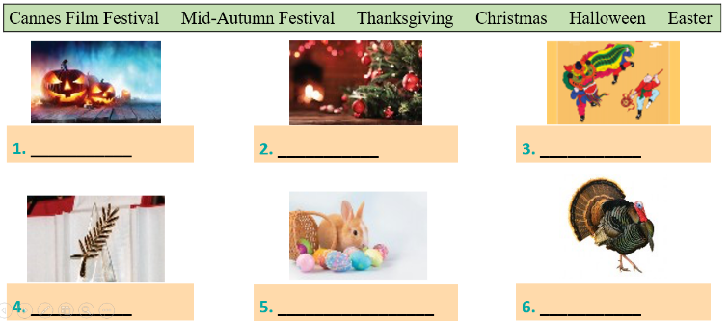  Answer key:  1. Christmas  2. painting eggs  3. candy apples  4. Cannes Film Festival  5. Mid-Autumn Festival  6. turkey  Task 4: Listen and repeat. Then underline the stressed syllable in each word. (p.94).  Pronunciation: Stress in two-syllable words  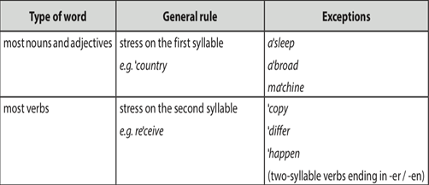  Answer key:  Task 5: Listen and repeat the sentences. Underline the stressed syllables in the bold words (p.94).  Answer key:  - We’re going to attend an Easter party at Nick’s house.  - The dancers will perform traditional dances at the festival.  - At Christmas, people usually buy presents for their family.  - Did you go to the Da Lat Flower Festival with your parents?  - My aunt is clever and patient.
ACTIVITY 4 – PRODUCTION (7’)
a) Aims:
- To test students' quick reaction to the targeted sounds.
b) Contents:
- Play the game “Up and down”
c) Products:
- Ss’ answer
d) Teaching steps:
Teacher’s and students’ activities |  | Content
*Teacher explains the rules:  Teacher says 1-15 words containing two-syllable words. Students stand up for the ones with first main stress pattern, sit down for the second main stress pattern.  ** Students play the game in teams.  *** Teacher helps students in the game.  **** Teacher gives feedback. |  | Game: “Up and down”
IV. WRAP-UP & HOMEWORK (3’)
- Teacher asks Ss to summarise what they have learnt in the lesson by asking them some questions.
- Teacher asks Ss to do exercises in workbook.
- Teacher asks Ss to prepare the next lesson “Unit 9 – A Closer look 2”

Planning date:
Teaching date:
PERIOD 70

UNIT 9: FESTIVALS AROUND THE WORLD
LESSON 3: A CLOSER LOOK 2

I. OBJECTIVES
By the end of this lesson, Ss will be able to:
1. Knowledge:
- Practice Yes/No questions
2. Core competence:
- Develop communication skills and creativity
- Be collaborative and supportive in pair work and teamwork
- Actively join in class activities
3. Personal qualities
- Develop self-study skills
II. PREPARATIONS
1. Teacher
- Grade 7 textbook, laptop, TV/Projector/ pictures and cards, speakers, lesson plan, sachmem.vn…
2. Students
- Grade 7 textbook, notebooks, school things….
III. TEACHING PROCEDURES
Notes
In each activity, each step will be represented as following
*Deliver the task
** Implement the task
*** Discuss
**** Giving comments or feedback

ACTIVITY 1 – WARM – UP & INTRODUCTION (5’)
a) Aims:
- To activate students’ prior knowledge related to the targeted grammar: Yes/No questions.
- To increase students’ interest.
- To enhance students’ skills of cooperating with team mates.
b) Contents: Play the game: Sentence puzzling
c) Products: Ss’ answers
d) Teaching steps:
Teacher’s and students’ activities | Content
* Teacher divides the class into 4 groups.  - Teacher delivers different sets of word cards to each group.  - Each group has to arrange the word cards to make meaningful sentences.  - 1 point for each correct answer.  ** Students play the game in groups.  *** Teacher and students discuss the answers.  **** Teacher confirms the answers and gives feedback.  Set 1:  Are you eating moon cakes?  Set 2:  Did they eat moon cakes at the festival last year?  Set 3:  Can he eat all these moon cakes? | Game: Sentence puzzling  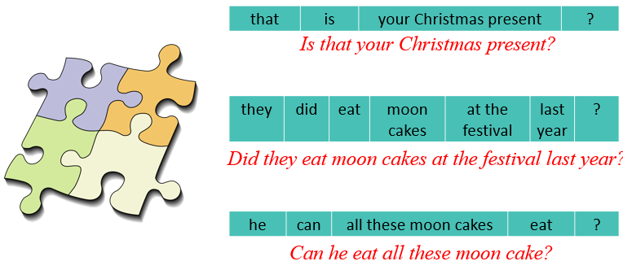
ACTIVITY 2 – PRESENTATION (15’)
a) Aims:
- To introduce the targeted grammar: Yes/No questions.
- To have students get to know about the Yes/No questions.
b) Contents:
- Teach the vocabularies
- Teach the points of grammar
c) Products:
- Lists of vocabularies
- Answer key
d) Teaching steps:
Teacher’s and students’ activities | Content
* Teacher asks students to study the Grammar box.  - Teacher draw students’ attention to the use and how to form a Yes/No question with an auxiliary verb or with a modal verb.  ** Teacher then asks some more able students to give some more examples.  Yes/No questions  We use put the auxiliary verb or modal verb before the subject.  *** Teacher and students discuss the answers.  **** Teacher confirms the answers and gives feedback. | GRAMMAR  Yes/ No questions  *These questions need either a Yes/No answer.  * We form a Yes/ No questions with an auxiliary verb (be, do or have). We put the auxiliary verb or modal verb before the subject.  Aux verb + S + V (-inf) + O?  Examples:  - Are you tired?  - Did you get many Christmas presents?  - Can you eat all the cakes?
ACTIVITY 3 – PRACTICE (18’)
a) Aims:
- To check students’ understanding of the Yes/No questions.
- To help Ss practise making Yes/No questions.
- To give further practice with Yes/No questions.
- To give further practice with Yes/No questions.
b) Contents:
- Fill in each blank with a correct auxiliary verb or modal verb.
- Change the sentences into Yes/No questions.
- Match the questions in column A with their answers in column B.
- Mark is talking to Trang about the Mid-autumn Festival. Fill in the blanks with Trang’s answers below.
c) Products:
- Answer key
d) Teaching steps:
Teacher’s and students’ activities |  | Content
* Teacher has students work individually.  ** Students work individually to complete the sentences.  *** Teacher lets students work in pairs and exchange the answers before checking with the whole class (explain each sentence if necessary).  **** Teacher confirms the answers and gives feedback.  * Teacher has students work individually.  ** Students work individually to complete the sentences.  *** Teacher lets students work in pairs and exchange the answers before checking with the whole class (explain each sentence if necessary).  **** Teacher confirms the answers and gives feedback.  * Teacher asks students to read the instruction.  ** Teacher asks students to do the exercise individually and match the questions in column A with the answers in column B.  *** Teacher then has them work in pairs, comparing their sentences. Teacher can go around to help students.  **** Teacher confirms the answers and gives feedback.  *Teacher divides the class into 2 teams. Each team will send a leader to play the game on the board.  - Teacher explains the instructions of the game:  - Teacher gives each team a set of cards with phrases from the box.  - The two leaders of the teams come to the board and pin the cards under the correct number.  - Who can finish faster with the correct answer will be the winner.  ** Students play the games in team mode.  *** Teacher has students to write down the correct answer.  **** Teacher confirms the answers and gives feedback. Teacher can ask for translation to check their understanding. |  | Task 1: Fill in each blank with a correct auxiliary verb or modal verb (p.95).  Answer key:  1. Do  2. Did  3. Are  4. Can  5. Does  Task 2: Change the sentences into Yes/No questions (p.95).  Answer key:  1. Can your mother make a costume for you?  2. Will she bake a birthday cake for him?  3. Are the dragon dances interesting?  4. Does the Rio Carnival take place every year in Brazil?  5. Did they see a fireworks display on New Year’s Eve?  Task 3: Match the questions in column A with their answers in column B (p.95).  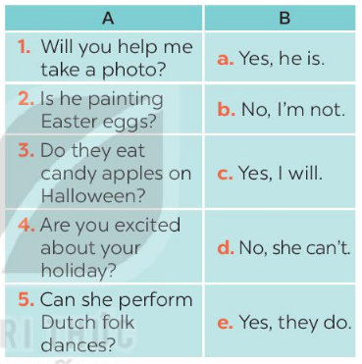  Task 4: Mark is talking to Trang about the Mid-autumn Festival. Fill in the blanks with Trang’s answers below (p.95).  Game: Who is faster?  Answer key:  1. b  2. e  3. a  4. c  5. d
ACTIVITY 4 – PRODUCTION (5’)
a) Aims:
- To help Ss practise producing Yes/No questions.
b) Contents:
- Work in groups. One student thinks of a festival he/she likes. Other students ask Yes/No questions to find out what the festival is.
c) Products:
- Ss’ conversations
d) Teaching steps:
Teacher’s and students’ activities | Content
* Teacher has students work in groups.  ** One student thinks of a festival that he/she likes. Other students ask Yes/No questions to find out what the festival is.  The group leader keeps a record of the group’s performance.  *** Teacher moves around to observe and pays attention to Ss’ yes/no questions.  **** Teacher asks some groups to perform in front of the class, confirms the answers and gives feedback. | Task 5: Game. Festival mystery. Work in groups. One student thinks of a festival he/she likes. Other students ask Yes/No questions to find out what the festival is (p.95).  Example:  A: Do many countries celebrate the festival?  B: Yes, they do.  A: Do children like the festival?  B: Do they paint eggs?  A: Yes, they do.  C: Is it Easter?  B: Yes, it is.
IV. WRAP-UP & HOMEWORK (3’)
- Teacher summarises the main points of the lesson:
+ Yes/No questions
- Teacher asks Ss to make Yes/No questions about Festival
- Teacher asks Ss to do exercise in Workbook
- Teacher asks Ss to prepare the next lesson “Unit 9 – Communication”

Planning date:
Teaching date:
PERIOD 71

UNIT 9: FESTIVALS AROUND THE WORLD
LESSON 4: COMMUNICATION

I. OBEJECTIVES
By the end of this lesson, Ss will be able to:
- Express disappointment
- Understand the concept of festival symbols and their meanings
- Talk about the concept of festival symbols and their meanings
1. Knowledge:
a. Vocabulary: revise vocabulary on types of festivals and festival activities
b. Grammar: structures to express disappointment
2. Core competence:
- Develop communication skills and creativity
- Be collaborative and supportive in pair work and teamwork
- Actively join in class activities
3. Personal qualities
- Develop self-study skills
II. PREPARATIONS
1. Teacher
- Grade 7 textbook, laptop, TV/Projector/ pictures and cards, speakers, lesson plan, sachmem.vn…
2. Students
- Grade 7 textbook, notebooks, school things….
III. TEACHING PROCEDURES
Notes
In each activity, each step will be represented as following
* Deliver the task
** Implement the task
*** Discuss
**** Giving comments or feedback

ACTIVITY 1 – WARM – UP & INTRODUCTION (5’)
a) Aims:
- To activate students’ knowledge and interest.
- To enhance students’ skills of cooperating with teammates
b) Contents: Play the game “Name the festivals”
c) Products: Ss’ answers
d) Teaching steps:
Teacher’s and students’ activities | Content
*Teacher divides the class into 2 teams. Teacher shows pictures of some festivals on the slides.  ** Ss give the correct names of the festivals as fast as possible. The one with more correct answers is the winner.  *** Students work in team mode      **** Teacher checks and gives feedback.   | Game: Name the festivals    
ACTIVITY 2 – PRESENTATION (15’)
a) Aims:
- To help students get to know the ways to express disappointment.
- To help students practise the ways to express disappointment.
b) Contents:
- Teach the way to express disappointment
- Listen and read the conversation. Pay attention to the highlighted sentences.
- Work in groups. Make a similar conversation for each situation below.
c) Products:
- Expressing disappointment
- Ss’ conversation
d) Teaching steps:
Teacher’s and students’ activities | Content
* Teacher lets students listen to the examples in Ex. 1 in the book.  ** Teacher draws their attention to the form of ways to express disappointment.  *** Teacher and students discuss the form of ways to express disappointment, and give some other expressions.  **** Teacher confirms the answers and gives feedback.  * Teacher has students work in groups to discuss and make similar conversation for each situation.  ** Students work in groups to discuss.  *** Teacher then asks students to exchange their answer among class.  **** Teacher moves around to observe, provides help and gives feedback. | I - EVERYDAY ENGLISH  Task 1: Listen and read the conversation. Pay attention to the highlighted sentences.  Expressing disappointment  * It was disappointing!  * It was a big disappointment.  Other expressions:  * That’s too bad!  * What a disaster!  * That’s so disappointing!  Task 2: Work in groups. Make a similar conversation for each situation below.  1. Your friend went to a film festival for teenagers, but there were not many films he / she liked.  2. Your friend went to the market to buy decorations for the Mid-Autumn Festival. But there were not many decorations to choose from.
ACTIVITY 3 – PRACTICE (15’)
a) Aims:
- To help Ss understand the concept of festival symbols.
- To provide Ss with some Christmas symbols and their meanings.
- To help Ss understand the symbols and meanings of other festivals.
- To let students practise talking about festival symbols and their meanings.
b) Contents:
- Listen to Mark talking about festival symbols. Fill in each blank with ONE word.
- Work in pairs. Match each festival with its symbol and meaning.
- Work in groups. Choose a festival and talk about its symbol(s) and meaning.
c) Products:
- Answer key
- Ss’ speakings
d) Teaching steps:
Teacher’s and students’ activities | Content
* Teacher asks Ss what they think of when they talk about Christmas, i.e. Christmas symbols. Elicit answers from students.  Have Ss read the sentences given. Ask them to predict what word to use to fill in each blank. Write their answers on the board.  ** Students work individually. Then listen to the recording and check the answers.  *** Teacher invites some Ss to share their answers.  **** Teacher gives feedback and correction (if needed)  * Teacher introduces some new words if necessary (prosperity, reunion).  ** Ss works in pairs to finish the task.  *** Teacher allows student to cross check first.  **** Teacher confirms the answers and gives feedback.  * Teacher lets students group up and spend 5 minutes on taking notes of a festival.  ** Students work in groups.  Example:  When we talk about Christmas, we think of the Christmas tree. It is the symbol of a long life.  *** All group members choose a festival and talk about its symbols and meanings.  **** Teacher moves around to observe and offers help if needed. | II – FESTIVAL SYMBOLS  Task 3: Listen to Mark talking about festival symbols. Fill in each blank with ONE word.  Answer key:  1. think  2. meaning  3. life  4. happiness  Task 4: Work in pairs. Match each festival with its symbol and meaning.  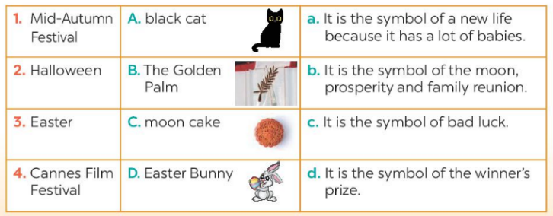  Answer key:  1. C-b  2. A-c  3. D-a  4. B-d  Task 5: Work in groups. Choose a festival and talk about its symbol(s) and meaning.
ACTIVITY 4 – PRODUCTION (7’)
a) Aims:
- To let students practice talking about festival symbols and their meanings.
b) Contents:
- Work in groups. Interview two of you friends about their favourite food and drink. Write their answers in the table.
c) Products:
- Ss’ presentations
d) Teaching steps:
Teacher’s and students’ activities | Content
* Teacher invites some students to talk about festival symbols and their meanings.  ** Students share their group’s answer.  *** Teacher allows students to cross check first.  **** Teacher listens, gives comments or corrections if needed. | Task 6: Presentation
IV. WRAP-UP & HOMEWORK (7’)
- Teacher has Ss say what they have learnt in the lesson:
+ Vocabulary of the fesstivals
+ Yes/ No question
- Teacher asks Ss to prepare the next lesson “Unit 9 – Skills 1”

Planning date:
Teaching date:
PERIOD 72
UNIT 9: FESTIVALS AROUND THE WORLD
Lesson 5: Skills 1

I. OBJECTIVES
By the end of this lesson, Ss will be able to gain:
1. Knowledge:
- Develop reading skill about an unusual festival
- Develop speaking skill: talking about a festival they enjoy
2. Core competence:
- Develop communication skills and creativity
- Be collaborative and supportive in pair work and teamwork
- Develop presentation skill
- Actively join in class activities
3. Personal qualities
- Develop self-study skills
II. PREPARATIONS
1. Teacher
- Grade 7 textbook, laptop, TV/Projector/ pictures and cards, speakers, lesson plan, sachmem.vn…
2. Students
- Grade 7 textbook, notebooks, school things….
III. TEACHING PROCEDURES

ACTIVITY 1 – WARM – UP & INTRODUCTION (5’)
a) Aims:
- To introduce the topic of reading.
- To enhance students’ skills of cooperating with team mates.
b) Contents: Play the game “Who is faster?”
c) Products: Ss’ answers
d) Teaching steps:
Teacher’s and students’ activities | Content
* Teacher divides the class into 2 teams.  - Each team has to run in a relay to the board to write the correct types of festivals and their symbols and meaning under the posters.  - The team with more correct answers will be the winner.  ** Students play the game in team mode.  *** Teacher and students discuss the answers.  **** Teacher confirms the answers and gives feedback. | Game: Who is faster?
ACTIVITY 2 – PRESENTATION (10’)
a) Aims:
- To lead in the reading skills.
- To provide students with some lexical items before reading the text.
b) Contents:
-
- Work in pairs. Discuss the following questions.
- Read Phong’s blog. Match the underlined words in the text with their meanings.
c) Products:
- Lists of vocabularies
- Answer key
d) Teaching steps:
Teacher’s and students’ activities | Content
* Teacher has students work in pairs, look at the pictures in the book. Ask Ss to discuss what/who they see in the pictures and answer the questions.  ** Students works in pairs.  *** Teacher and students discuss the questions and answers.  **** Teacher accepts all students’ questions.  * Teacher introduces the vocabulary.  ** Teacher asks students to get the meaning in context and try to make up sentences with of the following words:  1. join (v)  2. feature (v)  3. performance (n)  *** Teacher and students discuss the answers.  **** Teacher confirms student’s answers and checks their pronunciation and gives feedback. | READING  Task 1: Work in pairs. Look at the pictures. Which events do you think happen at the Twins Day Festival? (p.97)  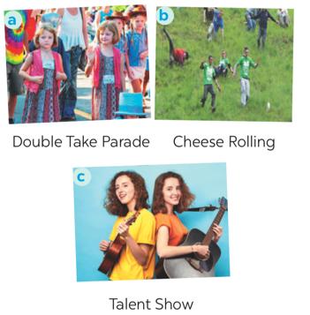  Vocabulary  1. join (v)  2. feature (v)  3. performance (n)  Answer key:  Pictures 1 + 3: Twins Day Festival
ACTIVITY 3 – PRACTICE (20’)
a) Aims:
- To develop the skill of guessing the meanings of new words in context.
- To develop reading skill for specific information (scanning).
- To help students identify how to ask and answer about a festival they attended.
b) Contents:
- Match each word from the email in 1 with its meaning.
- Read the email again. Complete each sentence with no more than TWO words
- Match the questions and answer about a festival someone joined
c) Products:
- Answer key
d) Teaching steps:
Teacher’s and students’ activities | Content
* Teacher tells Ss what they are going to do. Ask Ss how to do the exercise and elicits answers from Ss.  If needed, tell them that to do the exercise they can follow these steps:  + Read the words in the left column  + Locate each word in the text  + Read around the word to get the general meaning  + Read the definitions in the right column, find the suitable meaning to match each word.  Ask Ss to repeat the steps (they can speak in Vietnamese).  ** Students read the text and do the task in individuals.  *** Teacher allows students to share their answers before discussing as a class and encourages them to give evidence.  **** Teacher calls some students to give the answer, explain which sentence give them the information.  * Teacher can set a longer time limit for students to read the text again and complete the sentences.  Briefly tell them the steps: read the sentences – underline key words – locate the key words in the text – find the words to complete the sentences.  ** Teacher asks students to work in individuals and find the answer.  *** Teacher allows students to share their answers before discussing as a class and encourages them to give evidence.  **** Teacher calls a student to write his/her answer on the board, then check sentence by sentence with class.  * Teacher tells Ss they are going to ask and answer about a festival they attended and that this activity can serve as a model for them to follow in the writing task.  ** Teacher asks students to work individually and then check in pairs.  *** Teacher can go around to help weaker students.  **** Teacher call on some pairs to give the answers and check as the whole class. | Task 2: Match each word from the email in 1 with its meaning (p.98)  Answer key:  1. b  2. d  3. a  4. c  Task 3: Read the email again. Complete each sentence with no more than TWO words (p.98).  Answer key:  1. first weekend  2. countries  3. walked together  4. performance  5. Fun Run  6. exciting  SPEAKING  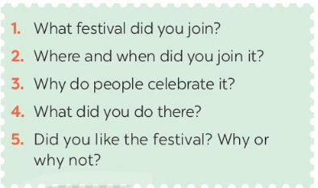  Talk about a festival  Task 4: Match the questions and answer about a festival someone joined (p.98).  Answer key:  1. d  2. b  3. e  4. c  5. a
ACTIVITY 4 – PRODUCTION (7’)
a) Aims:
- To give Ss practice in asking and answering about a festival Ss attended.
- To help students improve next time.
- To help some students enhance presentation skill
b) Contents:
- Work in pairs. Ask and answer about a festival you and your friend joined, using the questions in 4 as cues. Tell the class about the festival your partner joined.
c) Products:
- Ss’ speaking
d) Teaching steps:
Teacher’s and students’ activities | Content
* Teacher has students to work in pairs, ask and answer about a festival they attended.  ** Students work in pairs to do the task.  *** Teacher goes around to help students.  **** After finishing, teacher can call some pairs to give presentations in front of the class. | Task 5: Work in pairs. Ask and answer about a festival you and your friend joined, using the questions in 4 as cues. Tell the class about the festival your partner joined.  
IV. WRAP-UP & HOMEWORK (3’)
- Teacher has Ss summarise what they have learnt in the lesson with the two skills.
- read skill for specific information about an unusual festival
- talk about a festival you enjoy
- Teacher asks Ss to make a conversation, video and upload on given drive link.
- Teacher asks Ss to prepare the next lesson “Unit 9 – Skills 2”

Planning date:
Teaching date:
PERIOD 73
  - UNIT 9: FESTIVALS AROUND THE WORLD
LESSON 6: SKILLS 2

I. OBJECTIVES
By the end of this lesson, Ss will be able to gain:
- Listen for special information about a festival
- Write an email to describe a festival
1. Knowledge:
a. Vocabulary: types of festivals, festival activities
b. Grammar: review
2. Core competence:
- Develop communication skills and creativity
- Be collaborative and supportive in pair work and teamwork
- Actively join in class activities
3. Personal qualities
- Develop self-study skills
II. PREPARATIONS
1. Teacher
- Grade 7 textbook, laptop, TV/Projector/ pictures and cards, speakers, lesson plan, sachmem.vn…
2. Students
- Grade 7 textbook, notebooks, school things….
III. TEACHING PROCEDURES
Notes
In each activity, each step will be represented as following
* Deliver the task
** Implement the task
*** Discuss
**** Giving comments or feedback

ACTIVITY 1 – WARM – UP & INTRODUCTION (5’)
a) Aims:
- To warm up and get Ss’ interest.
- To lead in the new lesson.
b) Contents: Play the game “Our eating habits”
c) Products: Ss’ answers
d) Teaching steps:
Teacher’s and students’ activities | Content
* Teacher tells the rules of the game:  - Each student gets a piece of paper, draws a table with 3 rows and 3 columns, then fill in the table with names of some festivals randomly.  - Teacher calls out the names of some festivals. Each time the teacher calls out a word, the students search for the right square on their paper and mark.  - The student who has 3 words highlighted in a row yells “Bingo” and wins.  ** Students play the game in individuals  *** Teacher and students discuss the answers.  **** Teacher confirms the answers and gives feedback. | Bingo!
ACTIVITY 2 – PRESENTATION (7’)
a) Aims:
- To prepare Ss for the listening text.
- To help Ss check their answer in Task 1.
b) Contents:
- Look at the animal. Discuss the questions with a partner.
- Listen to Mark talking about how his family celebrates a festival. Check your answers.
c) Products:
- Ss’ answer
- Answer key
d) Teaching steps:
Teacher’s and students’ activities | Content
* Teacher asks students to work in pairs, read the questions and answer.  ** Students quickly discuss with a partner.  *** Teacher allows Ss to cross check.  **** Teacher calls some Ss to give their answer on the board and elicits their answers.  * Teacher tells Ss what they are going to listen to and plays the recording.  ** Students listen and check their answers.  *** Teacher allows students to peer check first.  **** Teacher confirms the answers and gives feedback. | LISTENING  Task 1: Look at the animal. Discuss the questions with a partner.  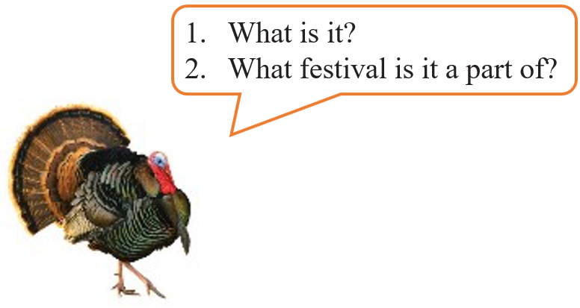  Task 2: Listen to Mark talking about how his family celebrates a festival. Check your answers.  Answer key:  1. A turkey  2. Thanksgiving
ACTIVITY 3 – PRACTICE (20’)
a) Aims:
- To help students develop listening skills for specific information.
- To brainstorm ideas and make an outline for Ss’ writing.
- To practise how to write a paragraph about a festival
b) Contents:
- Listening again and decide whether the following statements are true or false.
- Think about a festival that your family usually celebrates. Fill in the blanks with your answers.
- Write an email of about 70 words to tell Mark about the festival. Use the notes in 4.
c) Products:
- Answer key
d) Teaching steps:
Teacher’s and students’ activities | Content
* Teacher asks students to read through the statements, have a guess before they listen to the recording the second time and write their guesses on the board.  ** Teacher plays the recording again. Ask students to listen and choose the correct answer.  *** Teacher lets students peer-check with a partner.  **** Teacher calls some students to give the answers to the class and correct the mistakes where necessary, encourages students to correct the false statements.  Audio Script:  Hello everyone. I’m Mark. Today I’m going to talk about Thanksgiving, or Turkey Day. It’s a national holiday. People from Canada and the USA celebrate it every year to be thankful for successful harvests. In the USA, we celebrate it on the fourth Thursday of November. We usually prepare a feast for family and friends. Both adults and children take part in the food preparation. Some of the traditional foods are turkey, sweet potatoes, and cornbread. After the meal, we play board games together. My family usually takes this opportunity to help others. My parents volunteer to cook and serve food to homeless people. My sister and I read books to old people in a nursing home near our house.  * Teacher asks students to work individually to complete the mind map.  ** Students in individuals and decide on their festival.  *** Teacher goes around and helps if needed.  **** Teacher calls some Ss to give their answer (if time allows) and gives feedback.  * Teacher shows a model of a short paragraph about a festival (T may use the audio script or reading passage-page 97). Then recalls students’ knowledge on the structure of an email.  ** T has Ss write their email in individuals based on the information in 4.  *** Teacher allows students to cross check first.  **** Teacher gives feedback. | Task 3: Listening again and decide whether the following statements are true or false.  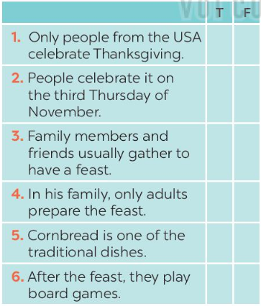  Answer key:  1. F  2. F  3. T  4. F  5. T  6. T  Task 4: Think about a festival that your family usually celebrates. Fill in the blanks with your answers.  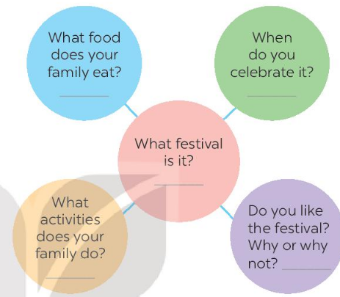  Task 5: Write an email of about 70 words to tell Mark about the festival. Use the notes in 4.  
ACTIVITY 4 – PRODUCTION (10’)
a) Aims:
- To peer check, cross check and final check students’ writing.
b) Contents:
- Give peer-reflection & evaluation
c) Products:
- Ss’ writing
d) Teaching steps:
Teacher’s and students’ activities | Content
* Teacher asks students read their “production”.  ** Students listen to each other’s work.  *** Students then give comments to each other.  **** Teacher then gives feedback as a class discussion. | 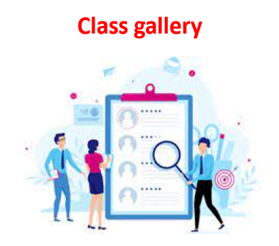  Task 6:  Class gallery
IV. WRAP-UP & HOMEWORK (3’)
- Teacher has Ss summarise what they have learnt in the lesson with the two skills.
If there is time, have them draw a mind map to summarise the main points of the lesson.
- Teacher asks Ss to rewrite the emails on their notebook.
- Teacher asks Ss to prepare the next lesson “Unit 9 – Looking back & project”

Planning date:
Teaching date:
PERIOD 75
UNIT 9: FESTIVALS AROUND THE WORLD
LESSON 7: LOOKING BACK & PROJEC
I. OBJECTIVES
By the end of this lesson, Ss will be able to gain:
1. Knowledge
Review the vocabulary and grammar of Unit 9
Apply what they have learnt (vocabulary and grammar) into practice through a project
2. Core competence
- Develop communication skills and creativity
- Develop presentation skill
- Develop critical thinking skill
- Be collaborative and supportive in pair work and team work
- Actively join in class activities
3. Personal qualities
- Be more creative when doing the project
- Develop self-study skills

II. PREPARATIONS
1. Teacher
- Grade 7 textbook, laptop, TV/Projector/ pictures and cards, speakers, lesson plan, sachmem.vn…
2. Students
- Grade 7 textbook, notebooks, school things….
III. TEACHING PROCEDURES

ACTIVITY 1 – WARM – UP & INTRODUCTION (5’)
a) Aims:
- To revise the vocabulary related to the topic and lead in the next part of the lesson.
- To enhance students’ skills of cooperating with team mates.
b) Contents: Play the game “Brainstorming”
c) Products: Type of festival
d) Teaching steps:
Teacher’s and students’ activities | Content
* Teacher divides the board, and divides the class into 2 teams.  ** Members of each team take turns and write as many types of festivals as possible in 2 minutes.  *** Students cross check their answers first.  **** Teacher confirms the answers and gives feedback. The group having more correct answers is the winner. | Brainstorming  Type of festivals
ACTIVITY 2 – PRESENTATION (5’)
a) Aims:
- To revise the language focus that students have learnt in Unit 9
b) Content: Complete the chart about language learnt in Unit 9
c) Products: the chart about language learnt in Unit 9
d) Teaching steps:
Teacher’s and students’ activities | Content
*Teacher shows an unfinished chart which summarizes the language that students have learnt in Units 9  - Teacher asks Ss to complete the chart individually.  **Ss do the task and complete the chart  ***Teacher calls some Ss share their answers.  - Ss give their answers  **** Teacher checks and corrects | 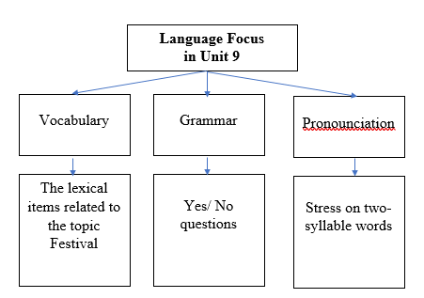  I – LOOKING BACK
ACTIVITY 3 – PRACTICE (15’)
a) Aims:
- To help students revise vocabulary items they have learnt in the Unit 9.
- To help students revise Yes/No questions.
b) Contents:
- Circle the correct words or phrases in brackets
- Complete each sentence by filling in the blank with a word or phrase in the box
- Choose the correct question A or B
- Answer the following questions about yourself.
c) Products:
- Answer key
d) Teaching steps:
Teacher’s and students’ activities | Content
* Teacher encourages students to complete the task individually.  ** Students do the task individually.  *** Students exchange their textbooks with their partners.  **** Teacher gives feedback as a class discussion.  * Teacher encourages students to complete the task individually.  ** Students do the task individually.  *** Students exchange their textbooks with their partners.  **** Teacher gives feedback as a class discussion.  * Teacher encourages students to complete the task individually.  ** Students do the task individually.  *** Students exchange their textbooks with their partners.  **** Teacher calls some Ss to read aloud their answers and gives feedback.  * Teacher encourages students to complete the task individually.  ** Students do the task individually.  *** Students share their answer in groups of 3 of 4.  **** Teacher calls some Ss to read aloud their answers and gives feedback. | VOCABULARY  Task 1: Circle the correct words or phrases in brackets (p.100)  Answer key:  1. fireworks  2. Cannes Film Festival  3. painting  4. candy apples  5. Thanksgiving  Task 2: Complete each sentence by filling in the blank with a word or phrase in the box (p.100).  Answer key:  1. lion dances  2. floats  3. costumes  4. Bunny  5. gathering  GRAMMAR  Task 3: Choose the correct question A or B (p.100).  Answer key:  1. A  2. B  3. A  4. B  5. B  Task 4: Answer the following questions about yourself.  1. Are you interested in festivals?  2. Do you eat banh chung at Tet?  3. Can you cook any traditional food?  4. Did you see fireworks display last year?  5. Does your family gather together at Tet?
ACTIVITY 4 – PRODUCTION (13’)
a) Aims:
- To allow students to apply what they have learnt (vocabulary and grammar) into practice through a project.
- To develop teamwork skills
- To give students authentic practice in using target language
b) Contents:
- Posters exhibition
c) Products:
- Ss’ posters
d) Teaching steps:
Teacher’s and students’ activities | Content
* Teacher has students work in groups and gives instructions to students as follow:  1. Choose one of your favourite festivals and design a poster for it, including:  – name of the festival  – the time/ place it takes place  – its meanings  – its activities  – pictures or photos to illustrate the festival  2. Organise them into an exhibition.  3. Vote for the best poster.  * Students do the project in groups.  *** Students vote for the best poster.  **** Teacher gives feedback. | PROJECT  Posters exhibition  
IV. WRAP-UP & HOMEWORK (2’)
- Teacher asks students to talk about what they have learnt in the lesson.
- Prepare for the next lesson: Unit 10 – Lesson 1. Getting started.

Planning date:
Teaching date:
PERIOD 76
REVIEW 3
LANGUAGE

I. OBJECTIVES
By the end of this lesson, students will be able to: Review pronunciation, vocabulary and the grammar points they have learnt in unit 7, 8, 9.
1. Knowledge
+ Vocabulary: Revise words related to music and arts; food and drinks; to school facilities and school activities.
+ Grammar: Practice on the vocabulary items and grammar points Ss have already studied in Units 7,8,9.
+ Pronunciation: the sounds learnt in Unit 7 (/ai/ and /ei/) and Unit 8 (/iə/ and eə/) and the pronunciation of two-syllable words learnt in Unit 9.
2. Competence
a) General competencies: - Develop communication skills and creativity; Be collaborative and supportive in pair work and team work; Actively join in class activities
b) Personal qualities
- Group work and independent working, pair work, linguistic competence, cooperative learning and communicative competence.
- Raise students’ awareness of the need to keep their neighbourhood green.
3. Qualities: - Be responsible and hard working; Develop self-study skills.
II. PREPARATIONS
Teacher: Grade 7 text book, laptop, TV, pictures and realia, Computer connected to the Internet. Sach mem.vn.
Students: Text books, pencils, pics, blank papers, realia,….
III. PROCEDURE:
In each activity, each step will be represented as following:
* Task delivering ** Task performance
*** Report and discussion **** Judgement

Activity 1. WARM UP (5’- GW)
* Aim: To remind students the knowledge that they have learnt in Units 7-8-9.
* Content: Having some warm-up activities to create a friendly and relaxed atmosphere to inspire Ss to warm up to the new lesson.
* Product: Having a chance to speak English; Revision.

* Implementation: Teacher’s instructions…...
* Teacher divides class into 3 big groups to draw a mindmap related to the knowledge they have learnt in Unit 7, 8, 9.  ** Ss do the task in group.  *** Teacher calls on some students to present their answer based on the mindmap.  **** Other Ss comment and teacher confirms. | Mindmap  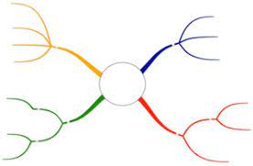
Activity 2. KNOWLEDGE FORMATION (5'- PW, IW)
* Aim: To help Ss review the pronunciation of the sounds learnt in Unit 7 (/ai/ and /ei/) and Unit 8 (/iə/ and eə/) and the pronunciation of two-syllable words learnt in Unit 9.
* Content: Pronounce (/ai/ and /ei/) and (/iə/ and eə/).
* Product: Listen and choose the word pronounced differently.

* Implementation: Teacher’s instructions…...
1: Choose the word in which the underlined part is pronounced differently.  * Teacher asks Ss to do the task individually.  ** Ss do this exercise individually, then share their answers with their partners.  *** Calls some Ss to check their answers.  **** T gives feedback and confirms the answers. | 1: Choose the word in which the underlined part is pronounced differently. (Ex 1a, P₁₀₂)  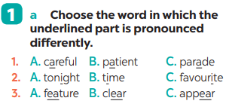  Key: 1. A 2. C 3. A
Activity 3. PRACTICE (30’-IW, PW, GW)
* Aim: To test students’ ability to choose the correct word to be used in a certain context; to help students review the words/phrases learnt; to help students review grammar elements taught in the three units.
* Content: Remind grammar Although, How far…
* Product: Do exercise correctly.

* Implementation: Teacher’s instructions…...
2: Choose the word which has a different stress pattern from that of the others.  * Teacher asks Ss to retell the rules of putting stress in two – syllable words.  ** Ss do this exercise individually, then share their answers with their partners.  *** T calls on some Ss to check their answers.  **** Teacher gives feedback and confirms the answers.  3: Write the phrases from the box under the road signs.  * Teacher allows Ss to do this task separately.  ** Ss do this exercise individually, then share their answers with their partners.  *** T calls on some Ss to check their answers.  **** Teacher gives feedback and confirms the answers.  4: Fill in each blank with a suitable word from the box. (Ex 3, p. 102)  * Teacher tells Ss to look at Ex 3 and asks them what kind of word can fill in each blank.  ** Ss do the task independently.  *** Teacher calls on some Ss to write answer on the board.  **** Teacher gives feedback and confirms the answers.  5: Which of the underlined parts in each question is incorrect? Find and correct it.  * Teacher asks Ss to read the sentences carefully to find the mistakes and correct.  ** Ss do the task independently and can share with their partners.  *** Teacher calls on some Ss to give their answers and correct the mistakes.  **** Teacher confirms.  6: Rewrite the sentences so that they have the same meanings as the original ones. Use the words given in brackets.  * Teacher asks Ss to read the sentences, then rewrite them.  ** Ss do the task independently.  *** Teacher calls on some Ss to write on the board so that other Ss can comment.  **** Teacher confirms the correct sentences. | 2: Choose the word which has a different stress pattern from that of the others. (Ex 1b, P₁₀₂)  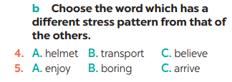  Key: 4. C 5. B  3: Write the phrases from the box under the road signs. (Ex 2, P₁₀₂)  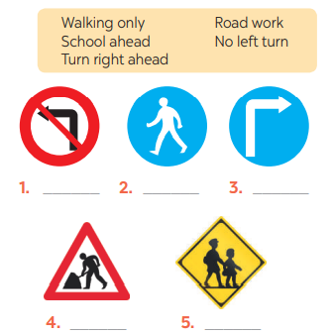  Key:  1. No left turn 2. Walking only  3. Turn right ahead 4. Road work  5. School ahead  4: Fill in each blank with a suitable word from the box. (Ex 3, P₁₀₂)  Key:  1. feast 2. shocking 3. Easter  4. fantasy 5. violent  5: Which of the underlined parts in each question is incorrect? Find and correct it. (Ex 4, P₁₀₂)  1. C (do did)  2. B (but Ø)  3. B (should shouldn’t)  4. B (to Ø)  5. C (However However,)  6: Rewrite the sentences so that they have the same meanings as the original ones. Use the words given in brackets. (Ex 5, P₁₀₂)  1. It’s about five kilometres from my house to my school.  2. How far is it from Ha Noi to Hai Phong?  3. Although he was tired, he still performed the lion dance. / He still performed the lion dance  although he was tired.  4. We / You / They shouldn’t walk here because this lane is for cycling only.  5. Though my sister lives far away, she comes back home every Tet. / My sister comes back home every Tet though she lives far away.

Activity 4. APPLICATION (5’-IW)
* Aim: To consolidate what students have learnt in the lesson; to prepare for the next lesson.
* Content: Give home assignment
* Product: Take note home assignment

* Implementation: Teacher’s instructions…...
Teacher asks students to talk about what they have learnt in the lesson.  * Home assignment  - T assigns the homework.  - Ss copy their homework.  - T explains it carefully | * Home assignment  Prepare for Review 3 – Skills.

Planning date:
Teaching date:
PERIOD 77
REVIEW 3
SKILLS
I. OBJECTIVES
By the end of this lesson, students will be able to: practice on the vocabulary items and grammar points Ss have already studied and the skills they have practised in Units 7, 8, 9
1. Knowledge
+ Vocabulary: A revision and practice on the vocabulary items Ss have already studied and the skills they have practised in Units 7,8,9.
+ Grammar: Practice on grammar points ss have already studied in Units 7,8,9.
+ Pronunciation: the sounds learnt in Unit 7 (/ai/ and /ei/) and Unit 8 (/iə/ and eə/) and the pronunciation of two-syllable words learnt in Unit 9.
2. Competence
a) General competencies: Develop communication skills and creativity; Be collaborative and supportive in pair work and team work; Actively join in class activities.
b) Personal qualities
- Group work and independent working, pair work, linguistic competence, cooperative learning and communicative competence.
- Raise students’ awareness of the need to keep their neighbourhood green.
3. Qualities: - Be responsible and hard working; Develop self-study skills.
II. PREPARATIONS
Teacher: Grade 7 text book, laptop, TV, pictures and realia, Computer connected to the Internet. Sach mem.vn.
Students: Text books, pencils, pics, blank papers, realia,….
III. PROCEDURE:
In each activity, each step will be represented as following:
* Task delivering ** Task performance
*** Report and discussion **** Judgement
Activity 1. WARM UP (5’- IW, GW)
* Aim: To increase students’ interest and lead them into the lesson.
* Content: Having some warm-up activities to create a friendly and relaxed atmosphere to inspire Ss to warm up to the new lesson.
* Product: Having a chance to speak English; Revision.
* Implementation: Teacher’s instructions…...
* Teacher writes on the board the word “FESTIVALS”, then asks Ss to retell as many festivals they have learnt in unit 9 as possible. After that, teacher asks Ss some questions:  + Do you like taking part in an interesting famous festival in the world?  + Do you know the name of the festival which they often throw tomatoes?  ** Ss do the task independently.  *** Ss calls on some Ss to give their ideas.  **** Teacher confirms and leads Ss to the passage they are going to read “La Tomanita” | Chatting:  FESTIVALS
Activity 2. KNOWLEDGE FORMATION (5'- IW)
* Aim: To help students practise asking about Traffic; To develop Ss’ knowledge of the vocabulary.
* Content:
* Product: Answer key
* Implementation: Teacher’s instructions…...
3: Interview your group members. Take notes of their answers and report to the class.  * Teacher asks Ss work in group of four, then give them a handout to interview other members in group to take note their answers.  ** Ss do the task in groups.  *** The representative in each group reports to the class.  **** Teacher corrects pronunciation, grammar or spelling if needed. | 3: Interview your group members. Take notes of their answers and report to the class. (Ex 3, P₁₀₃)
  Questions | S1 | S2 | S3
  1. How far is it from your house to your school?
  2. How do you go to school?
  3. What is good about walking?
  4. What is good about public transport?
Activity 3. PRACTICE (20’-IW, PW, GW)
* Aim: To help students practise reading for specific information; help students practise reading for general information; help students practise listening for specific information (gap-filling); help students write a paragraph describing a visit to a holiday city, based on the information provided.
* Content:
- Read the passage. Match the headings in the box with the paragraphs; Choose the correct answer A, B, or C to complete each sentence; Read the passage again and answer the questions; Listen & fill in each blank with ONE word.
* Product: - Suggested answers & answer key; write a paragraph about your favourite means of transport.
* Implementation: Teacher’s instructions…...
1: Read the passage. Match the headings in the box with the paragraphs.  * Teacher asks Ss to read the passage quickly and match the headings with the paragraphs.  ** Ss do the task individually first, then they can compare with their partners.  *** Some Ss give their answers.  ****Teacher confirms the correct answers.  2: Read the passage again and answer the questions.  * Teacher asks Ss to read the questions and the passages again carefully for details for their answers.  ** Ss do the task independently, then swap their answers with their partners and show where they find the information for their answers.  *** Some Ss give their answers in front of the class  **** Teacher checks Ss’ answers as a class.  4: Listen to Trang talking about watching films with her family. Fill in each blank with ONE word.  * Teacher has Ss to read the sentences carefully and guess what they can fill in the blank. Then, teacher plays the recording for the first time.  ** Ss do the task independently to listen and complete the sentences.  *** Teacher asks for their answers and write them on the board.  **** Teacher plays the recording again and confirms the correct answers. | 1: Read the passage. Match the headings in the box with the paragraphs. (Ex 1, P ₁₀₃)  Key: 1. B 2. C 3. A  2: Read the passage again and answer the questions. (Ex 2, P ₁₀₃)  Key  1. People hold it in Buñol, Spain on the last Wednesday of every August.  2. There is a ham.  3. A jet of water from the water cannons.  4. It’s one hour.  5. It’s a traditional Spanish rice dish.  4: Listen to Trang talking about watching films with her family. Fill in each blank with ONE word. (Ex 4, P₁₀₃)  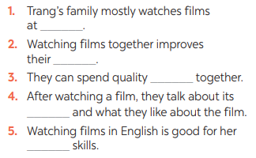  Key:  1. home 2. relationship  3. time 4. lessons  5. language
Activity 4. APPLICATION (10’-IW, PW, GW)
* Aim: Help students write a paragraph describing a visit to a holiday city, based on the information provided.
* Content: write a paragraph about your favourite means of transport.
* Product: - Suggested answers & answer key.
* Implementation: Teacher’s instructions…...
5: Write a paragraph of about 70 words about your favourite means of transport. You may use the following questions as cues.  * Teacher asks Ss to discuss with their partner the questions and encourages Ss to give as many reasons as possible.  ** Ss do the task in pairs to discuss, then write their paragraph individually.  *** Teacher calls on some Ss to write on the board, other Ss comment.  **** Teacher corrects the grammar, spelling, vocabulary. | 5: Write a paragraph of about 70 words about your favourite means of transport. You may use the following questions as cues. (Ex 5, P₁₀₃)  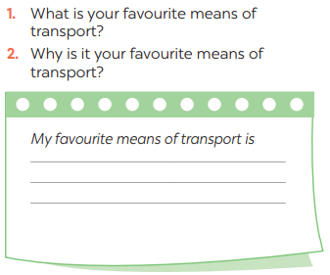

Activity 5. WRAP-UP & HOME WORK (5’)
* Aim: To consolidate what students have learnt in the lesson; To prepare vocabulary for the next lesson.
* Content: Home assignment.
* Product: Take home assignment.
* Implementation:
- Ask Ss what they have learnt so far. Have them recall the important grammar points, Vocabulary; Pronunciation
* HOME WORK
- Read again the conversation
- Do more exercises in workbook.
- Prepare for the next lesson.

Planning date:
Teaching date:
PERIOD 78
MID-TERM TEST

Planning date:
Teaching date:
PERIOD 79
UNIT 10: ENERGY SOURCES
LESSON 1: GETTING STARTED – TYPES OF ENERGY SOURCES

I. OBJECTIVES: By the end of this unit, students will be able to gain the following things:
1. Knowledge:
- To get the topic energy sources.
- have an overview about the topic energy sources
- To practice listening and reading.
-+ Vocabulary: - to talk about types of energy sources: . energy source (n.phr.), coal (n), renewable (a), run out (phr v).
2. Competence:
a) General competencies:
Students will be able to know more words and phrases about energy resources; Develop communication skills and cultural awareness
Collaborative and supportive in pair work and teamwork; Actively join in class activities.
b) Specific competencies:
- Students will be able to practice listening and reading the conversation between Lan and her father (Mr.Tan); ( They are talking about types of energy resources)
- Develop communication skills.
- Be cooperative and supportive in pair work and teamwork.
- Actively join in class activities.
3. Qualities:
- Develop awareness of travelling in town/city
- Be concerned to the local traffice
- Develop self-study skills.
II. PREPARATIONS
- Teacher: Grade 7 text book, laptop, projector / TV/ pictures and cards.....
- Students : Text books, studying equipment….
III. PROCEDURE:
Notes: In each activity, each step will be represented as following:
* Deliver the task.
* Implement the task.
* Discuss.
* Give comments or feedback.
Activity 1. WARM UP (5’-IW, GW)
* Aim:
To activate students’ knowledge on the topic of the unit
To enhance students’ skills of cooperating with team mates.

* Content:
To have some warm-up activities to create a friendly and relaxed atmosphere to inspire Ss to warm up to the subject and new lesson.
* Product: Having a chance to speak English and focus on the topic of the lesson..
* Implementation: Teacher’s instructions…
Teacher’s & Student’s activities | Content
* Teacher gives instructions  - One of the students in the group go to the board.  - Teacher secretly show 1 picture of a mean of transport to that student. He/She has to mime the picture and the other has to guess. Of course the other groups will also be allowed to guess.  - take turns go to the board until finish all the pictures.  **** Teacher checks and corrects if Ss pronounce the words incorrectly.  SET THE SCENE: PRE- QUESTIONS  * Teacher draws students’ attention to the pictures in the textbook and asks them some questions about the pictures. Teacher don’t confirm whether their answers are right or wrong.  1. Who are they?  2. What are they talking about?  ** Students work out and answer questions in pairs.  *** Students share their answers as a whole class.  **** Teacher asks them to read and listen to the conversation to check their answers. | BRAIN STORMING  Suggested answers:  1. They are Lan and her father / Mr. Tan  2. They are talking about types of enery resources.  3. (Students’ answer)
Activity 2. KNOWLEDGE FORMATION (15'- PW, IW)
* Aim:
- To help students use key language more appropriately before they read and listen
- To get students interested in the topic
- To set the context
- To help Ss understand the main idea of the text
* Content: Teach some new words. Read the conversation and find out new words.
* Product: Knowing more new words. Understanding the conversation; topic of the lesson, grammar points…
* Implementation: Teacher’s instructions…
Teacher’s & Student’s activities | Content
VOCABULARY:  * Teacher introduces the vocabulary by:  + showing the pictures illustrating the words;  + providing the synonym or antonym of the words;  + providing the definition of the words.  ** Students say the words.  *** Other students correct if the previous answers are incorrect.  **** Teacher shows and says the words aloud and asks students to repeat them.  Listen and read.  Task 1. Read for main ideas: What are Lan and her father talking about?  * Teacher asks Ss to look at the picture (p.107), answer the question:  What are Lan and her father talking about?  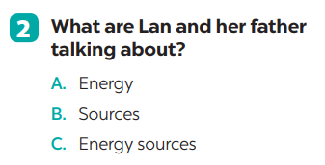  . | 1. Listen and read:  * Vocabulary  1. enery source (n)  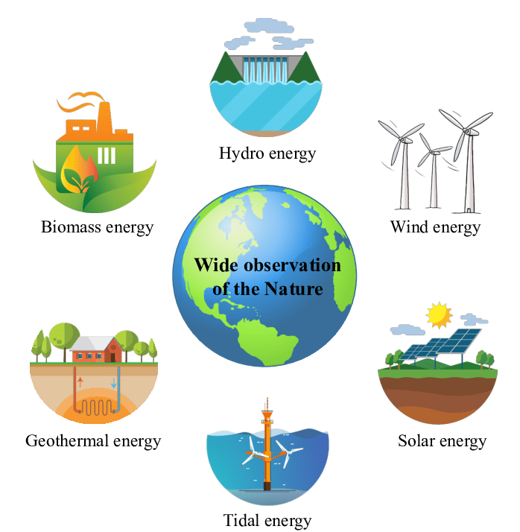  2. coal (n)    3. renewable (a): Can be replaced naturally and can be used without the risk of using it all up  4. run out (phr v): To use up or finish a supply of something  Task 1. Read for main ideas: What are Lan and her father talking about?  Answer: C
Activity 3. PRACTICE (15’-IW, PW, GW)
* Aim:
- To practise reading and listening for specific information
- To practise scanning
- To develop Ss' knowledge of vocabulary
- To help Ss gain more knowledge about the topic
* Product: Ss can learn how to use the words and phrases;
* Implementation: Teacher’s instructions…
Teacher’s Student’s activities | Content
Task 2: Read the conversation again and answer the questions.  * Teacher asks Ss to work individually to read and listen to the conversation and answer the questions and then share their answers with their partners who sit next to them. (peer check)  ** Ss do exercise 3 individually  *** Ss share and discuss with their partners to write all answer down on the notebooks.  **** Teacher corrects their answers as a class | Task 2: Read the conversation again and answer the questions.  Answers  1. Lan is doing a project on energy sources.  2. It’s power that we use to provide us with light, heat or electricity.  3. It comes from many different sources like coal, oil, natural gas, … and renewable sources  4. Renewable sources are those we can easily replace them such as: water, sun,…
Task 3: Match the words / phrases in the box with the correct pictures.  *** Teacher nominates Ss to read the words aloud and  **** Teacher checks and gives the correct answers.  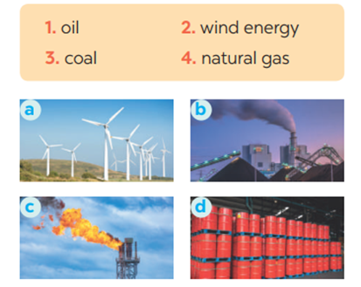 | Task 3: Match the words / phrases in the box with the correct pictures.  Suggested answers:  1. c 2. a 3. b 4. d
Activity 4. APPLICATION (7’-IW, PW, GW)
* Aim:
- To help Ss practice using what they have learnt in sentences.
- To help Ss practising talking about energy
- To practise team working
- To give students authentic practice in using target language
- To help Ss memorise the target language and skills that they have learned
- To help Ss practise the target language
- To consolidate what students have learnt in the lesson.
* Content: Doing the Quiz
* Product: Ss can remember the words. Revise and learn more new words.
* Implementation: Teacher’s instructions
Task 4: Complete each of the sentences with the correct word from the conversation  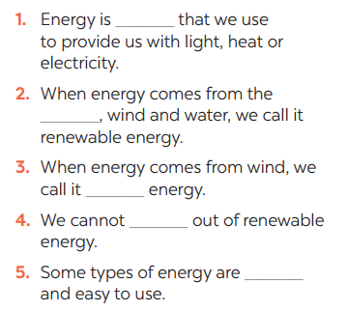  Task 5: Group discussion    * Teacher gives Ss clear instructions in order to make sure Ss know what to do  - ask students to discuss within their groups to answer the questions:  1. What is the best source of energy?  2. Why do you think it is the best one?  + Students discuss with their partners and take notes  - observer Ss while they are talking, note their language errors  ** Ss do as instructed. Then present what they have discussed.  **** Teacher gives Ss feedback.  - choose some useful or excellent words/ phrases/ expressions/ word choices Ss have used to suggest other students use them  - choose some typical errors and correct as a whole class without nominating the students’ names.  Consolidation  - Vocabulary of sources of energy  - Talking about energy sources.  * Home assignment  - Read again the conversation on page 106  - Do more exercises in workbook.  - Prepare new lesson: Lesson 2: A CLOSER LOOK _1 | Answers  1. power  2. sun  3. wind  4. run  Task 5: Group discussion  * Home assignment  - Read again the conversation on page 106  - Do more exercises in workbook.  - Prepare new lesson: Lesson 2: A CLOSER LOOK _1

Planning date:
Teaching date:
PERIOD 80
UNIT 10: ENERGY SOURCES
LESSON 2: A CLOSER LOOK 1

I. OBJECTIVES: By the end of this unit, students will be able to gain the following things:
1. Knowledge:
+ use the lexical items related to the topic sources of energy;
+ pronunciation: Stress in three-syllable words .
+ Vocabulary: - Use the vocabulary to talk about sources of energy:
+ Grammar:
2. Competence:
a) General competencies:
Students will be able to know more words and phrases about sources of energy; Develop communication skills and creativity; Actively join in class activities.
b) Specific competencies:
- Develop communication skills and cultural awareness.
- Be cooperative and supportive in pair work and teamwork.
- Actively join in class activities.
3. Qualities:
Develop awareness of energy sources and energy saving
- Develop self-study skills.
II. PREPARATIONS
- Teacher: Grade 7 text book, laptop, projector / TV/ pictures and cards.....
- Students : Text books, studying equipment….
III. PROCEDURE:
Notes: In each activity, each step will be represented as following:
* Deliver the task.
* Implement the task.
* Discuss.
* Give comments or feedback.
Activity 1. WARM UP (5’-IW, GW)
* Aim:
- To activate students’ knowledge on the topic of the unit
- To enhance students’ skills of cooperating with team mates
* Content:
To have some warm-up activities to create a friendly and relaxed atmosphere to inspire Ss to warm up to the subject and new lesson.
* Product: Having a chance to speak English and focus on the topic of the lesson..
* Implementation:Teacher’s instructions…
Teacher’s & Student’s activities | Content
+ Greeting  + CROSSWORDS  * Teacher gives instructions  ** Ss are divided into 2 groups  - Teacher show the crosswords onto the screen with hints/clues and students choose each line and take turn to answer.  - take turns to write until finish all the words or find out the key word.  ntroduce what they are going to study….  **** Teacher checks and corrects if Ss pronounce the words incorrectly. | + Greeting  + CROSSWORDS  Suggested answers:  Answers:  1- Sun  2- coal  3- oiL  4- renewable  5- natural gas
Activity 2. KNOWLEDGE FORMATION (15'- PW, IW)
* Aim:
- To help students use key language more appropriately
- To get students interested in the topic
- To set the context
- To help Ss understand the main idea of the text
* Content: Teach some new words. Read the conversation and find out new words.
* Product: Knowing more new words. Understanding the conversation; topic of the lesson, grammar points…
* Implementation: Teacher’s instructions…
Teacher’s & Student’s activities | Content
- VOCABULARY  *Pre- teach vocabulary:  * Teacher introduces the vocabulary by:  + providing the synonyms or antonyms of the words;  + providing the pictures of the words.  - Teacher has students read the phrases aloud and corrects their pronunciation if needed.  - Teacher asks students for the Vietnamese meanings of these phrases.  ** Students say the words.  *** Other students correct if the previous answers are incorrect.  **** Teacher shows and says the words aloud and asks students to repeat them.  Task 1. Match the types of energy in A * Teacher asks Ss to look at the table and match the energy with its source.  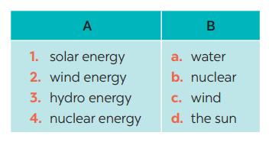  ** Ss work out and answer questions in pairs.  *** Ss share their answers as a whole class.  **** T asks them to to check their answers.  * Teacher asks students to make full sentences to tell about the sources of different energy. Then tell share them to share their sentences with a partner and correct for them. | * Vocabulary:  1. solar energy (n.phr.) /ˈsōlər ˈenədʒi/: năng lượng mặt trời    2. hydro energy (n.phr.) /ˈhīdrō ˈenədʒi/: năng lượng nước    3. nuclear (n) /njuː.klɪər/: hạt nhân    Task 1. Match the types of energy in A with the energy sources in B  Answer key:  Answers:  1- D 2 – C 3 – A 4 – B
Activity 3. PRACTICE (15’-IW, PW, GW)
* Aim:
- To practise identifying the meanings of road signs.
- To develop Ss' knowledge of vocabulary
- To help Ss deeply understand how to read the road signs
- To practise the targeted language in life context
* Product: Ss can learn how to use the words and phrases to do the exercises.
* Implementation: Teacher’s instructions…
Teacher’s Student’s activities | Content
Task 2: Write the phrases to label the pictures:  * Teacher asks Ss to look at the pictures and use the knowledge from Task 1 to guess the pictures.  Then work and share their answers with their partners who sit next to them. (peer check)  ** Ss do exercise 3 in pairs.  *** Ss share and discuss with their partners to write all words/ phrases down on the notebooks.  **** Teacher corrects their answers as a class.  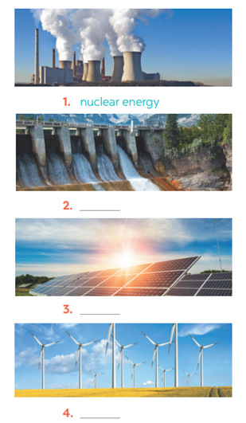 | Task 2: Write the phrases to label the pictures:  Answers  1. Nuclear energy  2. Hydro energy  3. Solar energy  4. Wind energy
Task 3: Complete the sentences with the words and phrases from 1 or 2.  * Teacher gives students time to do the exercise individually, then share their sentences.  *** Teacher nominates Ss to say the sentences aloud.  **** Teacher checks and gives the corrections if they have mistakes.  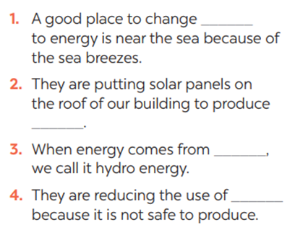 | Task 3: Complete the sentences with the words and phrases from 1 or 2.  Answers  1. wind  2. solar energy  3. water  4. nuclear
Activity 4. APPLICATION (7’-IW, PW, GW)
* Aim: - To help Ss identify the and classify the sounds
- To give students authentic practice in using pronouncing sounds in common words
- To help Ss memorise the target language and skills that they have learned
- To consolidate what students have learnt in the lesson.
* Content: Play a game: Simon says
* Product: Ss can remember the words. Revise and learn more new words.
* Implementation: Teacher’s instructions
PRONUNCIATION  Task 4: Listen and repeat. Pay attention to the stressed syllables in the words.  Teacher gives Ss time to listen and practice pronouncing the words with correct primary stress.  Task 5: Listen and repeat, paying attention to the stressed syllables in the underlined words.  ** Ss do as instructed  **** Teacher gives Ss feedback.  - choose some common mispronounced words and suggest students practise using them.  - choose some typical errors and correct as a whole class  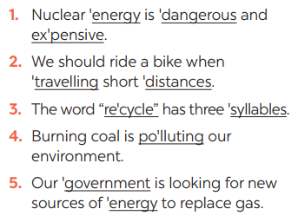  Consolidation  - Vocabulary about sources of energy.  - Pronunciation: Stress in three-syllable words  Homework:  Ss memorise the target language and skills that they have learned | 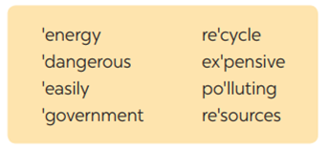  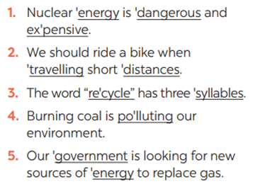  * Home assignment  - Exercises in the workbook

Planning date:
Teaching date:
PERIOD 81
UNIT 10: ENERGY SOURCES
LESSON 3: A CLOSER LOOK 2

I. OBJECTIVES: By the end of this unit, students will be able to gain the following things:
1. Knowledge:
Know how to use: THE PRESENT CONTINUOUS

Structure | Examples
1. Affirmative sentences: S + be + Ving | She is playing basketball in the school yard.
2. Negative sentences: S + be not + Ving | They are not using solar energy.
3. Y/N questions: Be + S + Ving? | Are you working on your Project?
4. W questions: W + S + be + Ving? | Where is your brother studying?
2. Competence:
a) General competencies:
Students will be able to know more words and phrases about energy sources; Develop communication skills and creativity; actively join in class activities.
b) Specific competencies:
- Develop communication skills and cultural awareness.
- Be cooperative and supportive in pair work and teamwork.
- Actively join in class activities.
3. Qualities:
- To educate the love of energy sources.
- Be ready to know the words about energy sources.
- Develop self-study skills.
II. PREPARATIONS
- Teacher: Grade 7 text book, laptop, projector / TV/ pictures and cards.....
- Students : Text books, studying equipment….
III. PROCEDURE:
Notes: In each activity, each step will be represented as following:
* Deliver the task.
* Implement the task.
* Discuss.
* Give comments or feedback.
Activity 1. WARM UP (5’-IW, GW)
* Aim:
- To activate students’ knowledge on the topic of the unit
- To enhance students’ skills of cooperating with team mates
* Content:
To have some warm-up activities to create a friendly and relaxed atmosphere to inspire Ss to warm up to the subject and new lesson.
* Product: Having a chance to speak English and focus on the topic of the lesson..
* Implementation:Teacher’s instructions…
Teacher’s & Student’s activities | Content
JUMBLE SENTENCES  * Teacher gives instructions  ** Teacher divides the class into 4 groups. Teacher delivers a set of word cards which are jumble sentences in present continuous to each group.  ** Students will have to work in groups to create as many correct sentences from the word cards as possible. The group with more correct sentences will **** Teacher gives feedback, then lead to the new lesson. | Suggested answers:  1. She is learning English now.  2. They are not using solar energy.  3. Are you working on your Project?  4. Where is your brother studying?  5. She is playing basketball in the school yard.
Activity 2. KNOWLEDGE FORMATION (15'- PW, IW)
* Aim:
To introduce students the form of the key grammar and how to use them appropriately
* Content: Teach some new words.
* Product: Knowing more new words. Understanding the conversation; topic of the lesson, grammar points…
* Implementation: Teacher’s instructions…
Teacher’s & Student’s activities | Content
the present continuous  - Teacher says: “This lesson today is going to tell you about “The present continuous”  * Teacher draws students’ attention to the grammar point and the example  . ** Ss read the grammar explicit and study the example.  *** Ss may discuss within groups/pairs before answering.  **** Teacher shows and says the sentences aloud and asks Ss to make similar sentences. | 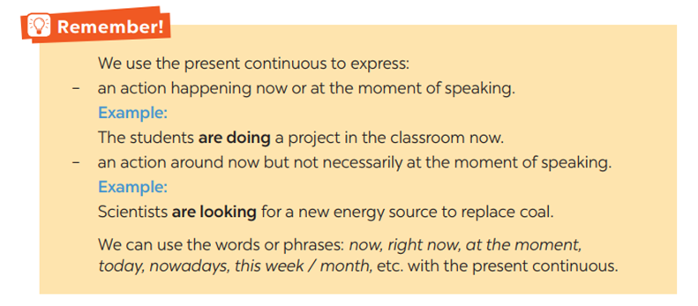
Activity 3. PRACTICE (15’-IW, PW, GW)
* Aim:
- To get students interested in the topic
- To set the context
- To help Ss understand the main idea of the text
- To practise using the present continuous.
- To practise the present continuous
- To practise making sentences using the present continuous
* Product: Ss can learn how to use the present continuous tense to do the exercises.
* Implementation: Teacher’s instructions…
Teacher’s Student’s activities | Content
Task 1. Work in pairs. Tell your partner what the people in the pictures are doing  * Teacher asks Ss to look at the pictures and work in pairs. Teacher asks them how would they ask and answer (using Present continuous)  ** Ss work out and answer questions with a partner.  *** Ss share their answers in pairs.  **** T asks them to to check their answers.  * Then tell share them to share their sentences as a whole in class and correct for them.  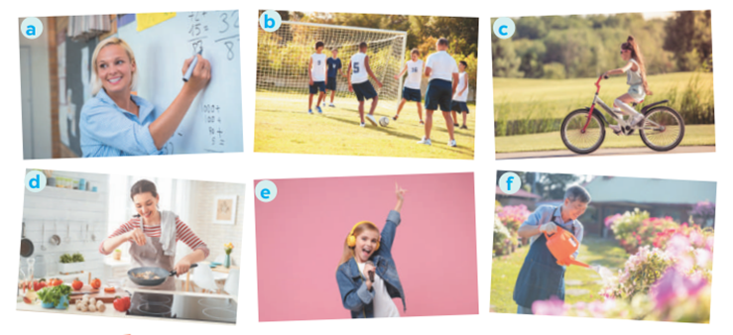 | Task 1. Work in pairs. Tell your partner what the people in the pictures are doing  Answers:  a- She is teaching maths/ is writing on the board.  b- They are play football/soccer.  c- She is riding her bike/bicycle.  d- She is cooking.  c- She is singing.  f- He is watering the flowers/plans/is doing gardening.
Task 2: Complete the sentences, using the present continuous form of the verbs in brackets.  * Teacher asks students to reaf the instructions carefully and do the exercise individually.  ** Ss do exercise then share with their partner.  *** Ss can check and correct for their partner  **** Teacher corrects their answers as a class.  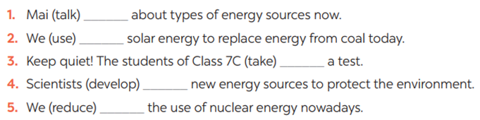 | Task 2: Complete the sentences, using the present continuous form of the verbs in brackets.  Answer:  - is talking  - are using  - are taking  - are developing  are reducing
Task 3: Circle the correct form of the verb in each sentence  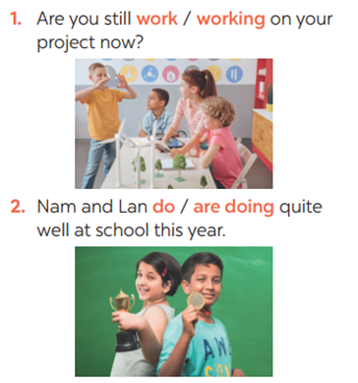  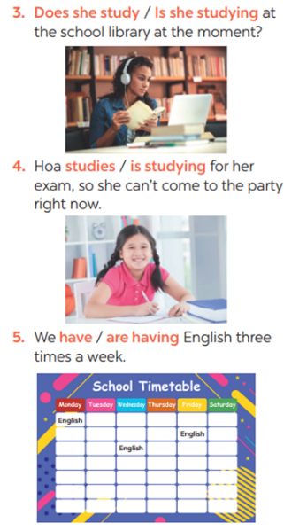  * Teacher asks students questions to make sure students understand the instructions  *** Teacher nominates Ss to read aloud the correct sentences.  **** Teacher checks and gives the corrections if they have mistakes. | Task 3: Circle the correct form of the verb in each sentence
Task 4: Write sentences about what the people are doing or not doing, using the suggestions.  * Teacher gives Ss time to do the exercise individually and peer check with their partner.  *** Teacher nominates Ss to read aloud the sentences. Then asks them to underline the words/phrases that can be found in Present continuous sentences  **** Teacher checks and gives the corrections if they have mistakes.  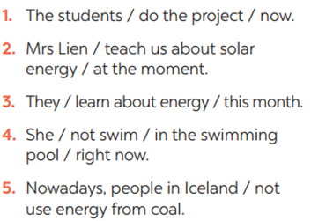 | Task 4: Write sentences about what the people are doing or not doing, using the suggestions.  Answers:  1- The students are doing the project now.  2- Mrs. Lien is teaching us about solar energy at the moment.  3- They are learning about energy this month.  4- She isn’t swimming in the swimming pool right now.  5- Nowadays, people in Iceland aren’t using energy from coal
Activity 4. APPLICATION (7’-IW, PW, GW)
* Aim:
To practise speaking using the present continuous
To help Ss memorise the target language and skills that they have learned
To consolidate what students have learnt in the lesson.
* Content: s +be+ V-ing.
* Product: Ss can know how to use the tense in contexts. Revise and learn more new words.
* Implementation: Teacher’s instructions
Task 5: Work in pairs. Ask and answer the following questions.  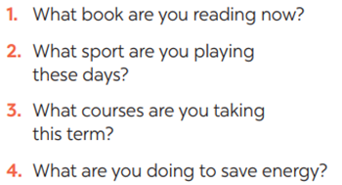  ** Ss work in pairs as instructed. Ss take note while doing the task.  **** Teacher walks around to give instructions and corrections (if nedded).  ***Teacher calls some students to report their partner’s answers using present continuous. Then gives Ss feedback  - choose some common mistakes and suggest students how to avoid them.  - encourage Ss use present continuous tense freely  - choose some typical errors and correct as a whole class  Consolidation  - The present continuous  * Home assignment  Do exercises in the workbook. | Task 5: Work in pairs. Ask and answer the following questions.  Suggested answers:  * Home assignment  Do exercises in the workbook.

Planning date:
Teaching date:
PERIOD 82
UNIT 10: ENERGY SOURCES
LESSON 4: COMMUNICATION

I. OBJECTIVES: By the end of this unit, students will be able to gain the following things:
1. Knowledge:
- Learn how to deal with some ways of asking for explanations
- Practise using some grammar points and vocabulary related to the topic
+ Vocabulary: - Use the vocabulary to talk about saves energy:
2. Competence:
a) General competencies:
Students will be able to know more words and phrases about energy resources; Develop communication skills and creativity; Actively join in class activities.
b) Specific competencies:
- Develop communication skills.
- Be cooperative and supportive in pair work and teamwork.
- Actively join in class activities.
3. Qualities:
- Be benevolent and responsible
- Be ready to know the words about energy resources.
- Develop self-study skills.
II. PREPARATIONS
- Teacher: Grade 7 text book, laptop, projector / TV/ pictures and cards.....
- Students : Text books, studying equipment….
III. PROCEDURE:
Notes: In each activity, each step will be represented as following:
* Deliver the task.
* Implement the task.
* Discuss.
* Give comments or feedback.
Activity 1. WARM UP (5’-IW, GW)
* Aim:
To introduce the lesson.
BRAINSTORMING
To lead in the lesson.
* Content: Playing a game: BRAINSTORMING
* Product: Having a chance to speak English and focus on the topic of the lesson..
* Implementation: Teacher’s instructions…
Teacher’s & Student’s activities | Content
GAME: BRAINSTORMING  * Teacher divides class into 2 teams and asks them to think of “TYPES OF ENERGY”  ** Ss have 1 min to think of the words related to the topic or they can discuss with their partners.  *** Each member from each team turn by turn run to the board and write one word.  **** Teacher corrects their answers.  - The team which has more correct words will be the winner  Teacher leads students into the lesson by telling what they are going to learn: “We are going to learn how to ask and answer for explanations and find out how well we save energy”. | 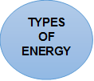
  Suggested answers:
  Solar, hydro, coal, natural gas, oil, wind,…
  TYPES OF ENERGY
Activity 2. KNOWLEDGE FORMATION (15'- PW, IW)
* Aim:
To let students know the structure to ask and answer for explanation..
* Content: Teach some new words.
* Product: Knowing more new words. Understanding the conversation; topic of the lesson, grammar points…
* Implementation: Teacher’s instructions…
Teacher’s & Student’s activities | Content
Task 1: Listen and read the conversation. Pay attention to the highlighted questions.  * Teacher plays the record for SS to listen and read the conversation.  ** Ss listen and practice saying with their partners.  *** Teacher calls some pairs to read aloud.  **** Teacher corrects pronunciation if needed.  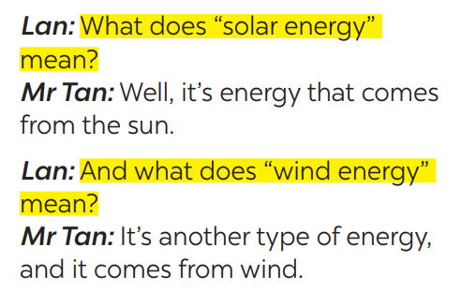  * Teacher asks Ss to pay attention to the highlighted parts and asks them some questions to elicit the new structure:  - Which tense do we use to ask and answer?  - Which question word and verb do we use?  - …..  ** Ss answer teacher’s questions to find out new structure to ask and answer for explanations  *** Some students give the new structure to the teacher.  **** Teacher corrects and writes on the board: | Task 1: Listen and read the conversation. Pay attention to the highlighted questions.  - Structure:  to ask:  - What do/does + S + mean?  to answer:  - S + mean(s)/be …
Activity 3. PRACTICE (15’-IW, PW, GW)
* Aim:
- To help students practise on how to ask and answer for explanations.
- To provide students with more awareness of ways to save energy and help them practice the skill of speaking
* Product: Ss can learn how to use the comparisons to do the excersises.
* Implementation: Teacher’s instructions…
Teacher’s Student’s activities | Content
Task 2: Work in pairs. Make similar conversations to ask for explanations.  * Teacher has SS look at the phrases in Ex 2 to make similar dialogue.  ** Ss work in pairs to make similar dialogue.  *** Teacher calls some pairs to present it in front of the class.  **** Teacher gives feedback and some comments.  * SAVING ENERGY | Task 2: Work in pairs. Make similar conversations to ask for explanations.  Suggested answers:  A: What does hydro energy mean?  B: It’s energy that comes from the sun. What does nuclear energy mean?  A: It’s energy that comes from the nuclear power.
Task 3: Work in pairs. Ask your partner the following questions and tick his or her answers in the boxes.* 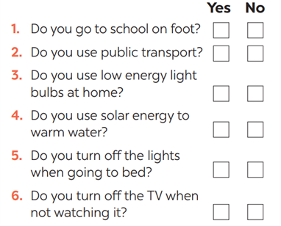* Teacher asks Ss to work in pairs and tick.  ** Ss so the task in pairs | Task 3: Work in pairs. Ask your partner the following questions and tick his or her answers in the boxes.
Task 4: Work in groups. Speech: how well your partner saves energy.  * Teacher gives students time to prepare. Meanwhile, teacher walks around the classroom to help students if they have difficulties find proper words/phrases/structures  *** Teacher calls some Ss to read aloud their work  **** Teacher let Ss listen and correct mistakes (if needed). | Task 4: Work in groups. Speech: how well your partner saves energy.  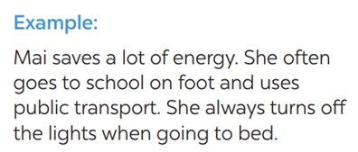
Activity 4. APPLICATION (7’-IW, PW, GW)
* Aim:
- To help students practicing speaking about saving energy
- To consolidate what students have learnt in the lesson.
* Content: present simple
* Product: Ss can remember the words. Revise and learn more new words.
* Implementation: Teacher’s instructions
Task 5: Answer the questions in 3 on your own. Speech: how well you save energy  * Teacher allows students time to answer the questions onto their notebooks and prepare.  ** Ss work individually.  *** Ss can practicing sharing to their partners  **** Teacher calls some students to read aloud their work. Teacher let Ss listen and correct mistakes (if needed).  Consolidation  Teacher asks students to talk about what they have learnt in the lesson.  * Home assignment  Do exercises in the workbook.  To prepare for the next lesson:  Skills 1. | Task 5: Answer the questions in 3 on your own. Speech: how well you save energy  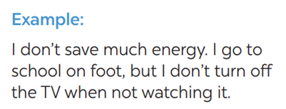  * Home assignment  Do exercises in the workbook.  To prepare for the next lesson:  Skills 1.

Planning date:
Teaching date:
PERIOD 84
UNIT 10: ENERGY SOURCES
LESSON 5: SKILLS 1

I. OBJECTIVES: By the end of this unit, students will be able to gain the following things:
1. Knowledge:
- Read for specific information about renewable and non-renewable sources of energy.
- Talk about advantages and disadvantages of different sources of energy
+ Vocabulary: - Use the vocabulary to talk about different sources of energy
+ Grammar:
2. Competence:
a) General competencies:
- Develop communication skills
- Be collaborative and supportive in pair work and team work
- Actively join in class activities
b) Specific competencies:
- Develop communication skills.
- Be cooperative and supportive in pair work and teamwork.
- Actively join in class activities.
3. Qualities:
- Be benevolent and responsible
- Develop self-study skills.
II. PREPARATIONS
- Teacher: Grade 7 text book, laptop, projector / TV/ pictures and cards.....
- Students : Text books, studying equipment….
III. PROCEDURE:
Notes: In each activity, each step will be represented as following:
* Deliver the task.
* Implement the task.
* Discuss.
* Give comments or feedback.
Activity 1. WARM UP (5’-IW, GW)
* Aim:
To introduce the topic of reading.
To lead in the lesson.
* Content: Playing a game: Hangman
* Product: Having a chance to speak English and focus on the topic of the lesson..
* Implementation: Teacher’s instructions…
Teacher’s & Student’s activities | Content
Game: Hangman  R E N E W A B L E  * Teacher divides class into 2 teams and asks them to think of the word which has 9 letters in it related the topic “ENERGY SOURCES”.  ** Ss have 1 min to think of the words related to the topic or they can discuss with their partners.  *** Each member from each team turn by turn guesses the letter in the secret word.  **** Teacher corrects their answers.  - The team which can find or guess the secret first will be the winner.  READING  - Teacher leads students into the lesson by telling what they are going to learn: “We are going to read a passage about renewable and non-renewable source of energy.” | R E N E W A B L E
Activity 2. KNOWLEDGE FORMATION (15'- PW, IW)
* Aim:
To provide students with some lexical items before reading the text
To introduce words related to skin conditions to Ss and help Ss have a general idea of what they are going to read
* Content: Teach some new words.
* Product: Knowing more new words. Understanding the conversation; topic of the lesson, grammar points…
* Implementation: Teacher’s instructions…
Teacher’s & Student’s activities | Content
* Vocabulary  - - Teacher introduces the vocabulary by:  + Providing the definition of the words and gives examples  Concept check: Rub out and Remember technique  * DISCUSSION:  * Teacher asks Ss to work in pairs to look at the Picture in Ex1 and discuss to answer the questions.  ** Ss work in pairs.  *** Teacher calls some Ss to check what they have discussed.  **** Teacher corrects | * Vocabulary  - produce (v) /prəˈdjuːs/ sản xuất  = to make things, mostly in large quantity  Examples: Companies produce many toys for children before Christmas.  - limited (a) /ˈlɪmɪtɪd/ bị hạn chế  = not very great in amount or extent  Examples: coal, oil, …  - available (a) /əˈveɪləbl/ có sẵn  = that you can get, buy or find  Examples: The coal takes a long time to be available again.  * DISCUSSION:  Suggested keys:  1. Coal, oil, hydro,…  2. Wind, solar,…  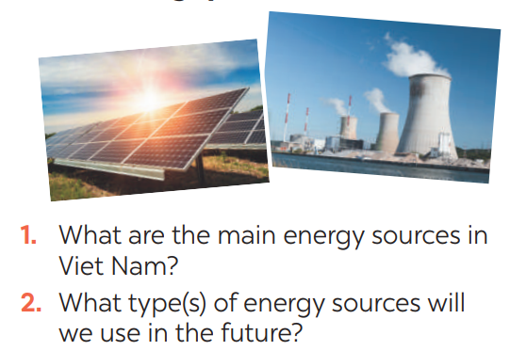
Activity 3. PRACTICE (15’-IW, PW, GW)
* Aim:
- To help Ss develop their reading skill for details and specific information (skimming and scanning)
- To help Ss further develop their reading skill for specific information (scanning).
- To check students’ reading comprehension.
- To help Ss talk about how they apply the rules in the reading to themselves.;
- To provide Ss an opportunity to ask and answer questions about the advantages and disadvantages of different types of energy sources.
* Product: Ss can learn how to do the exercises.
* Implementation: Teacher’s instructions…
Teacher’s Student’s activities | Content
Task 1: Read the text and choose the best option to complete the sentences.  * Teacher gives Ss time to: read each question, locate where the information appears in the text, read that part carefully and circle the correct answer.  ** Ss do the task independently  *** Teacher tells Ss to compare their answers in pairs before calling some of them to check.  **** Teacher confirms the correct answer and explains if needed.  1. Non-renewable sources are cheap  and ______.  A. available  B. easy to use  C. expensive  2. ______ come from the sun, wind or water.  A. Renewable sources  B. All energy sources  C. Non-renewable sources  3. When energy comes from water,  we call it ______.  A. wind energy  B. solar energy  C. hydro energy  4. Renewable energy sources are better  for ______.  A. the environment  B. our cars  C. hydro energy  Task 2: Read the text again and answer  the questions  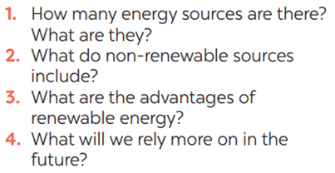*Teacher asks Ss to do the exercise carefully and individually.  ** Ss do the task independently.  *** Teachers has Ss compare their answers in pairs and call some Ss to give their ideas.  **** Teacher checks and confirms the correct answers. | 1. Read the email and match the highlighted words with their meanings. (Ex 2, p. 46)  Answer key:  1. B 2. A 3. C 3. A  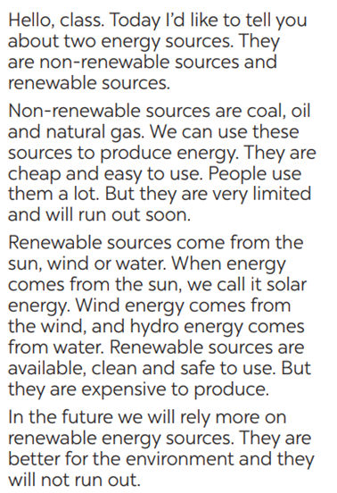  Task 2: Read the text again and  Answer key:  1. There are two energy sources. They  are non-renewable sources and renewable sources.  2. Non-renewable sources are coal, oil  and natural gas.  3. Renewable sources are available, clean and safe to use.  4. In the future, we will rely more on  renewable energy sources.
Task 3: Work in groups. Discuss and put the following words or phrases in the appropriate columns.  * Teacher asks Ss to work in groups and tells them to focus on the table.  ** Ss work in groups. Teacher goes around and listens and gives help if needed.  *** Teacher calls on some Ss to share their answers with the class. Teacher encourages  **** Teacher listens and corrects if needed  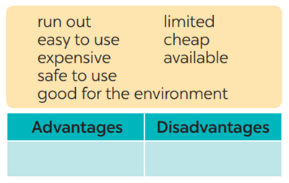 | Task 3: Work in groups. Discuss and put the following words or phrases in the appropriate columns.  Answer key:  Advantages: easy to use, safe to use, good for environment, cheap, available  Disadvantages: run out, expensive, limited, cheap
Task 4: Work in pairs. Ask and answer questions about the advantages and disadvantages of different energy sources  * Teacher has Ss work in pairs and asks them to take turns to ask and answer  ** Ss work in pairs to do the task. Teacher goes around, listens and gives help if needed.  *** Teacher calls on some pairs to share their answers with the class.  **** Teacher comments and correct | Task 4: Work in pairs. Ask and answer questions about the advantages and disadvantages of different energy sources  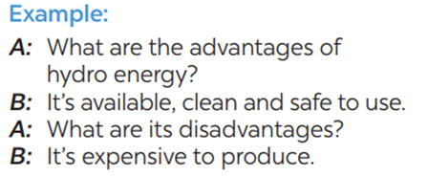
Activity 4. APPLICATION (7’-IW, PW, GW)
* Aim:
- To help students practice presenting the advantages and disadvantages of different types of energy source
- To consolidate what students have learnt in the lesson.
- To prepare for the next lesson Skills 2.
- To consolidate what students have learnt in the lesson.
* Content: Students talk about practice presenting the advantages and disadvantages of different types of energy source
* Product: Students’s dialogues.
* Implementation: Teacher’s instructions
Task 5: Give the advices on dangerous situations on the road.  * Teacher has students work in groups to prepare a presentation (poster/pictures/notes…)  *** Teacher calls on some groups to share their answers with the class.  **** Teacher comments and corrects if needed.  Consolidation  Teacher asks students to talk about what they have learnt in the lesson  * Home assignment  - Do exercises in the workbook.  - Prepare for the next lesson: Skills 2. | Task 5: Give the advices on dangerous situations on the road.  * Home assignment  - Do exercises in the workbook.  - Prepare for the next lesson: Skills 2.

Planning date:
Teaching date:
PERIOD 85
UNIT 10: ENERGY SOURCES
LESSON 6: SKILLS 2

I. OBJECTIVES: By the end of this unit, students will be able to gain the following things:
1. Knowledge:
+ Listening
- use the lexical items related to the topic Energy sources
- listen for main ideas and specific information about the topic how to save energy at home.
+ Writing: Write a paragraph of about 70 words about how you save energy at home.
2. Competence:
a) General competencies:
- Develop communication skills
- Be collaborative and supportive in pair work and team work
- Actively join in class activities
b) Specific competencies:
- Develop communication skills.
- Be cooperative and supportive in pair work and teamwork.
- Actively join in class activities.
3. Qualities:
- Be benevolent and responsible
- Be ready to know the words about energy resources.
- Develop self-study skills.
II. PREPARATIONS
- Teacher: Grade 7 text book, laptop, projector / TV/ pictures and cards.....
- Students : Text books, studying equipment….
III. PROCEDURE:
Notes: In each activity, each step will be represented as following:
* Deliver the task.
* Implement the task.
* Discuss.
* Give comments or feedback.
Activity 1. WARM UP (5’-IW, GW)
* Aim:
To activate students’ prior knowledge and vocabulary related to the lesson.
To introduce the new lesson.
* Content: “Traditional arts around the world” and asks students to think of it.
* Product: Having a chance to speak English and focus on the topic of the lesson..
* Implementation: Teacher’s instructions…
Teacher’s & Student’s activities | Content
PASS THE CHALK  * Teacher writes on the board the word “HOW TO SAVE ENERGY” and and divide the class into 2 groups.  ** Ss take turns to go to the board  *** Teacher calls some students to give their answers.  **** Teacher listens and give comments.  - Teacher introduces students the content of the lesson: “In the lesson today, we are going to listen to a person talking about how to save energy at home.” | PASS THE CHALK
Activity 2. KNOWLEDGE FORMATION (15'- PW, IW)
* Aim:
To help Ss brainstorm the topic and prepare for the listening text.
To help Ss develop their skill of listening for specific information
* Content: Teach some new words.
* Product: Knowing more new words. Understanding the conversation; topic of the lesson, grammar points…
* Implementation: Teacher’s instructions…
Teacher’s & Student’s activities | Content
Task 1: What can you see in this picture? What is special about it?  * Teacher asks ss to work in pairs to answer the questions in the picture.  ** Ss work with their partner to do the task.  *** teacher calls on some ss to answer.  **** teacher gives comments and leads ss  Task 2: Listen and circle the phrases you hear  * Teacher asks Ss to read and underline the key words.  ** Ss work independently to guess then listen to the recording once to check their guess.  *** Teacher calls on some students to give the answers the have listened. | Suggested answers:  - Solar energy  - Turn off the tap while brushing your teeth, use paper fan, …  Task 2: Listen and circle the phrases you hear  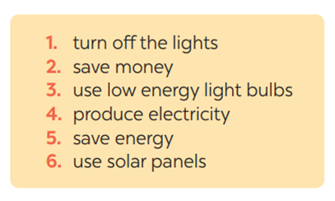What do you know about street painting?  Where do artists paint their pictures? Do they have to pay to paint there?
Activity 3. PRACTICE (15’-IW, PW, GW)
* Aim:
To help students develop their skill of listening for details.
To help Ss use what they have listened to life context.
* Product: Ss can learn how to do the excersises.
* Implementation: Teacher’s instructions…
Teacher’s Student’s activities | Content
Task 3: Listen again and tick T (True) or F (False) for each sentence  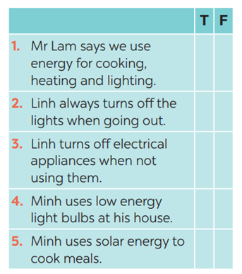  * Teacher asks Ss to read and underline the key words.  ** Ss work independently listen to the recording and tick T or F  *** Teacher calls on some students to give the answers the have listened. | Task 3: Listen again and tick T (True) or F (False) for each sentence  Answer key:  1. 3. 5.  2. 4.
Task 4: Discuss: What is the most effective way to save energy?  * Teacher tells Ss to work in groups to discuss and find out “What is the most effective way to save energy”. Write down onto the notebooks in full sentences  E.g. The most effective way to save energy is only read and write in day light  ** Ss work in groups. Teacher moves around and offers help if needed.  *** Teacher invites some Ss to share their answers.  **** Teacher corrects if needed. | Task 4: Discuss: What is the most effective way to save energy?
Activity 4. APPLICATION (7’-IW, PW, GW)
* Aim:
To help Ss prepare ideas to write a passage
To help Ss practise writing a passage about
70 words about how you save energy at home
To peer check, cross check and final check students’ writing.
To consolidate what students have learnt in the lesson.
To allow students finalize their passage after being checked by friends and the teacher.
To consolidate what students have learnt in the lesson.
* Content: Write a paragraph about how you save energy at home.
* Product: Students’s paragraph.
* Implementation: Teacher’s instructions
Task 5: Work in pairs. Read some ways to save energy at home. Choose three ways and write them in your notebook.  * Teacher asks Ss to write the methods they use to save energy at home then asks them to give out more if they can.  ** Ss think of it and can discuss with their partners.  *** Teacher calls on some Ss to raise their ideas.  **** Teacher listens and confirms.  Task 6: Write a paragraph of about 70 words about how you save energy at home.  * Teacher tells Ss that they are going to write a passage about how you save energy at home.  ** Teacher reminds Ss of the structure of a passage and steps to make an outline for the passage.  ** Ss work independently to do the task and try to use the notes from the previous tasks.  Teacher goes around and help if necessary.  Peer check and cross check  *** Teacher asks Ss to share their writing with their partners. Then, call on some Ss to show their writing in front of the class.  **** Teacher checks ideas, grammar, vocabulary and gives comments.  Consolidate  Teacher asks students to talk about what they have learnt in the lesson.  * Home assignment  - To allow students finalize their letter after being checked by friends and the teacher.  - Rewrite the letter on the notebook.  - Prepare for the next lesson: Looking back and project. | Task 5: Work in pairs. Read some ways to save energy at home. Choose three ways and write them in your notebook.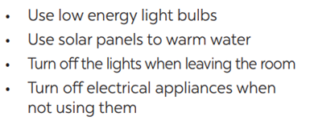  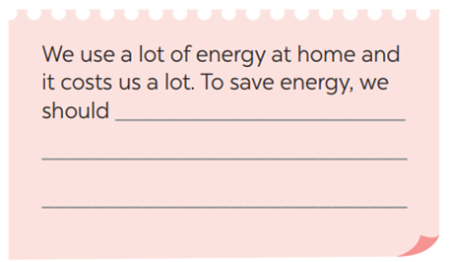  Suggested answers:  We use a lot of energy at home and it costs us a lot. To save energy, we should try making use of natural light more instead of keep the lights unnecessarily in the morning and afternoons. Moreover, we should unplug your electrical gadgets when not in use. These devices consume at least 10% of electricity even when inactive. Therefore, unplug them to save electricity. Most importantly, installing solar panels can help you excessively. They are very economical and help in saving a lot of energy. This can help in getting cheap electricity and protect the environment.  * Home assignment  - To allow students finalize their letter after being checked by friends and the teacher.  - Rewrite the letter on the notebook.  - Prepare for the next lesson: Looking back and project.

Planning date:
Teaching date:
PERIOD 86
UNIT 7: ENERGY SOURCES
LESSON 7: LOOKING BACK & PROJECT

I. OBJECTIVES: By the end of this unit, students will be able to gain the following things:
1. Knowledge:
- Review the vocabulary and grammar of Unit 10
- Apply what they have learnt (vocabulary and grammar) into practice through a project
2. Competence:
a) General competencies:
- Develop communication skills and creativity
- Be collaborative and supportive in pair work and team work
- Actively join in class activities
b) Specific competencies:
- Develop communication skills.
- Be cooperative and supportive in pair work and teamwork.
- Actively join in class activities.
3. Qualities:
- To educate the love of music and art.
- Be ready to know the words about music and arts.
- Develop self-study skills.
II. PREPARATIONS
- Teacher: Grade 7 text book, laptop, projector / TV/ pictures and cards.....
- Students : Text books, studying equipment….
III. PROCEDURE:
Notes: In each activity, each step will be represented as following:
* Deliver the task.
* Implement the task.
* Discuss.
* Give comments or feedback.
Activity 1. WARM UP (5’-IW, GW)
* Aim:
To help students revise the vocabulary items they have learnt in the unit.
To enhance students’ skills of cooperating with team mates.
* Content: saving energy resources and asks students to think of it.
* Product: Having a chance to speak English and focus on the topic of the lesson.
* Implementation: Teacher’s instructions…
Teacher’s & Student’s activities | Content
Quick revision check  * Teacher asks Ss to think of what they have learnt already in Unit 10.  ** Ss work in pairs to do the task.  ***Teacher calls some students to retell.  **** Teacher confirms and leads them to do all the exercises in books.  Task 1: Match the adjectives in A with the nouns in B to make phrases  * Teacher has Ss work individually.  ** Ss do this activity individually, then compare their answers with their partners.  *** Teacher asks for Ss’ answers. **** Teacher confirms the correct ones and asks students to make sentences using the phrases.  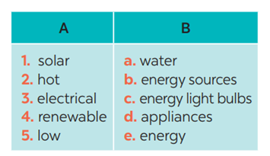 | Answer keys:  1. e 2. a  3. d 4. b 5. c
Activity 2. KNOWLEDGE FORMATION (15'- PW, IW)
* Aim:
- To help Ss revise the vocabulary items (verbs) they have learnt in the unit
- To help Ss revise grammar points.
* Content: Teach some new words.
* Product: Students’s answer.
* Implementation: Teacher’s instructions…
Teacher’s & Student’s activities | Content
Task 2: Complete the sentences, using the phrases in 1  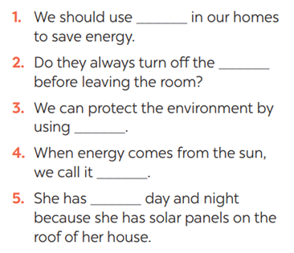* * Teacher has Ss work individually.  ** Ss do this activity then compare their answers with their partners.  *** Teacher asks for Ss’ answers.  **** Teacher confirms the correct ones | Task 2: Complete the sentences, using the phrases in 1  Answer keys:  1. low energy light bulbs  2. electrical applicances  3. renewable energy sources  4. solar energy  5. hot water
Task 3: Complete the sentences by using the correct form of the present continuous or present simple of the verbs in brackets.  * Teacher asks Ss to recall the structures of “The present continuous”, and tell them to do Ex 3 in the book.  ** Ss do the exercise individually and swap with their partners.  *** Teacher calls some Ss to check their answer.  **** Teacher confirms the correct answer.  1. Look! It (rain) ______ heavily.  2. Normally they (start) ______ school at eight o’clock in the morning.  3. He hasn’t got a bike at the moment, so he (walk) ______ to school this week.  4. He always (do) ______ his homework in the evening.  5. I’m afraid I have no time to help just now. I (write) ______ an essay | Task 3: Complete the sentences by using the correct form of the present continuous or present simple of the verbs in brackets.  Answer keys:  1- is raining  2- start  3- is walking  4- does  5- am writing
Activity 3. PRACTICE (15’-IW, PW, GW)
* Aim:
To help Ss revise the grammar points of the unit
* Product: Students’s answers.
* Implementation: Teacher’s instructions…
Teacher’s Student’s activities | Content
Task 4: Find ONE mistake in each sentence and correct it  * Teacher asks Ss to do the task.  ** Ss work individually to do the task.  *** Teacher calls Ss to give out their answers.  **** Teacher checks and confirms their answer.  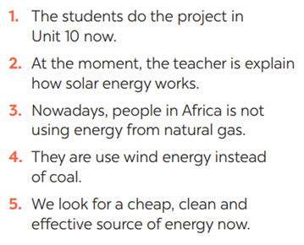 | Task 4: Find ONE mistake in each sentence and correct it  Answer keys:  1. do -> are doing  2. explain -> explaining  3. is -> are  4. use -> using  5. look -> are looking
Activity 4. APPLICATION (7’-IW, PW, GW)
* Aim:
To help Ss develop team work skills and pratice using what they have learnt to make a poster
To consolidate what students have learnt in the lesson.
To prepare for the next lesson.
* Content: Apply what they have learnt (vocabulary and grammar) into practice through a project.
* Product: Posters exhibition
* Implementation: Teacher’s instructions
Task 5: Discussion: Which tips can be applied in your school.  * Teacher asks Ss to dicuss in groups of 4-6  * Teacher also has Ss spend some time to make their brainstorm, narrow down the ideas, make a poster out of these ideas and practise presenting within their groups.  ** Ss discuss with their group memebers.  *** Some students raise their ideas and explain their answers among groups  **** Teacher listens, correct (if needed) and confirms.    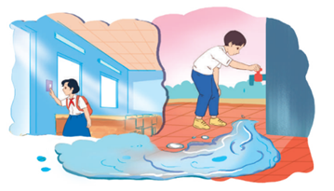  Task 6: : Poster presentation: How to save energy in your school  * Teacher asks Ss to work in groups of 4 – 6 to stick their posters onto the classroom’s wall and present about them.  ** Ss work in group to do the task.  *** Teacher calls some groups to present their poster to the class  **** Teacher confirms and corrects*  Consolidate  Teacher asks students to talk about what they have learnt in the lesson  Home assignment  Prepare for the next lesson: Unit 5 – Getting Started | \  * Home assignment  Prepare for the next lesson: Unit 5 – Getting Started

Planning date:
Teaching date:
PERIOD 86
MID-TERM TEST CORRECTION

Planning date:
Teaching date:
PERIOD 87
UNIT 11: TRAVELLING IN THE FUTURE
LESSON 1: GETTING STARTED – I HOPE WE WILL HAVE A HYPERLOOP SOON!

  - I. OBJECTIVES
1. Knowledge
- An overview about the topic TRAVELLING IN THE FUTURE.
- Vocabulary to talk about future means of transport.
2. Core competence
- Develop communication skills and creativity
- Be collaborative and supportive in pair work and team work
- Actively join in class activities
3. Personal qualities
- Develop self-study skills
II. PREPARATIONS
1. Teacher
- Grade 7 textbook, laptop, TV/Projector/ pictures and cards, speakers, lesson plan, sachmem.vn…
2. Students
- Grade 7 textbook, notebooks, studying equipment ….
III. TEACHING PROCEDURES
Notes
In each activity, each step will be represented as following
* Deliver the task
** Implement the task
*** Discuss
**** Giving comments or feedback

ACTIVITY 1 – WARM – UP & INTRODUCTION (5’)
a) Aims:
- To set the context for the listening and reading text.
- To introduce the topic of the unit.
b) Contents: Play the game “Chitchatting”
c) Products: Ss’ answers
d) Teaching steps:
Teacher’s and students’ activities | Content
* Teacher has Ss to look at the picture and talk about it by answering these questions.  ** Ss work in pairs to do the task.  *** Teacher calls on some Ss to give their ideas about it.  **** Teacher listens, comments, then leads Ss to the new lesson.  Questions  Teacher says: “In the lesson today we are going to learn a new unit about “Travelling in the future”. Let’s start to see and find out more information related to our new topic”. | Chitchatting    + How do you people travel every day?  + What do you think about the traffic in the picture?  + How about traffic in the future?
ACTIVITY 2 – PRESENTATION (15')
a) Aims:
- To introduce the new words.
- To set the context for the introductory conversation;
b) Contents:
- Teach the vocabularies
- Look at the pictures in the textbook and asks them some questions about the pictures.
c) Products:
- Lists of vocabularies
- Ss’ answers
d) Teaching steps:
Teacher’s and students’ activities | Content
* Teacher introduces the vocabulary by:  + showing the pictures illustrating the words  + providing the synonym or antonym of the words  + providing the definition of the words  ** Ss say the words.  *** Other Ss correct if the previous answers are incorrect.  **** Teacher shows and says the words aloud and asks Ss to repeat them.  Checking techniques: Rub out and Remember  * Teacher draws students’ attention to the pictures in the textbook and asks them some questions about the pictures. Teacher don’t confirm whether theirs are right or wrong.  + Who are they?  + Where are they?  + Where are they going?  + What can you see outside the coach?  + What can you see in the bubble?  + What could they be talking about?  ** Ss work out and answer questions in pairs.  *** Ss share their answers as a whole class.  **** T asks them to read and listen to the conversation to check their answers. | Vocabulary:  1. eco – friendly (a): [visual + explanation]  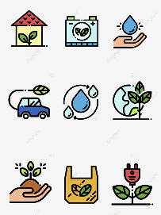  2. fume (n): [visual + explanation]    3. hyperloop (n): [visual + explanation]    4. teleporter (n): [visual + explanation]  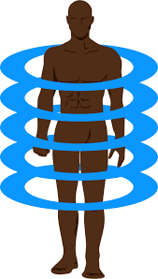  5. campsite (n): [visual + explanation]    Suggested answers:  + They are Minh and Ann.  + They are on a coach.  + They are going to the campsite.  + Outside the coach, we can see the crowded street. There is a traffic jam.  + In the bubble, there is a system of tubes. Minh is thinking about a means of transport.
ACTIVITY 3 – PRACTICE (15’)
a) Aims:
- To practice the targeted language and the background knowledge
- To help Ss read for specific information about Ann and Minh’s conversation.
– To help Ss recognise the words / phrases used to describe means of transport;
– To help Ss further understand the text.
b) Contents:
- Listen and read. What are Ann and Minh talking about?
- Read the conversation again and tick T (True) or F (False)
- Find the words and phrases that describe the means of transport in the conversation and write them in the correct columns.
c) Products:
- Answer key
d) Teaching steps:
Teacher’s and students’ activities | Content
* Teacher plays the recording, asks students to underline the words related to the topic. (Teacher may check the meaning of some words if necessary.)  - Teacher can play the recording more than once.  - Students listen and read.  ** Teacher can invite some pairs of students to read aloud.  *** Teacher refers to the questions previously asked.  **** Then, teacher confirms the correct answer: “Ann and Minh are talking about future modes of travel.  * Teacher asks Ss to work in pairs to read the conversation again and underline the key words in each sentence.  ** Ss work in pairs to do the task.  *** Ss answer and point out where in the conversation they find the information for their answers.  **** Teacher checks the answers as a class.  * Teacher asks Ss to work in pairs to read the conversation again and to underline the words / phrases that describe means of transport: hyperloop and teleporter.  ** Ss work in pairs to pick out words / phrases they have found to write down in the correct column.  *** Teacher asks some Ss to read out words / phrases they have found in the conversation to put into each column.  **** Teacher checks the answers as a class | Task 1. Listen and read. What are Ann and Minh talking about?  (Ex 1, 2, p. 114, 115)  Answer key: 2B  Task 2: Read the conversation again and tick T (True) or F (False). (Ex 3, p. 115)  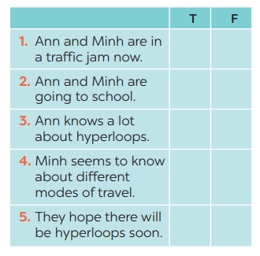  Answer keys:  - T 2. F 3. F 4. T 5. T  Task 3: Find the words and phrases that describe the means of transport in the conversation and write them in the correct columns. (Ex 4, p. 115)  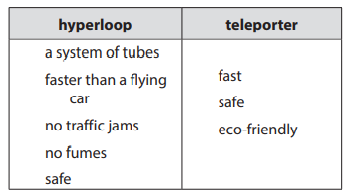Answer keys:
ACTIVITY 4 – PRODUCTION (15’)
a) Aims:
– To help Ss review vocabulary related to different means of transport;
– To give Ss a chance to develop creative thinking;
b) Contents:
- Do the quiz
c) Products:
- Answer key
d) Teaching steps:
Teacher’s and students’ activities | Content
* Teacher asks Ss to work in pairs to discuss to find out the vehicles in these sentences.  ** Ss work in pairs to do the task  *** Teacher reads out loud each question and the pairs answer. The pair who correctly completes its first wins  * Then, teacher has Ss work in pairs again to discuss how the vehicles they have thought of will be like in 50 years.  ** Ss work in pairs to do the task.  *** Teacher calls SS give any description about future means of transport they can imagine.  **** Teacher corrects grammar or pronunciation mistakes if needed. | Task 4: Quiz (Ex 5, p. 115)  1. It has two wheels and you pedal it.  2. It has four wheels. It runs on petrol or  electricity, and can carry up to eight  passengers.  3. It carries many passengers and runs  on tracks.  4. It sails on the sea. It needs wind to sail.  5. It travels in space. It can even carry  people to the moon.  Answer keys:  1. bicycle / bike  2. car  3. train  4. sailing boat  5. rocket / spaceship
IV. WRAP-UP & HOMEWORK
- Teacher asks students to talk about what they have learnt in the lesson:
+ Vocabulary of Traveling in the future
+ Reading for specific information and details
+ Scanning
- Do the exercises in the workbook
- Name at least 10 means of transport around the world.
- Prepare the next lesson “Unit 11 – A Closer Look 1”

Planning date:
Teaching date:
PERIOD 88

UNIT 11: TRAVELLING IN THE FUTURE

LESSON 2: A CLOSER LOOK 1

I. OBJECTIVES
By the end of this lesson, Ss will be able to gain:
1. Knowledge
- Vocabulary:
+ use the lexical items related to the topic Travelling in the future.
Pronunciation: say sentences with correct stress
2. Core competence
- Develop communication skills.
- Be collaborative and supportive in pair work and teamwork.
- Actively join in class activities.
3. Personal qualities
- Be ready to know the words about future means of transport.
- Develop self-study skills.
II. PREPARATIONS
1. Teacher
- Grade 7 textbook, laptop, TV/Projector/ pictures and cards, speakers, lesson plan, sachmem.vn…
2. Students
- Grade 7 textbook, notebooks, school things….
III. TEACHING PROCEDURES
Notes
In each activity, each step will be represented as following
* Deliver the task
** Implement the task
*** Discuss
**** Giving comments or feedback

ACTIVITY 1 – WARM – UP & INTRODUCTION (5’)
a) Aims:
- To help Ss review the previous lesson.
– To create a fun atmosphere in the class.
- To lead in the lesson about vocabulary and pronunciation.
b) Contents: Play the game “Miming”
c) Products: Suggested answers
d) Teaching steps:
Teacher’s and students’ activities | Content
* Teacher calls 1 student come to the board and whispers into Ss’ ears one means of transport.  ** Ss think of how to mine it, and the others are ready to guess  *** Ss mine the action for the others to guess the means of transport.  **** Teacher confirms the correct answer. The student who guesses correctly is the winner.  Teacher leads students into the lesson by telling them that “In today lesson, we are going to learn more words to talk about Future means of transport and how to say sentences with correct stress.” | 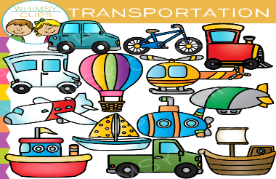  Game: Miming  Suggested answers:  1. hyperloop  2. flying car  3. train  4. bike  5. motorbike  6. boat
ACTIVITY 2 – PRESENTATION (10’)
a) Aims:
- To introduce visually some words related to the topic.
b) Contents:
- Teach the vocabularies
c) Products:
- Lists of vocabularies
- Answer key
d) Teaching steps:
Teacher’s and students’ activities | Content
* Teacher introduces the vocabulary by:  + providing the synonym or antonym of the words  + providing the pictures of the words  - Teacher have students read the phrases aloud and correct their pronunciation if needed.  - Teacher asks students for the Vietnamese meanings of these phrases.  ** Ss say the words.  *** Other Ss correct if the previous answers are incorrect.  **** Teacher shows and says the words aloud and asks Ss to repeat them  Checking techniques:  “Rub out and remember” | VOCABULARY  1. bamboo - copter (n): [visual +explanation]    2. skyTran (n): [visual + explanation]    3. solar - powered (a): [visual + explanation]  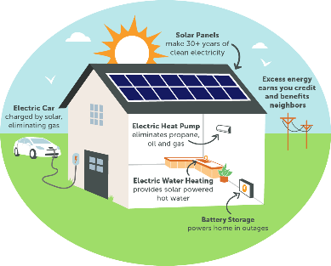  4. (to) sail: [visual + explanation]  
ACTIVITY 3 – PRACTICE (20’)
a) Aims:
- To introduce some modes of future travel.
- To help Ss learn to use the right verbs for the appropriate mode of travel.
- To help Ss practise using the learnt words in the right context.
b) Contents:
- Write the words or phrases under the correct pictures. Then listen, check, and repeat.
- Write words or phrases from 1 in the correct columns.
- Complete the sentences, using the words from the box.
c) Products:
- Answer key
- The role of marking sentence stress
d) Teaching steps:
Teacher’s and students’ activities | Content
* Teacher asks students to choose the words and phrases in the box to write under the correct pictures with their partners.  ** Ss work in pairs to do the task.  *** Teacher calls on some students to read aloud the words and asks them why they think a word / phrase should go with a picture  **** Teacher plays the recording for Ss to check their answers, has them to repeat chorally and individually, corrects their pronunciation and explain the meaning of these words/ phrases if needed.  * Teacher asks students to look at Ex 2 to write words and phrases in 1 in the correct columns  ** Ss work independently to do the task.  *** Some Ss give their answers.  **** Teacher checks students ‘answers as a class.  * Then, teacher asks Ss work in pair to add more words to each column.  ** Ss work in pairs to di the task.  *** Teacher calls on some Ss to give their answers.  **** Teacher confirms and corrects.  * Teacher has Ss look at the box, practice saying the words, then work individually to complete the sentence.  ** Ss work individually to do the task.  *** Some Ss read aloud the complete sentences  **** Teacher confirms the correct answers.  * Teacher writes the words “Sentence stress” on the board and asks them “What is sentence stress?”. Then, teacher has Ss watch the video to understand more about it.  https://www.youtube.com/watch?v=  d2SF3DHXeC8&t=228s  ** Ss work independently to do the task.  *** Teacher calls some Ss to check their understanding.  **** Teacher confirms, then asks them to read “Remember” in 1 minute.  + What are stressed words?  + What are unstressed words? | Task 1: Write the words or phrases under the correct pictures. Then listen, check, and repeat. (Ex. 1, p. 116)  Answer keys:  1. solar-powered ship  2. flying car  3. bamboo-copter  4. hyperloop  5. skyTran  Task 2: Write words or phrases from 1 in the correct columns. (Ex 2, p. 116)  Answer keys:  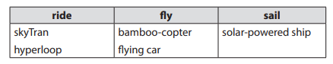  Suggested answers:  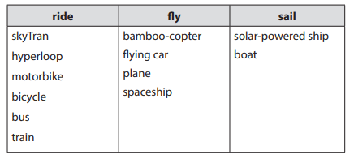  Task 3: Complete the sentences, using the words from the box. (Ex 3, p. 116)  Answer keys:  1. bamboo-copter  2. fly  3. ride  4. hyperloop  5. eco-friendly  PRONUNCIATION  Sentence Stress  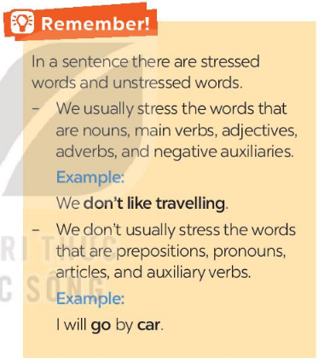
ACTIVITY 4 – PRODUCTION (7’)
a) Aims:
- To help students practise pronouncing sentences with correct stress.
- To help Ss be aware of the words they have to stress in a sentence
– To help Ss practise saying sentences with correct stress
b) Contents:
- Listen to the sentences and repeat. Pay attention to the bold syllables.
- Listen to the sentences and repeat. How many stresses are there in each sentence?
c) Products:
- Ss’ answer
d) Teaching steps:
Teacher’s and students’ activities | Content
* Teacher has students read the sentences and underline the stressed words. Then, ask them to listen to the recording once first and pay attention to the stressed syllables.  ** SS do the task independently, try to listen and repeat sentences as many times as possible as a class, a group and individually  *** Teacher calls some students to read out the sentences.  **** Teacher corrects their pronunciation and stress if needed.  * Teacher plays the recording for Ss to listen and repeat; then ask Ss to count the number of stresses in each sentence.  ** Ss do the task individually.  *** Teacher calls on some Ss to read the sentences in front of the class.  **** Teacher corrects their pronunciation if needed. | Task 4: Listen to the sentences and repeat. Pay attention to the bold syllables. (Ex 4, p. 116)  Suggested answers:  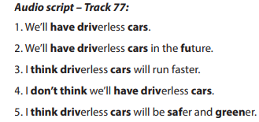  Task 5: Listen to the sentences and repeat. How many stresses are there in each sentence? (Ex 5, p.116)  Suggested answers:  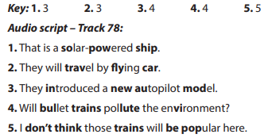
IV. WRAP-UP & HOMEWORK (3’)
- Teacher asks Ss to summarise what they have learnt in the lesson by asking them some questions.
- Teacher asks Ss to do exercises in workbook.
- Teacher asks Ss to prepare the next lesson “Unit 11 – A Closer look 2”

Planning date:
Teaching date:

PERIOD 89

UNIT 11: TRAVELLING IN THE FUTURE

LESSON 3: A CLOSER LOOK 2

I. OBJECTIVES
By the end of this lesson, Ss will be able to:
1. Knowledge
know how to recognize “The future simple: Will”
a. We use will + V:
+ to talk about future activities
Eg: We will buy an electric scooter soon.
+ to make predictions
Eg: We will probably use electric cars because normal cars cause too much pollution.
b. Possessive pronouns
+ to demonstrate ownership
Eg: This is our house. It’s ours.
2. Core competence
- Develop communication skills
- Be collaborative and supportive in pair work and team work
- Actively join in class activities
3. Personal qualities
Be responsible and hard working

II. PREPARATIONS
1. Teacher
- Grade 7 textbook, laptop, TV/Projector/ pictures and cards, speakers, lesson plan, sachmem.vn…
2. Students
- Grade 7 textbook, notebooks, school things….
III. TEACHING PROCEDURES
Notes
In each activity, each step will be represented as following
*Deliver the task
** Implement the task
*** Discuss
**** Giving comments or feedback

ACTIVITY 1 – WARM – UP & INTRODUCTION (5’)
a) Aims:
- To activate students’ prior knowledge and vocabulary related to the targeted grammar
- To introduce the targeted grammar of the lesson.
b) Contents: Play the game: Sentence puzzling
c) Products: Ss’ answers
d) Teaching steps:
Teacher’s and students’ activities | Content
* Teacher asks Ss some questions to lead into the lesson.  + How does your father go to work every day?  + What color is it?  + How will you travel when you are 30?  ** Ss work in dependently to do the task.  *** Teacher calls on some Ss to answer.  **** Teacher confirms and write some key sentences on the board.  Teacher says: “Today, we are going to learn how to use Will in the future and possessive pronouns.” | GAME: CHATTING  Mine is white  I will….  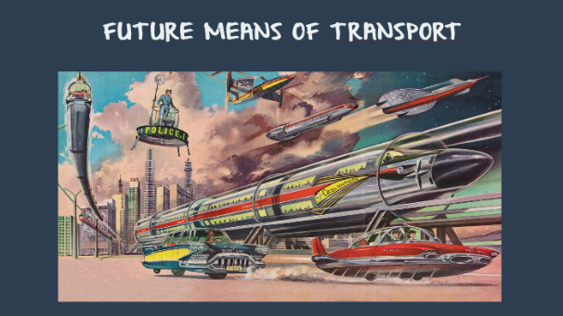
ACTIVITY 2 – PRESENTATION (15’)
a) Aims:
- To introduce students the form and the usage of the future simple.
- To revise the possessive pronouns
b) Contents:
- Teach the points of grammar
c) Products:
- The usage, the form of the future simple
- Possessive pronoun
d) Teaching steps:
Teacher’s and students’ activities | Content
* Teacher has Ss read “Remember box” in some minutes.  ** Ss work independently to read.  *** Teacher calls on some Ss to answer teacher’s questions to make sure they can understand how to use and form The Future Simple well.  + “Do we use The Future Simple to talk about past, present or future activities?”  + Teacher writes on the board: “People will go to school by solo wheel in 2030” and asks Ss: “In this situation, what do we use the future tense for?”  + “To make a negative form, do we say will not or not will?” (Just add NOT behind Will)  + “For questions, where we can put Will?” (Before subjects)  **** Teacher confirms, and corrects grammar if needed, then write on the board:  * Teacher writes on the board an example then asks Ss some questions to remind them.  + Do we use a possessive pronoun instead of a phrase? (hers = her bicycle)  + Does a possessive pronoun come before a noun?  + Let’s complete this table  +** Ss work individually to answer teacher’s questions  *** Teacher calls on some Ss to give their ideas.  **** Teacher confirms and corrects. | GRAMMAR 1: THE FUTURE SIMPLE  + Usage: to talk about future activities and to make predictions.  + Form: (+) S + will + V  (-) S + will + not (won’t)  (?) Will + S + V?  GRAMMAR 2: POSSESSIVE PRONOUNS (review)  Eg:  This is your bicycle.  That bicycle is her bicycle. → hers
  Personal pronouns | Possessive adjectives | Possessive pronouns
  I | my | mine
  You | your | yours
  We | our | ours
  They | their | theirs
  He | his | his
  She | her | hers
  It | its | its
ACTIVITY 3 – PRACTICE (18’)
a) Aims:
- To help Ss use the right verb form to talk about future activities.
- To help Ss practise making full sentences about future activities using prompts.
- To help Ss use the correct forms of future simple to make predictions.
- To review possessive pronouns.
b) Contents:
- Complete the sentences with will or won’t.
- Rearrange the words and phrases to make sentences.
- Use the correct form of the verbs in brackets to complete the conversation.
- Replace the underlined phrases with possessive pronouns.
c) Products:
- Answer key
d) Teaching steps:
Teacher’s and students’ activities |  | Content
* Teacher asks students to do the exercise individually and then compare their answers with a classmate.  ** Ss do the task individually.  *** Some Ss explain their choices.  ****Teacher confirms the correct answers.  * Teacher has students work individually to rearrange the words to make sentences.  ** Ss do the task individually.  *** Some Ss write their answer on the board.  ****Teacher confirms the correct answers.  * Teacher asks Ss to work in pairs to complete the conversation.  ** Ss work in pairs to do the task.  *** Teacher calls on Ss to read aloud the complete conversation.  **** Teacher confirms the correct answers helps them to correct mistakes if needed.  * Teacher asks Ss to do the task individually to replace the underlined phrases with the correct possessive pronouns.  ** Ss do the task individually and compare with their partners.  *** Some Ss read aloud their answers on the board.  **** Teacher confirms the correct answers. |  | Task 1: Complete the sentences with will or won’t. (Ex 1, p. 117)  Answer key:  1. won’t  2. will  3. will  4. won’t  5. Will  Task 2: Rearrange the words and phrases to make sentences. (Ex 2, p. 117)  Answer key:  1. We will have driverless cars in 2030.  2. Cities won’t allow cars in 2050.  3. Will electric cars be popular?  4. We will use solar-powered buses soon.  5. Will we have enough parking places in ten years?  Task 3: Use the correct form of the verbs in brackets to complete the conversation. (Ex 3, p. 117)  Suggested answers:  1. will take  2. won’t have  3. Will ... have  4. won’t drive  5. won’t be  Task 4: Replace the underlined phrases with possessive pronouns. (Ex 5, p. 118)  Suggested answers:  1. theirs  2. mine  3. His  4. Yours  5. Ours
ACTIVITY 4 – PRODUCTION (5’)
a) Aims:
- To help Ss practise talking about some future means of transport
b) Contents:
- Look at the pictures and tell your partner if you will / won’t travel by these means of transport.
c) Products:
- Ss’ speakings
d) Teaching steps:
Teacher’s and students’ activities | Content
* Teacher asks Ss to work in pairs to describe the picture.  ** SS work with their partners to do the task.  ***Some pairs talk about their choices and reasons why they will / won’t use those means of  travelling.  **** Teacher listens to Ss to correct common errors after Ss finish speaking. | Task 5: Look at the pictures and tell your partner if you will / won’t travel by these means of transport. Give reason(s). (Ex 4, p. 118)  Suggested answers:  - In picture 1, I can see a / an (electric) bus / coach. I can see many people on this bus / coach. I think I will go  to school by electric coach because it has no fumes, and it can carry many people at the same time.  - In picture 2, I can see a flying car. It is flying over a city. I think I will travel by flying car. It will be fun to fly in  one. I will be able to see the city below (or I can fly it when the roads are congested).  - In picture 3, I can see a ship. It has solar panels. I will travel on a solar-powered ship to visit some islands.  It will be comfortable / fun to travel by solar-powered ship.  - In picture 4, I can see a bamboo-copter. I will fly a bamboo-copter to work. It will be fun / fast. (or I won’t use a bamboo-copter to travel from one place to another. It will be dangerous. You might get hurt when it  is windy …).  - In picture 5, I can see a car with a lot of smoke behind it. I won’t go by car in the future. It pollutes the  environment.
IV. WRAP-UP & HOMEWORK (3’)
- Teacher summarises the main points of the lesson:
+ The Present Simple
+ Possessive Pronouns
- Teacher asks Ss to make 5 sentences using the present simple
- Teacher asks Ss to do exercise in Workbook
- Teacher asks Ss to prepare the next lesson “Unit 11 – Communication”

Planning date:
Teaching date:

PERIOD 90

UNIT 11: TRAVELLING IN THE FUTURE

LESSON 4: COMMUNICATION

I. OBEJECTIVES
By the end of this lesson, Ss will be able to:
1. Knowledge
- learn how to how to make predictions.
- practise using some grammar points and vocabulary related to the topic.
2. Core competence
- Develop communication skills
- Be collaborative and supportive in pair work and team work
- Actively join in class activities
3. Personal qualities
- Be benevolent and responsible
II. PREPARATIONS
1. Teacher
- Grade 7 textbook, laptop, TV/Projector/ pictures and cards, speakers, lesson plan, sachmem.vn…
2. Students
- Grade 7 textbook, notebooks, school things….
III. TEACHING PROCEDURES
Notes
In each activity, each step will be represented as following
* Deliver the task
** Implement the task
*** Discuss
**** Giving comments or feedback

ACTIVITY 1 – WARM – UP & INTRODUCTION (5’)
a) Aims:
- To revise the old lesson and introduce the new lesson.
- To lead in the lesson.
b) Contents: Chatting
c) Products: Ss’ answers
d) Teaching steps:
Teacher’s and students’ activities | Content
* Teacher checks Ss’ knowledge of the previous lessons by asking them to make sentences using The Future Simple or possessive pronouns.  ** Ss think of a sentence individually.  *** Teacher calls on some Ss to read aloud their sentences.  **** Teacher confirms, corrects grammar and pronunciation if needed.  - Teacher leads students into the lesson by telling what they are going to learn: “We are going to learn how to make predictions and use the grammar and the vocabulary related to our topic Travelling in the future” | Chatting  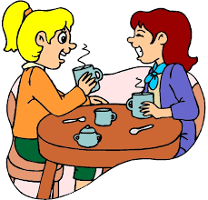
ACTIVITY 2 – PRESENTATION (10’)
a) Aims:
- To introduce to Ss how to make predictions
b) Contents:
- Teach some structures to make predictions
- Listen and read the conversation.
c) Products:
- Making predictions
- Listen and read the conversation.
d) Teaching steps:
Teacher’s and students’ activities | Content
* Teacher lets students listen to the examples in Ex. 1 in the book.  ** Teacher draws their attention to the form of ways to express disappointment.  *** Teacher and students discuss the form of ways to express disappointment, and give some other expressions.  **** Teacher confirms the answers and gives feedback.  * Teacher plays the record for SS to listen and read the conversation  ** Ss listen and practice saying with their partners.  *** Teacher calls some pairs to read aloud.  **** Teacher corrects pronunciation if needed.  * Teacher asks Ss to pay attention to the highlighted parts and asks them some questions to elicit the new structure  ** Ss answer teacher’s questions to find out new structure to express preferences.  *** Some students give the new structure to the teacher.  **** Teacher corrects and writes on the board | I - EVERYDAY ENGLISH  Making predictions  * Some structures to make predictions  - We certainly will/ won’t  - It probably won’t/ will  Task 1: Listen and read the conversation. (Ex 1, p. 119)  - Structure: to make predictions  - We certainly will/ won’t …  if you are sure about your predictions.  - It probably won’t/ will …  if you are not sure about your predictions.
ACTIVITY 3 – PRACTICE (20’)
a) Aims:
- To help Ss practise making predictions.
- To help Ss learn more about what information they can discover when talking about a means
of transport
– To help Ss practise asking and answering questions about a future means of transport.
b) Contents:
- Make similar conversation.
- Complete the conversation between Mark and Lan with the questions and answers from the box.
- Choose one means of transport below and make a similar conversation as in 3.
c) Products:
- Answer key
- Ss’ speakings
d) Teaching steps:
Teacher’s and students’ activities | Content
* Teacher has SS look at the situation in Ex 2 to make similar dialogue.  ** Ss work in pairs to make similar dialogue.  *** Teacher calls some pairs to present it in front of the class.  **** Teacher gives feedback and some comments.  * Teacher asks Ss to work in pairs to read the conversation and complete it with the questions and answers from  the box  ** Ss do the task in pairs  *** Teacher calls some Ss to give their answer and explain it.  **** Teacher confirms the correct answers.  * Teacher asks Ss to n pairs to ask and answer questions about which means of transport they would like to  use to travel to school. Ask them to use the example in 3. Elicit any other questions and answers they  can ask and answer about a means of transport.  ** Ss work in pairs.  *** Teacher invites some pairs to role-play, asking and answering the questions in front of the class  **** Teacher confirms and corrects if needed. | II – HOW WILL CHILDREN GO TO SCHOOL?  Task 2: Make similar conversation. (Ex 2, p. 119)  1. travelling long distances by hyperloop.  2. travelling to other planets for holidays.  Suggested answers:  Situation 1:  A: Do you think we will travel long distances by hyperloop?  B: We certainly / probably will.  A: Will it allow us to travel to other planets?  B: It probably / certainly won’t.  Situation 2:  A: Do you think people will travel to other planets for their holidays?  B: They certainly / probably will.  A: Will holidays on other planets be expensive / interesting?  B: They certainly will (be).  Task 3: Complete the conversation between Mark and Lan with the questions and answers from the box. (Ex 3, p, 119)  Answer key:  1. B  2. A  3. D  4. C  Task 4: Choose one means of transport below and make a similar conversation as in 3. (Ex 4, p. 119)  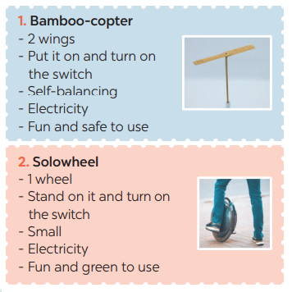  Suggested answer:  For the conversation about bamboo-copter, for example, T may guide Ss to ask questions:  1. So what means of transport will students use to go to school?  2. How many fans does it have?  3. How will it work?  4. What will it run on?  5. Why would you like to go to school by bamboo-copter?  – For the Solo wheel, T instructs Ss to ask similar questions.

ACTIVITY 4 – PRODUCTION (7’)
a) Aims:
- To help Ss practise talking about which means of transport they would like to use to travel to school
– To help Ss practise giving reasons
– To help Ss practise reporting.
b) Contents:
- Choose one means of transport that you would like to use to travel to school. Give reasons.
c) Products:
- Ss’ presentations
d) Teaching steps:
Teacher’s and students’ activities | Content
* Teacher asks Ss to work in group to discuss which means of transport they would like to use to travel to  school  ** Ss work in groups to take notes several means of transport for Ss to think of such as a bamboo-copter, a solowheel , a scooter or a bicycle and reasons for them to use:  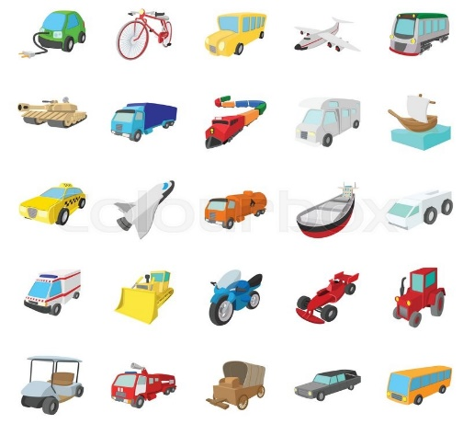  + It is safe / fast / green / fun / economical / convenient.  + It doesn’t cause noise or pollution.  + It doesn’t make fumes.  + It doesn’t pollute the environment.  - Teacher goes round the class to monitor and give support if necessary.  *** Ss from each group present their ideas to the class.  **** Teacher comments on their clarify, language, fluency, grammar, etc. | Task 5: Choose one means of transport that you would like to use to travel to school. Give reasons. (Ex 5, p. 119)
IV. WRAP-UP & HOMEWORK (7’)
- Teacher has Ss say what they have learnt in the lesson:
+ Vocabulary of the means of transport
+ The present simple
+ Possessive pronouns
- Teacher asks Ss to prepare the next lesson “Unit 11 – Skills 1”

Planning date:
Teaching date:

PERIOD 91

UNIT 11: TRAVELLING IN THE FUTURE
LESSON 5: SKILLS 1

I. OBJECTIVES
By the end of this lesson, Ss will be able to gain:
1. Knowledge
+ Reading:
- read for general and specific information about a future car.
+ Speaking:
talk about why a means of transport will / won’t be popular
2. Core competence
- Develop communication skills
- Be collaborative and supportive in pair work and team work
- Actively join in class activities
3. Personal qualities
Be benevolent and responsible
II. PREPARATIONS
1. Teacher
- Grade 7 textbook, laptop, TV/Projector/ pictures and cards, speakers, lesson plan, sachmem.vn…
2. Students
- Grade 7 textbook, notebooks, school things….
III. TEACHING PROCEDURES

ACTIVITY 1 – WARM – UP & INTRODUCTION (5’)
a) Aims:
- To introduce the topic of reading.
- To enhance students’ skills of cooperating with team mates.
- To lead in the lesson about Skills 1.
b) Contents: Play the game “Networking”
c) Products: Suggested answers
d) Teaching steps:
Teacher’s and students’ activities | Content
* Teacher asks Ss to think of the forms of transport they have used and any that they would like to experience.  ** Ss in groups to share.  *** Teacher calls on groups to see how many different forms of transport they can list. The group which has more corrects ones will be the winner.  **** Teacher confirms and corrects.  -Teacher leads students into the lesson by telling what they are going to learn: “In the lesson today, we are going to read and find some information about a kind of means of transport.” | Game: NETWORKING  FORMS OF TRANSPORT  Suggested answers:  tank, hot-air balloon, helicopter, yacht, bicycle, horse and carriage, RollsRoyce, hang glider, mule, double – decker bus, elephant, spaceship, etc.
ACTIVITY 2 – PRESENTATION (10’)
a) Aims:
- To lead in the reading skills.
- To provide students with some lexical items before reading the text.
b) Contents:
-
- Work in pairs. Discuss the following questions.
- Read Phong’s blog. Match the underlined words in the text with their meanings.
c) Products:
- Lists of vocabularies
- Answer key
d) Teaching steps:
Teacher’s and students’ activities | Content
*-Teacher introduces the vocabulary by:  + Providing the synonym or antonym of the words.  + Providing the pictures of the words.  + Providing the definition of the words.  Concept check: Rub out and Remember | READING  * Vocabulary  a. (to) charge [ visual + explanation]  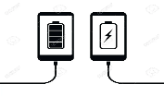  b. passenger (n) [ visual + explanation]    c. economical (a) [ visual + explanation]    d. autopilot (adj, n) [ visual + explanation]    e. function (n) [ visual + explanation]    f. (to) run on [ visual + explanation]    * BRAINSTORMING:  Task 1. Look at the picture and find the words or phrases to describe it. (Ex 1, p. 120)    Suggested answer:  The car: convenient, safe, comfortable, modern, automatic, automated, autopilot, etc.  The driver: relaxing / isn’t driving, etc.
ACTIVITY 3 – PRACTICE (20’)
a) Aims:
- To improve Ss’ skills of reading for the general idea.
- To improve Ss’ skills of reading for details.
- To check students’ reading comprehension.
- To enable Ss to ask and answer questions about a car company
b) Contents:
- Read the passage and answer the question.
- Read the passage again and complete the fact file with no more than two words or a number.
- Retelling
- Look at the fact file in 3 then ask and answer questions about it.
c) Products:
- Answer key
d) Teaching steps:
Teacher’s and students’ activities | Content
* Teacher tells Ss to read the text quickly and find out the main idea of the paragraph individually.  ** Ss work independently to read.  *** Some Ss read out their answer and explain their choices.  **** Teacher confirms, corrects, and explains that B and C are just facts.  * Teacher tells Ss that they are going to read to passage again to complete the table about the company and its car. Teacher also reminds Ss to look at the information on the left first before doing the task to guess what types of information they need to scan.  ** Ss work independently to do the task.  *** Teacher calls on some Ss to give their answers and points out where they can find the information.  **** Teacher corrects and confirms.  * Teacher asks Ss to close their books and just look at the table in task 2 to retell what they have read about “Roadrunner”.  ** Ss work on pairs, take turns to retell.  *** Some Ss retell all the information about “Roadrunner”.  **** Teacher listens and corrects if needed  * Teacher asks Ss to work in pairs to look at the table once more times to make questions about Roadrunner and its car based on the fact file in 3.  ** Ss work in pairs to make questions, then answer these questions.  *** Teacher calls on some pairs to role – play it in front of the class.  **** Teacher corrects Ss’ grammar and pronunciation mistakes if needed. | Task 2: Read the passage and answer the question. (Ex 2, p. 120)  Answer key: A  Task 3: Read the passage again and complete the fact file with no more than two words or a number. (Ex 3, p. 120)  Answer key:  * Retelling  SPEAKING  Task 4: Look at the fact file in 3 then ask and answer questions about it. (Ex 4, p. 120)  Suggested questions:  * When was Speed introduced? / When did they introduce Speed?  • What do you know about Safety? / What is special about Safety?  • What functions do these models have?  • What do these models run on?  • What can passengers do when they are travelling in the car?
ACTIVITY 4 – PRODUCTION (7’)
a) Aims:
- To help Ss practise reasoning skill
b) Contents:
- Discuss why Roadrunner’s cars will or won’t become popular in the near future. Report your reasons to the class.
c) Products:
- Ss’ reports
d) Teaching steps:
Teacher’s and students’ activities | Content
* Teacher writes on the board: “Why Roadrunner’s cars will or won’t become popular in the near future?” and asks Ss to work in groups to discuss it.  ** Ss work in groups to do the task. Teacher goes around to help them if needed.  *** Teacher invites one representative of each group to report the answers of their own group to the class | Task 5: Discuss why Roadrunner’s cars will or won’t become popular in the near future. Report your reasons to the class. (Ex 5, p. 120)  Suggested answers:  + Roadrunner’s cars will become popular in the near future, because they are fast / safe / comfortable /  modern.  + Roadrunner’s cars run on electricity, so they are eco-friendly / green / they do not pollute the  environment.  + Roadrunner’s cars have an autopilot function, so they are very comfortable and modern
IV. WRAP-UP & HOMEWORK (3’)
- Teacher has Ss summarise what they have learnt in the lesson with the two skills.
- read for general and specific information about a future car.
- talk about why a means of transport will / won’t be popular
- Teacher asks Ss to make a conversation, video and upload on given drive link.
- Teacher asks Ss to prepare the next lesson “Unit 11 – Skills 2”

Planning date:
Teaching date:

PERIOD 92

UNIT 11: TRAVELLING IN THE FUTURE

LESSON 6: SKILLS 2

I. OBJECTIVES
By the end of this lesson, Ss will be able to gain:
1. Knowledge
+ Listening
listen for general and specific information about some future means of transport;
+ Writing: write about the advantages of a future means of transport.
2. Core competence
- Develop communication skills
- Be collaborative and supportive in pair work and team work
- Actively join in class activities
3. Personal qualities
Be benevolent and responsible
II. PREPARATIONS
1. Teacher
- Grade 7 textbook, laptop, TV/Projector/ pictures and cards, speakers, lesson plan, sachmem.vn…
2. Students
- Grade 7 textbook, notebooks, school things….
III. TEACHING PROCEDURES
Notes
In each activity, each step will be represented as following
* Deliver the task
** Implement the task
*** Discuss
**** Giving comments or feedback

ACTIVITY 1 – WARM – UP & INTRODUCTION (5’)
a) Aims:
- To prepare Ss for the listening by focusing them on some words / phrases
- To lead in the new lesson.
b) Contents: Make a discussion
c) Products: Ss’ answers
d) Teaching steps:
Teacher’s and students’ activities | Content
* Teacher asks Ss to look at the words or phrases in Ex 1 (p. 121) and think of which ones are used to describe the future means of the transport.  ** Ss thinks of it individually, then discuss with their partners. Teacher encourages Ss to give reasons for their answers.  *** Teacher calls some students to give their answers.  **** Teacher listens and give comments.  -Teacher introduces students the content of the lesson: “In the lesson today, we are going to listen to a talk between Mr. Ha and his students about future means of transport.” | DISCUSSION  Task 1. Circle the words/ phrases that you think are used to describe the future means of transport  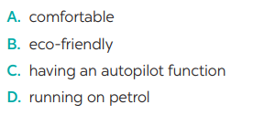
ACTIVITY 2 – PRESENTATION (7’)
a) Aims:
- To provide students with some lexical items before listening the text
- To activate Ss’ knowledge of the topic of the listening text
-- To improve Ss’ skills of listening for general information
b) Contents:
- Teach vocabularies
- Listen to a talk between Mr Ha and his students. How many means of transport are they talking about? Circle the correct answer.
c) Products:
- List of vocabularies
- Answer key
d) Teaching steps:
Teacher’s and students’ activities | Content
*-Teacher introduces the vocabulary by:  + Providing the synonym or antonym of the words.  + Providing the pictures of the words.  + Providing the definition of the words.  Concept check: Rub out and Remember  * Teacher asks students to read through the statements, have a guess before they listen to the recording the second time and write their guesses on the board.  ** Teacher plays the recording again. Ask students to listen and choose the correct answer.  *** After listening once, T calls on some Ss to give their answer.  **** Teacher plays the recording again and confirms the correct answer. | LISTENING  *Vocabulary  1. bullet train (n) [visual + explanation]    2. (to) use up [visual + explanation]    3. comfortable (a) [visual + explanation]    Task 2: Listen to a talk between Mr Ha and his students. How many means of transport are they talking about? Circle the correct answer. (Ex 2, p. 121 - cont)  Answer key: C
ACTIVITY 3 – PRACTICE (23’)
a) Aims:
- To improve Ss’ listening comprehension and note taking skills.
- To check Ss’ memory about what they have listened.
- To prepare Ss for the writing activity
- To help Ss practise writing.
b) Contents:
- Listen to the talk again and complete each sentence with ONE word.
- Choose one future means of transport in 3 and tick the words and phrases that describe its advantages. Can you add more words and phrases?
- Write a paragraph of about 70 words about the advantages of the means of transport you’ve chosen.
c) Products:
- Answer key
-Ss’ writings
d) Teaching steps:
Teacher’s and students’ activities | Content
* Teacher asks Ss to read the sentences and to predict the words they need to fill in each blank.  ** Ss works in pairs to do the task. Then teacher plays the recording for Ss to listen and fill in the blank.  *** Teacher calls on some Ss to give theirs answers and writes them on the board.  **** Teacher plays the recording again as many times as needed for Ss to check their answers and clearly understand the conversation.  Audio script – Tracks 80 + 81:  - Mr Ha: Now, let’s turn to future means of transport. How do you think people will travel in 2050, Tom?  - Tom: I think people will use bullet trains. Bullet trains will be faster and safer than cars and they can help avoid traffic accidents.  - Lan: I think skyTrans will also be popular, too. They will not use up much space and will be safe because they run on autopilot. - Tom: But skyTrans may be too expensive for students to use. Bamboo-copters will be cheaper and easier for them to use. They will just put on their bamboo-copters and fly to school.  - Mr Ha: Sounds interesting. How about travelling on sea?  - Lan: I think people will use solar-powered ships to travel on sea. They will be eco-friendly and comfortable …  *Teacher asks Ss to choose a future means of transport in Ex 3 and discuss with their partner by ticking the boxes or add as many words/ phrases as possible.  ** Ss do the task in pairs.  *** Teacher calls on some Ss to read out loud and encourages Ss to make sentences with the words/ phrases.  **** Teacher corrects and confirms.  * Teacher tells Ss that they are going to write about the advantages of the means of transport they ‘ve chosen. Teacher reminds them to start their writing as shown below.  ** Ss do the task independently.  *** Teacher allows students to cross check first.  **** Teacher gives feedback. | Task 3: Listen to the talk again and  complete each sentence with ONE word.  (Ex 3, p. 121)  Answer key:  1. accidents  2. autopilot  3. expensive  4. Bamboo-copters  5. eco-friendly  Task 4: Choose one future means of transport in 3 and tick the words and phrases that describe its advantages. Can you add more words and phrases? (Ex 4, p. 121)  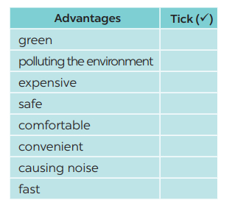  Suggested answers: economical, carrying many passengers, avoiding traffic jams, having an autopilot function, driverless, etc.  Task 5: Write a paragraph of about 70 words about the advantages of the means of transport you’ve chosen. (Ex 5, p. 121)  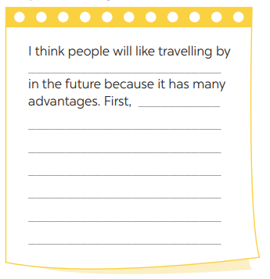
ACTIVITY 4 – PRODUCTION (7’)
a) Aims:
- To peer check, cross check and final check students’ writing.
b) Contents:
- Give peer-reflection & evaluation
c) Products:
- Ss’ writing
d) Teaching steps:
Teacher’s and students’ activities | Content
* Teacher asks students read their “production”.  ** Students listen to each other’s work.  *** Students then give comments to each other.  **** Teacher then gives feedback as a class discussion. | Task 6:  Class gallery
IV. WRAP-UP & HOMEWORK (3’)
- Teacher has Ss summarise what they have learnt in the lesson with the two skills.
If there is time, have them draw a mind map to summarise the main points of the lesson.
- Teacher asks Ss to rewrite the emails on their notebook.
- Teacher asks Ss to prepare the next lesson “Unit 11 – Looking back & project”

UNIT 11: TRAVELLING IN THE FUTURE

LESSON 7: LOOKING BACK & PROJECT

I. OBJECTIVES
By the end of this lesson, Ss will be able to gain:
1. Knowledge
- review the vocabulary and grammar of Unit 11
- apply what they have learnt (vocabulary and grammar) into practice through a project.
2. Core competence
- Develop communication skills and creativity
- Be collaborative and supportive in pair work and team work
- Actively join in class activities
3. Personal qualities
- Be benevolent and responsible
- Develop self-study skills
II. PREPARATIONS
1. Teacher
- Grade 7 textbook, laptop, TV/Projector/ pictures and cards, speakers, lesson plan, sachmem.vn…
2. Students
- Grade 7 textbook, notebooks, school things….
III. TEACHING PROCEDURES

ACTIVITY 1 – WARM – UP & INTRODUCTION (5’)
a) Aims:
- To help students revise the vocabulary items they have learnt in the unit.
- To enhance students’ skills of cooperating with team mates.
b) Contents: Play the game “Brainstorming”
c) Products: Means of transport
d) Teaching steps:
Teacher’s and students’ activities | Content
* Teacher divides the board, and divides the class into 2 teams.  ** Members of each team take turns and write as many types of festivals as possible in 2 minutes.  *** Students cross check their answers first.  **** Teacher confirms the answers and gives feedback. The group having more correct answers is the winner. | Brainstorming  Means of transport

ACTIVITY 2 – PRESENTATION (5’)
a) Aims:
- To revise the language focus that students have learnt in Unit 11
b) Content: Complete the chart about language learnt in Unit 11
c) Products: the chart about language learnt in Unit 11
d) Teaching steps:
Teacher’s and students’ activities | Content
*Teacher shows an unfinished chart which summarizes the language that students have learnt in Units 11  - Teacher asks Ss to complete the chart individually.  **Ss do the task and complete the chart  ***Teacher calls some Ss share their answers.  - Ss give their answers  **** Teacher checks and corrects | I – LOOKING BACK  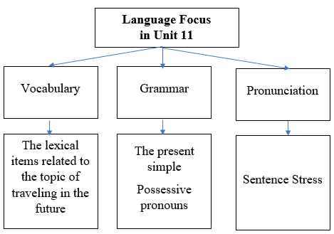
ACTIVITY 3 – PRACTICE (15’)
a) Aims:
- To help Ss revise the learnt vocabulary.
– To help Ss use the right adjectives / phrases to describe the appropriate means of transport.
- To help Ss review the words / phrases about music and arts used in the context of a passage;
– To give Ss some information of the Louvre Museum - the world’s largest art museum.
b) Contents:
- Write three adjectives or phrases to describe each picture.
- Complete the sentences with the words and phrases from the box.
- Find one mistake in each sentence and correct it.
- Read the passage and put the verbs in brackets in the correct future form.
c) Products:
- Answer key
d) Teaching steps:
Teacher’s and students’ activities | Content
* Teacher asks Ss to work individually to look at the three pictures and think of the words or phrases they have learnt to describe means of transport.  ** Ss do the task independently.  *** Teacher asks for Ss’ answers.  **** Teacher confirms the correct ones  * Teacher has Ss work individually to put the right words / phrases into the correct blanks.  ** Ss do this activity individually, then compare their answers with their partners.  *** Teacher asks for some Ss to read aloud the sentences.  **** Teacher confirms the correct answer.  * Teacher asks Ss to find one mistake in each sentence and correct it  ** Ss do the exercise individually and swap with their partners.  *** Teacher calls some Ss to check their answers.  **** Teacher confirms the correct answer.  * Teacher asks Ss to put the verbs in brackets in the correct form  ** Ss work individually to do the task.  *** Teacher calls 1- 2 Ss to read out the passage.  **** Teacher checks and confirms their answers. | VOCABULARY  Task 1: Write three adjectives or phrases to describe each picture. (Ex. 1, p. 122)  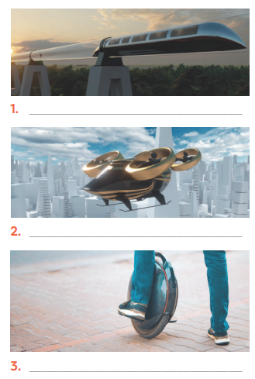  Answer keys:  1. fast, green, carrying many passengers  2. fast, convenient, autopilot function  3. electric, green, convenient  Task 2: Complete the sentences with the words and phrases from the box. (Ex. 2, p. 122)  Answer keys:  1. eco-friendly  2. runs on  3. bamboo-copter  4. driverless  5. Bullet trains  GRAMMAR  Task 3: Find one mistake in each sentence and correct it. (Ex. 3, p. 122)  Answer keys:  1. Her → Hers  2. Our → Ours  3. My → Mine  4. its → his  5. yours → your  Task 4: Read the passage and put the verbs in brackets in the correct future form. (Ex 4, p. 122)  Answer keys:  1. will travel  2. won’t go  3. will need  4. won’t carry  5. Will … come
ACTIVITY 4 – PRODUCTION (13’)
a) Aims:
- To allow students to apply what they have learnt (vocabulary and grammar) into practice through a project.
- To develop teamwork skills
- To give students authentic practice in using target language
b) Contents:
- Posters exhibition
c) Products:
- Ss’ posters
d) Teaching steps:
Teacher’s and students’ activities | Content
* Teacher asks Ss to look at the picture and imagine a future means of transport they would like to see in the future. Teacher tells SS that they can draw pictures or pin the pictures or photos on A0 paper to illustrate their ideas.  ** Ss do the task in group. Teacher goes around to help if necessary and check their progress.  *** Teacher calls some groups to present their poster to the class  **** Ss in other groups comment. Teacher confirms and corrects. | PROJECT  Our future means of transport
IV. WRAP-UP & HOMEWORK (2’)
- Teacher asks students to talk about what they have learnt in the lesson.
- Prepare for the next lesson: Unit 12 – Lesson 1. Getting started.

Planning date:
Teaching date:
PERIOD 94
UNIT 12: ENGLISH-SPEAKING COUNTRIES
LESSON 1: GETTING STARTED – A HOLIDAY IN AUSTRALIA.

I. OBJECTIVES: By the end of this unit, students will be able to gain the following things:
1. Knowledge:
- An overview about the topic “English-speaking countries”
- Lexical items related to people and places in English-speaking countries
+ Pronunciation:
+ Vocabulary: Use the words related to people and places in English-speaking countries.
1. island (n)
2. sunset (n)
3. landscape (n)
4. penguin (n)
+ Grammar:
2. Competence:
a) General competencies:
- Students will be able to know more words and phrases about means of transport.
- Develop communication skills and cultural awareness
- Be collaborative and supportive in pair work and teamwork
- Actively join in class activities
b) Specific competencies:
- Group work and independent working, pair work, linguistic competence, cooperative learning and communicative competence.
- Sts can introduce themselves or one another fluently.
3. Qualities: The love of country; The awareness about importance of speaking English; Be ready to talk about English speaking countries.
- Develop self-study skills.
II. PREPARATIONS
Teacher: Grade 7 text book, laptop, TV, pictures and realia, Computer connected to the Internet, Sach mem.vn
Students: Text books, pencils, pics, blank papers, realia,….
III. PROCEDURE:
In each activity, each step will be represented as following:
* Task delivering
** Task performance
*** Report and discussion
**** Judgement
Activity 1. WARM UP (5’-IW, GW)
* Aim:
- To activate students’ knowledge on the topic of the unit
- To lead in the topic of the lesson.
To set the context for the introductory conversation.
* Content: Flags matching
* Product: Having a chance to speak English and focus on the topic of the lesson.
* Implementation: Teacher’s instructions…
Teacher’s & Student’s activities | Content
Flags matching  * Teacher divides the class into 2 big groups and asks them to match the flag illustrations with names of the countries.  ** Students work in groups to discuss and do the matching.  *** Teacher allows students to share their answers before discussing as a class and encourages them to pronounce the names of the countries correctly.  **** Teacher asks students to explain their choice, checks the answers as a class, gives feedback then introduces the similarity of these countries “English-speaking countries”. | Flags matching  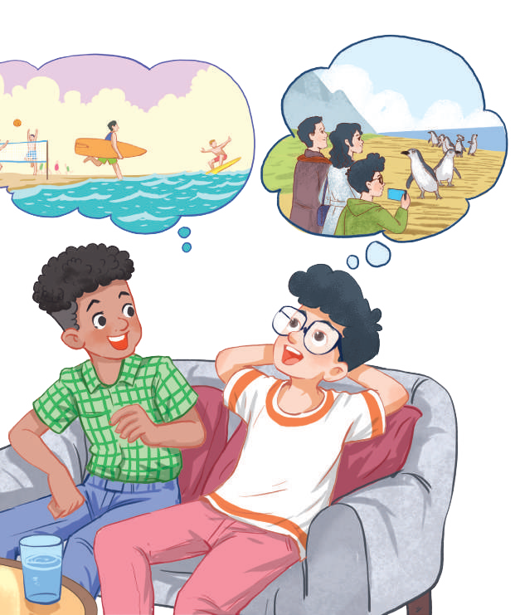
  * Teacher draws students’ attention to the picture in the textbook and asks them some questions about it:
  - What activities are they talking about?
  surfing
  penguin watching
  - In what English-speaking country can they do these activities?
  Australia
  ** Students raise hands to answer the questions.*** Students discuss and give comments to their friends’ answers.
  **** Teacher confirms the correct answers: They are Phong and Mark. They are talking about Phong’s holiday in Australia. They mention Phong’s use of English in real life, his travels, and Australia’s people and landscapes.
   |  |  | 
  The USA | Canada |  | The UK
   |  | 
  New Zealand |  |  |  | Australia
Activity 2. KNOWLEDGE FORMATION (15'- PW, IW)
* Aim:
- To provide students with vocabulary.
- To help students well-prepared for the listening and reading tasks.
* Content: Teach some new words.
* Product: Ss learn how to use them.
* Implementation: Teacher’s instructions…
Teacher’s & Student’s activities | Content
Vocabulary:  * Teacher introduces the vocabulary.  ** Teacher introduces the vocabulary by:  - providing the pictures  - eliciting the definition of the words  *** Teacher rubs out and checks  **** Teacher checks students’ pronunciation and gives feedback. Teacher reveals that these four words will appear in the reading text and asks students to open their textbook to discover further. | Vocabulary:  1. island (n)  2. sunset (n)  3. landscape (n)  4. penguin (n)    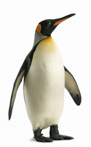
  sunset
  penguin
Activity 3. PRACTICE (15’-IW, PW, GW)
* Aim:
- To have students get to know the topic.
- To help students get the main idea of the conversation.
- To draw students’ attention to the key information of the text and see how much they can remember about the text.
- To introduce some key words related to the topic.
* Product: Students’ answers.
* Implementation:
Teacher’s Student’s activities | Content
Task 1: Listen and read (p. 124).  * Teacher can play the recording more than once.  ** Students listen and read.  *** Teacher can invite some pairs of students to read aloud.  **** Teacher check students’ pronunciation ad give feedback.  Task 2: What are Phong and Mark talking about? (p. 125).  * Teacher asks to answer the question without reading the conversation again.  ** Students choose the most suitable option A B or C.  *** Teacher allows students to share their answers before discussing as a class and encourages them to pronounce the words / phrases correctly.  **** Teacher asks students to explain their choice and checks the answers as a class and gives feedback.  Task 3: Read again and tick the information you can find in the conversation. (p. 125)  * Teacher asks students to work individually to complete tick the information they can find in the conversation.  ** Students work individually to read the sentences and do the task without referring to the text.  *** Teacher allows students to share answers before discussing as a class.  **** Teacher calls on some students to give the answers and asks them where they find the information.  Task 4: Complete the sentences with the words and phrases from the box. (p. 125)  * Teacher asks students to read the words and phrase in the box and work on their meanings. These words have appeared somewhere in the previous units (except the word Australians).  ** Students fill in the blanks with the most suitable words/phrases.  *** Teacher allows students to share answers before discussing as a class.  **** Teacher can ask students to read aloud the full sentences and correct their pronunciation if needed. | Task 1: Listen and read (p. 124).  Task 2: What are Phong and Mark talking about? (p. 125).  Answer key: A  Task 3: Read again and tick the information you can find in the conversation. (p. 125)  Answer key:  1. In Australia, Phong used English in real life.  4. Australia is beautiful.  5. Australians love outdoor activities.  Task 4: Complete the sentences with the words and phrases from the box. (p. 125)  Answer key:  1. landscape  2. penguin watching  3. island  4. sunset  5. Australians
Activity 4. APPLICATION (7’-IW, PW, GW)
* Aim:
- To introduce the names of five English-speaking countries and their capital cities through a game.
- To create a fun atmosphere in the class.
* Content: Matching game: What’s its capital city?
* Product: Students’ answer.
* Implementation: Teacher’s instructions
Task 5: Matching game: What’s its capital city? (p. 125)  * Teacher writes the countries and the capital cities on the board (like in the book).  ** Students discuss in their groups and do the task.  *** Teacher can go around to help weaker students.  **** Teacher stops the game when time is up. The first group to find all the correct answers wins. | Task 5: Matching game: What’s its capital city? (p. 125)  Answer key:  1. Washington D.C.  2. Ottawa  3. London  4. Canberra  5. Wellington
* Wrap up  - To help Ss memorise the target language and skills that they have learned.  * Homework:  - To prepare vocabulary for the next lesson: A closer look 1. | * Wrap up  - Teacher refers to the unit title again then together with students, orally list the names of English-speaking countries and their capital cities in the lesson.  * Homework:  - Find more English-speaking countries.  - Exercises in the workbook

Planning date:
Teaching date:
PERIOD 95
UNIT 12: ENGLISH-SPEAKING COUNTRIES
LESSON 2: A CLOSER LOOK 1

I. OBJECTIVES: By the end of this unit, students will be able to gain the following things:
1. Knowledge:
- Pronunciation: Ask questions with the correct rising and falling intonation.
+ Vocabulary: Use the words related to people and places in English-speaking countries.
1. native (adj)
2. amazing (adj)
3. unique (adj)
4. local (adj)
5. ancient (adj)
+ Grammar:
2. Competence:
a) General competencies:
- Students will be able to know more words and phrases about English speaking countries.
- Be collaborative and supportive in pair work and teamwork
- Actively join in class activities
b) Specific competencies:
- Group work and independent working, pair work, linguistic competence, cooperative learning and communicative competence.
- Sts can introduce themselves or one another fluently.
3. Qualities: The love of country; The awareness about importance of speaking English; Be ready to talk about English speaking countries.
- Develop self-study skills.
II. PREPARATIONS
Teacher: Grade 7 text book, laptop, TV, pictures and realia, Computer connected to the Internet, Sach mem.vn
Students: Text books, pencils, pics, blank papers, realia,….
III. PROCEDURE:
In each activity, each step will be represented as following:
* Task delivering
** Task performance
*** Report and discussion
**** Judgement
Activity 1. WARM UP (5’-IW, GW)
* Aim:
To recall students’ vocabulary on community activities.
* Content: Homework checking:
* Product: Having a chance to speak English and focus on the topic of the lesson.
* Implementation: Teacher’s instructions…
Teacher’s & Student’s activities | Content
Homework checking:
* Teacher divides the class into groups of four and asks them to share their homework.
** Students work in groups to:
- discuss and share names of English-speaking countries.
- list all the names of English-speaking countries in a piece of paper.
*** Teacher asks the groups to swap their pieces of paper and do cross checking. The group with the most correct names of English-speaking countries will be the winner.
**** Teacher confirms the answers and give compliments to the winner.

Activity 2. KNOWLEDGE FORMATION (15'- PW, IW)
* Aim:
To introduce the new words.
* Content: Teach some new words, some action verbs go with nouns.
* Product: Ss learn how to use them.
* Implementation: Teacher’s instructions…
Teacher’s & Student’s activities | Content
Vocabulary pre-teach:  * Teacher introduces the vocabulary.  ** Teacher introduces the vocabulary by:  - providing the pictures  - providing the definition of the words.  *** Teacher asks students to repeat.  *** Teacher rubs out and checks | Vocabulary pre-teach:  1. native (adj)  2. amazing (adj)  3. unique (adj)  4. local (adj)  5. ancient (adj)
Activity 3. PRACTICE (15’-IW, PW, GW)
* Aim:
To introduce some key words (nouns) related to people and places through pictures.
To introduce some key words (adjectives) to describe people and places in context.
To introduce some more nouns and phrases through explanations.
To help students recognise and practise the rising and falling intonation with questions.
To provide students with more practice in the intonations of questions.
* Product: Students’ answers.
* Implementation:
Teacher’s Student’s activities | Content
Task 1: Write the words or phrases under the correct pictures. (p. 126)  * Teacher has students read aloud the words in the box and and asks them to match the words with the pictures illustrating them within 3 - 4 minutes.  ** Students read the words and phrases in the box and match them with the pictures.  *** Teacher asks them to share their answers in pairs before checking the answers as a class.  **** Teacher invites students to take turns to read out their answers and corrects their pronunciation if needed.  Task 2: Use the words in the box to complete the sentences. (p. 126)  * Teacher asks to read the words in the box first, explains their meanings if needed then allows students 5 minutes to do the task.  ** Students do the task individually.  *** Teacher allows students to swap their textbooks to peer check first.  **** Teacher confirms the answers and gives feedback, if necessary.  Ask Ss to read the words in the box first. Explain their meanings if needed.  Task 3: Work in pairs. Discuss and write the word or phrase in the box next to its explanation. (p. 126)  * Teacher asks students to work in pairs to read the words and phrase first and see if they know any of them.  ** Students have 4 - 5 minutes to discuss and complete the task.  *** Teacher asks students to work in pairs to swap their answers and peer check.  **** Teacher checks their answers as a class. | Task 1: Write the words or phrases under the correct pictures. (p. 126)  Answer key:  1. kangaroo  2. island country  3. tattoo  4. Scottish kilt  5. castle  6. coastline  Task 2: Use the words in the box to complete the sentences. (p. 126)  Answer key:  1. amazing  2. ancient  3. unique  4. local  5. native  Task 3: Work in pairs. Discuss and write the word or phrase in the box next to its explanation. (p. 126)  Answer key:  1. tower  2. symbol  3. capital  4. boat ride
Pronunciation: Rising and falling intonation for questions  Task 4: Listen and repeat, paying attention to the intonation of the following questions. (p. 126)  * Teacher writes two short questions on the board: a yes / no question and a wh-question. Have some Ss say aloud the questions first, then ask other students to pay attention to the intonation at the end of the questions.  - Can you speak English?  - What is the capital of Scotland?  ** Students look at the questions with the rising and falling already marked, listen and repeat as a class, a group, and finally as individuals.  *** Teacher plays the recording for Ss to listen once, then listen and repeat as a class, a group, and finally as individuals. Teacher can play the recording as many times as necessary.  **** Teacher elicits the pattern from students: use rising intonation for yes / no questions and falling intonation for wh-questions.  Task 5: Circle the correct intonation. Then listen and repeat. (p. 126)  * Teacher has students circle the correct intonation individually, based on what they have learnt in Task 4.  ** Teacher plays the recording for students to listen and repeat each question and check their answers.  *** Teacher corrects them if needed and calls on some students to read the questions aloud.  **** Teacher plays the recording again and ask students to repeat each question after the recording. Teacher confirms the answers. | Pronunciation: Rising and falling intonation for questions  Task 4: Listen and repeat, paying attention to the intonation of the following questions. (p. 126)  - Can you speak English?  - What is the capital of Scotland?  Audio script  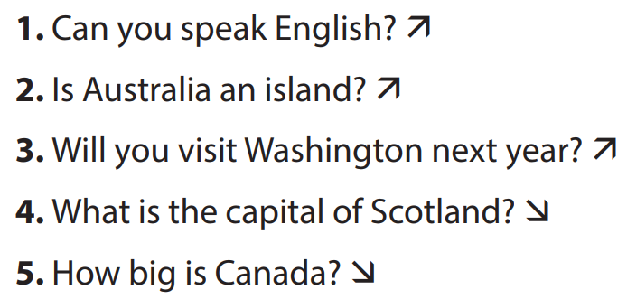  Task 5: Circle the correct intonation. Then listen and repeat. (p. 126)  Audio script  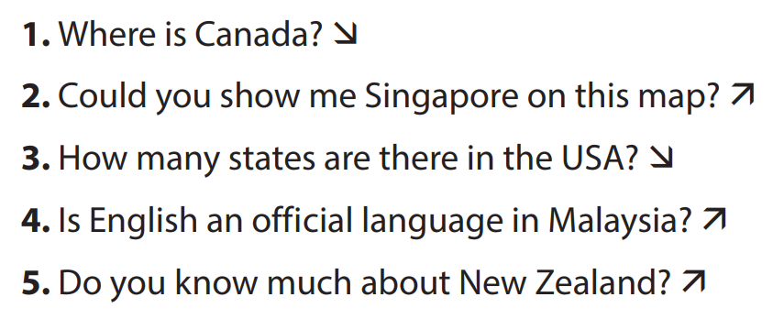
Activity 4. APPLICATION (7’-IW, PW, GW)
* Aim:
To test students' quick reaction to the targeted intonation.
* Content: Game: Up or Down?
* Product: Students’ answer.
* Implementation: Teacher’s instructions
Game: Up or Down?  * Teacher explains the rules:  - Teacher divides the class into 2 teams.  - Students will listen to questions which are made up from the words in the lesson.  - Students will have to stand up if it is a yes / no question and sit down if it is a wh-question.  - The team will receive minus points equivalent to the number of students who pose incorrect actions (stand up or sit down).  - The team with less minus points will be the winner.  ** Students play the game.  *** Teacher helps students in the game.  **** Teacher gives feedback. | Game: Up or Down?
* Wrap up  - To help Ss memorise the target language and skills that they have learned.  * Homework:  To review the vocabulary in this lesson and prepare for the incoming Project lesson.  - To prepare vocabulary for the next lesson: A closer look 1. | * Wrap up  - Teacher refers to the unit title again then together with students, orally list the names of English-speaking countries and their capital cities in the lesson.  * Homework:  To review the vocabulary in this lesson and prepare for the incoming Project lesson.- Exercises in the workbook
Planning date:
Teaching date:
PERIOD 96
UNIT 12: ENGLISH-SPEAKING COUNTRIES
LESSON 3: A CLOSER LOOK 2

I. OBJECTIVES: By the end of this unit, students will be able to gain the following things:
1. Knowledge:
- Understand the use of use articles
- Practice using articles correctly
+ Pronunciation: Ask questions with the correct rising and falling intonation.
+ Vocabulary: Use the words related to people and places in English-speaking countries.
+ Grammar: Articles: a/an/the
2. Competence:
a) General competencies:
- Students will be able to know more words and phrases about English speaking countries.
- Be collaborative and supportive in pair work and teamwork
- Actively join in class activities
b) Specific competencies:
- Group work and independent working, pair work, linguistic competence, cooperative learning and communicative competence.
- Sts can introduce themselves or one another fluently.
3. Qualities: The love of country; The awareness about importance of speaking English; Be ready to talk about English speaking countries.
- Develop self-study skills.
II. PREPARATIONS
Teacher: Grade 7 text book, laptop, TV, pictures and realia, Computer connected to the Internet, Sach mem.vn
Students: Text books, pencils, pics, blank papers, realia,….
III. PROCEDURE:
In each activity, each step will be represented as following:
* Task delivering
** Task performance
*** Report and discussion
**** Judgement
Activity 1. WARM UP (5’-IW, GW)
* Aim:
- To activate students’ prior knowledge related to the targeted grammar: the past simple.
* Content: Picture describing
* Product: Having a chance to speak English and focus on the topic of the lesson.
* Implementation: Teacher’s instructions…
Teacher’s & Student’s activities | Content
Picture describing  * Teacher asks students to describe the picture.    ** Students look at the picture and describe it.  *** Teacher and students discuss some sentences used to describe the picture:  **** Teacher corrects students answers if needed and confirms the use of articles “a/an” or “the” | Picture describing  - I see a clock. The clock is The Big Ben Clock Tower.  - I see two buses. The buses are double-decker ones.
Activity 2. KNOWLEDGE FORMATION (15'- PW, IW)
* Aim:
To teach students the use of articles “a/an” or “the”
* Content: Articles “a/an” or “the”
* Product: Ss learn how to use them.
* Implementation: Teacher’s instructions…
Teacher’s & Student’s activities | Content
* Articles: a/an/the  * Teacher lets students watch the following video and asks them to summarise the use of articles “a/an” or “the”:  https://www.youtube.com/watch?v=drTyYqbz6Xk  ** Teacher then asks students to study the grammar box and give some more examples.  *** Teacher and students discuss the examples.  **** Teacher confirms the answers and gives feedback. | * Articles: a/an/the  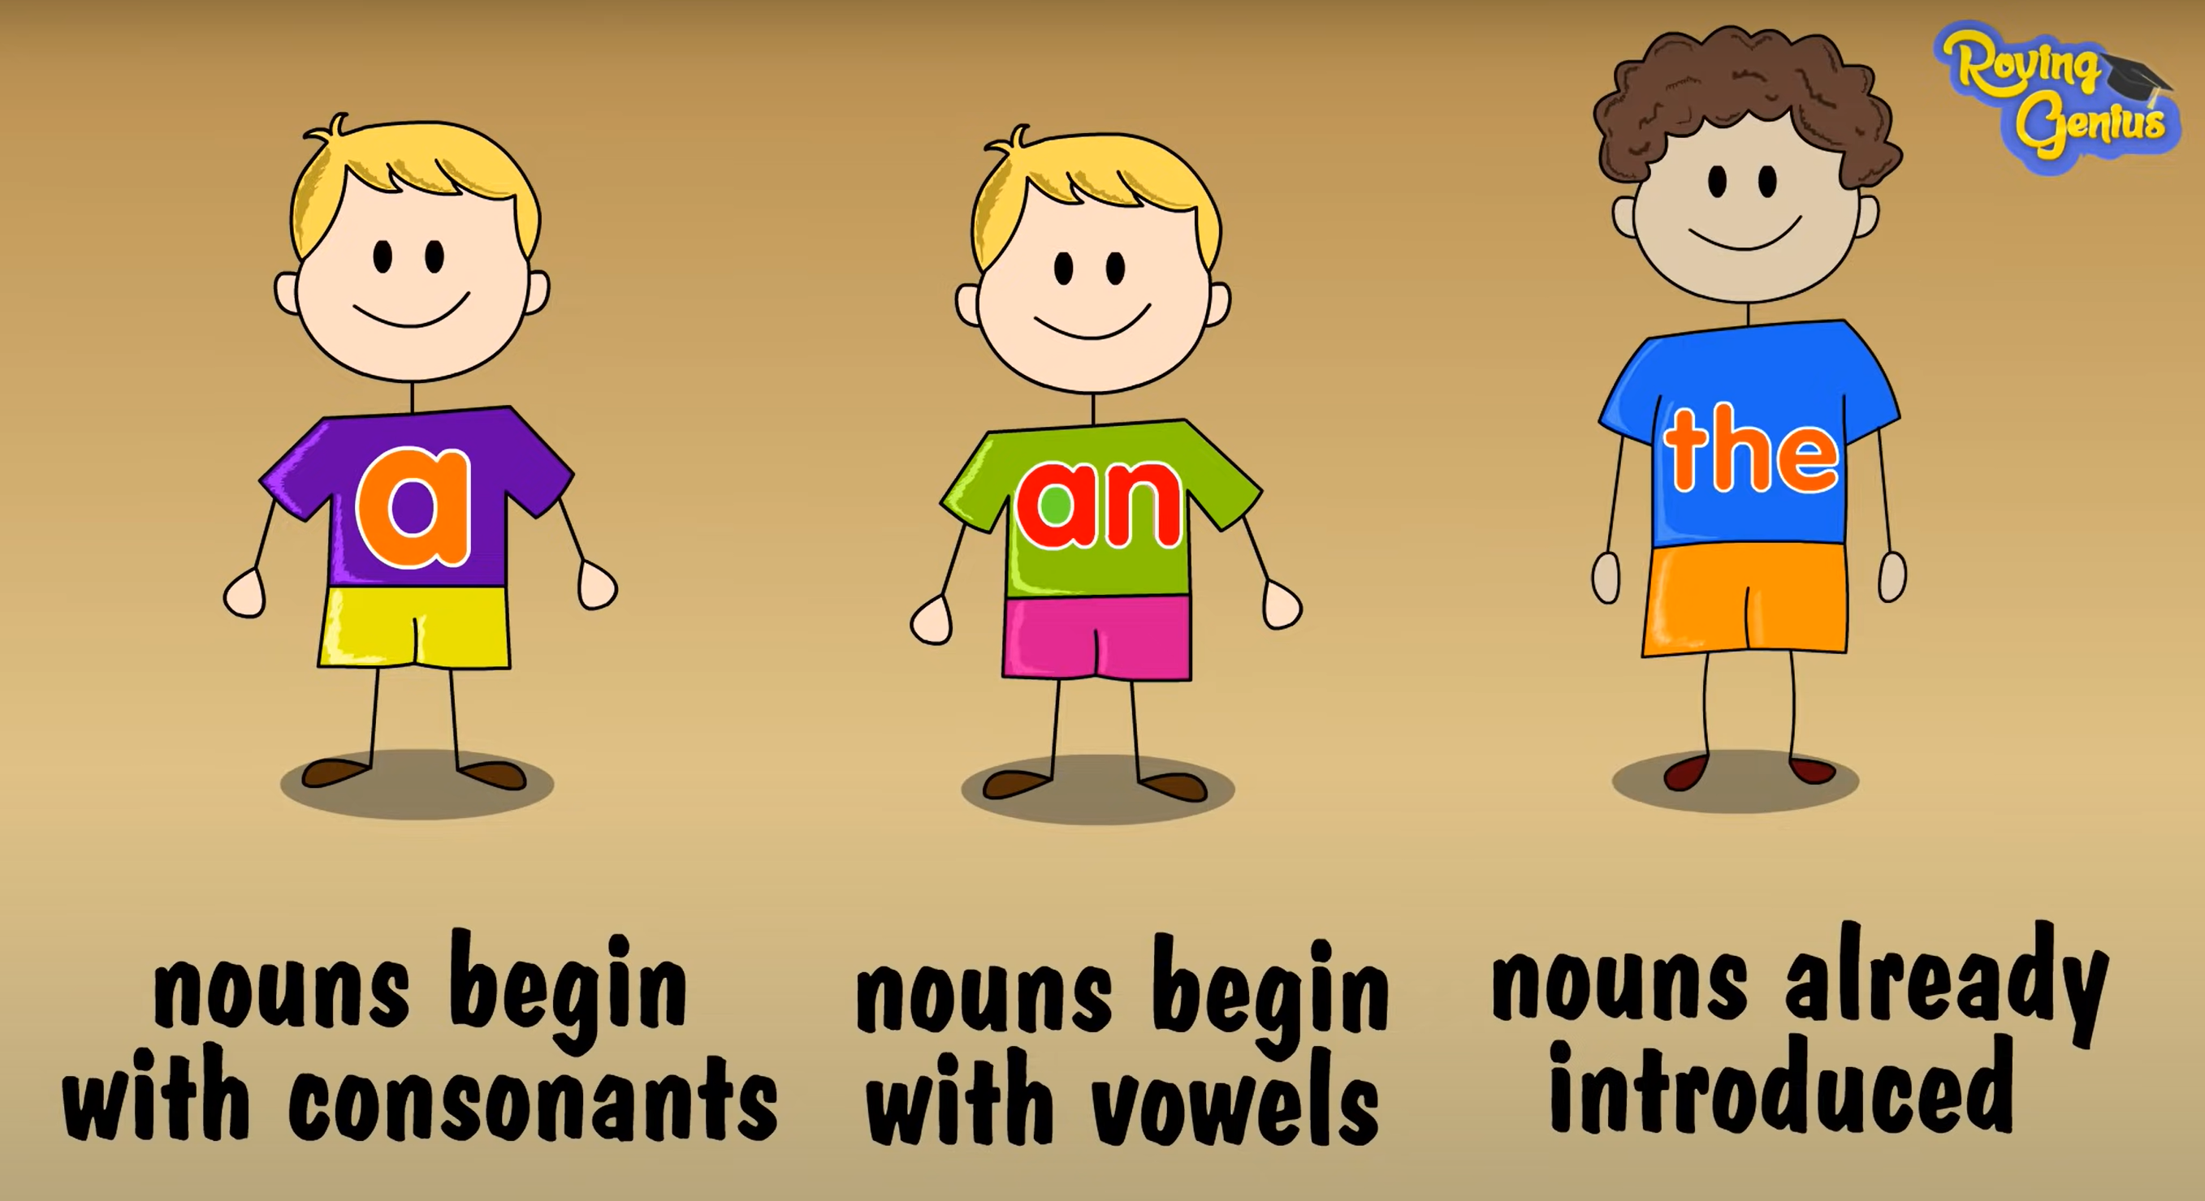
Activity 3. PRACTICE (15’-IW, PW, GW)
* Aim:
To help students revise the uses of articles they have learnt in Grade 6.
To help students practise the uses of the as presented in the Remember! box.
To teach students the use of articles with nationalities.

To give students further practice in articles.
* Product: Students’ answers.
* Implementation:
Teacher’s Student’s activities | Content
Task 1: Complete the sentences with “a / an” or “the” (p. 127)  * Teacher has students work individually.  ** Students work individually to complete sentences with the articles.  *** Teacher lets students work in pairs and exchange the answers before checking with the whole class (explain each sentence if necessary).  **** Teacher confirms the answers and gives feedback.  Task 2: Put in "the" where necessary. (p. 127)  * Teacher has students work individually.  ** Students work individually to complete the sentences.  *** Teacher lets students work in pairs and exchange the answers before checking with the whole class (explain each sentence if necessary).  **** Teacher confirms the answers and gives feedback.  Task 3: Put in “a / an” or “the”. (p. 127)  * Teacher allows students some time to read the table first, then do the exercise.  ** Students work in pairs to complete the task.  *** Teacher then has students compare their sentences. Teacher can go around to help students.  **** Teacher confirms the answers and gives feedback. (Note: The English, the Japanese, the French, but Australians, Canadians, Russians.)  Task 4: Complete the sentences with “a / an”, or “the” (p. 128)  * Teacher has students do this exercise individually.  ** Students complete the exercise individually.  *** Teacher lets students work in pairs and exchange the answers before checking with the whole class (explain each sentence if necessary).  **** Teacher confirms the answers and gives feedback. | Task 1: Complete the sentences with “a / an” or “the” (p. 127)  Answer key:  1. the  2. an  3. a  4. a  5. the  Task 2: Put in "the" where necessary. (p. 127)  Answer key:  1. The – x  2. x – the  3. the – the  4. the (SGV sai key)  5. the – the  Task 3: Put in “a / an” or “the”. (p. 127)  Answer key:  1. a  2. an  3. an  4. the  5. a  Task 4: Complete the sentences with “a / an”, or “the” (p. 128)  Answer key: (SGV sai key)  1. an  2. The  3. the  4. the  5. an  6. the
Activity 4. APPLICATION (7’-IW, PW, GW)
* Aim:
To provide students with more advanced practice in articles.
* Content: Game – Faster detective.
* Product: Students’ answer.
* Implementation: Teacher’s instructions
Task 5: Game – Faster detective.  * Teacher introduces the rules of the game:  - The class will be divided into 2 teams.  - Each team will have to detect errors in some sentences (if any) then make correction as fast as possible.  - The team with more correct answers will be the winner.  ** Students play the games.  *** Teacher lets the 2 teams discuss and give comments to their answers.  **** Teacher confirms the corrects answers and gives compliments to the winner. | Task 5: Game – Faster detective.  Answer key:  1. “What do you call a person from England?” – “The Englishman.”  Correct  - Edinburgh is a capital city of Scotland.  the  3. Queenstown is a amazingly beautiful town.  an  4. Are ancient castles an attraction of Scotland?  5. Where can you see a red telephone box?
* Wrap up  - To help Ss memorise the target language and skills that they have learned.  * Homework:  Reactivate the knowledge that students have gained.  - To prepare vocabulary for the next lesson: Communication. | * Wrap up  - Teacher asks students to summarise what they have learnt in the lesson.  - Teacher has them say out loud the articles.  * Homework:  To review the vocabulary in this lesson and prepare for the incoming Project lesson.  - Exercises in the workbook

Planning date:
Teaching date:
PERIOD 97
UNIT 12: ENGLISH-SPEAKING COUNTRIES
LESSON 4: COMMUNICATION

I. OBJECTIVES: By the end of this unit, students will be able to gain the following things:
1. Knowledge:
- Express amazement
- Know interesting facts about English-speaking countries
a. Vocabulary: vocabulary on the topic “English-speaking countries”.
b. Grammar: structures to express amazement.
2. Competence:
a) General competencies:
- Students will be able to know more words and phrases about English speaking countries.
- Be collaborative and supportive in pair work and teamwork
- Actively join in class activities
b) Specific competencies:
- Group work and independent working, pair work, linguistic competence, cooperative learning and communicative competence.
- Sts can introduce themselves or one another fluently.
3. Qualities: The love of country; The awareness about importance of speaking English; Be ready to talk about English speaking countries.
- Develop self-study skills.
II. PREPARATIONS
Teacher: Grade 7 text book, laptop, TV, pictures and realia, Computer connected to the Internet, Sach mem.vn
Students: Text books, pencils, pics, blank papers, realia,….
III. PROCEDURE:
In each activity, each step will be represented as following:
* Task delivering
** Task performance
*** Report and discussion
**** Judgement
Activity 1. WARM UP (5’-IW, GW)
* Aim:
To introduce the topic of the lesson.
* Content: Guessing the remaining of the picture
* Product: Having a chance to speak English and focus on the topic of the lesson.
* Implementation: Teacher’s instructions…
Teacher’s & Student’s activities | Content
Guessing the remaining of the picture
* Teacher asks students to guess the remaining of the picture:
- Who are wearing these skirts?
- Do you know the name of this kind of skirt?

** Students answer the questions.
*** Teacher and students discuss the answers.
**** Teacher confirms the answers, reveals the remaining of the picture and provide more information on the Scottish kilts.

Activity 2. KNOWLEDGE FORMATION (15'- PW, IW)
* Aim:
To introduce two ways to express amazement.
* Content: Express amazement.
* Product: Ss learn how to use them.
* Implementation: Teacher’s instructions…
Teacher’s & Student’s activities | Content
Giving compliments  Task 1: Listen and read the conversations, paying attention to the highlighted parts. (p. 128)  * Teacher plays the recording for students to listen and read the conversations and asks students to pay attention to the highlighted parts.  ** Students pay attention to the highlighted parts.  *** Teacher elicits the expressions of amazement.  **** Teacher confirms the answers and gives feedback. | Giving compliments  Task 1: Listen and read the conversations, paying attention to the highlighted parts. (p. 128)  2 ways to express amazement:  - Wow ... I didn’t know that!  - Amazing!
Activity 3. PRACTICE (15’-IW, PW, GW)
* Aim:
To introduce to students two ways to express amazement and to provide them some practice.
To help students learn some facts about English-speaking countries through a quiz.
To provide students with more facts about English-speaking countries and encourage interaction through responding.
* Product: Students’ answers.
* Implementation:
Teacher’s Student’s activities | Content
Task 2: Work in pairs. Make similar dialogues with the following situations, using expressions of amazement. (p. 128)  * Teacher has students work in pairs to make similar dialogues.  ** Students work in pairs to make similar dialogues, using the contexts given:  *** Teacher asks some pairs to practice the dialogue so that the whole class can give comments.  **** Teacher gives feedback as a class.  Interesting facts about English-speaking countries  Task 3: Work in groups. Discuss and write the name of the country next to the fact. (p. 129)  * Teacher has students work in groups to read the facts, discuss, and do the matching.  ** Students work in groups to complete the task.  *** Teacher has the groups cross check and discuss.  **** Teacher gives feedback and correction (if needed)  Task 4: Work in pairs. Read some facts about English-speaking countries and tick the column true for you. Then role play by one person saying one statement aloud and the other responding to it. (p. 129)  * Teacher asks students to read the instructions, then the example to know what they have to do.  ** Students work in pairs read the facts and tick the column true for them, then take turns with one saying a fact aloud and the other responding with his / her answer.  *** Teacher calls on 2 - 3 pairs to role-play in front of the class.  **** Teacher corrects any grammar or pronunciation mistakes if necessary. | Task 2: Work in pairs. Make similar dialogues with the following situations, using expressions of amazement. (p. 128)  - New Zealand has the cleanest and safest air on the planet.  - There are no snakes in New Zealand.  - More than half of all the lakes in the world are in Canada.  Interesting facts about English-speaking countries  Task 3: Work in groups. Discuss and write the name of the country next to the fact. (p. 129)  Answer key:  1. Australia  2. The USA  3. Canada  4. The UK  5. New Zealand  Task 4: Work in pairs. Read some facts about English-speaking countries and tick the column true for you. Then role play by one person saying one statement aloud and the other responding to it. (p. 129)  Example:  A: New York is the biggest city but not the capital of the USA.  B: I know this.  A: The state of Alaska in the USA has over 2,600 islands.  B: This is new to me.
Activity 4. APPLICATION (7’-IW, PW, GW)
* Aim:
To encourage students to share what they know about English-speaking countries with the class.
* Content: Some interesting facts you know about English-speaking countries.
* Product: Students’ answer.
* Implementation: Teacher’s instructions
Task 5: Work in groups. Share with your group some interesting facts you know about English-speaking countries. The group takes notes and presents its findings to the class. (p. 129)  * Teacher asks students work in groups and allows them time to think about a fact they know and how to say it.  ** Students share the facts in the group. The group leader takes notes of the facts. Some Ss may repeat facts which have previously appeared in the unit. This is also a revision activity.  *** Teacher calls on group representatives to share the facts with the class.  **** Teacher gives feedback on their reports. | Task 5: Work in groups. Share with your group some interesting facts you know about English-speaking countries. The group takes notes and presents its findings to the class. (p. 129)  Answer:  A: There are more sheep than people in New Zealand, around 6 sheep per person.  B: I know this.  A: Canada has the longest coastline in the world  B: This is new to me.
* Wrap up  - To help Ss memorise the target language and skills that they have learned.  * Homework:  - Reactivate the knowledge that students have gained.  - To prepare vocabulary for the next lesson: Skills 1. | * Wrap up  - Teacher asks students to summarise what they have learnt in the lesson.  - Teacher has them say out loud the articles.  * Homework:  - Prepare some photos of your favourite English-speaking country.  - Exercises in the workbook

Planning date:
Teaching date:
PERIOD 98
UNIT 12: ENGLISH-SPEAKING COUNTRIES
LESSON 5: SKILLS 1

I. OBJECTIVES: By the end of this unit, students will be able to gain the following things:
1. Knowledge:
- Develop reading skill for specific information about New Zealand
- Develop speaking skill: talk about Scotland
a. Vocabulary: vocabulary on the topic “English-speaking countries”.
1. shining (adj)
2. historic (adj)
3. rich (adj)
b. Grammar:
2. Competence:
a) General competencies:
- Students will be able to know more words and phrases about English speaking countries.
- Be collaborative and supportive in pair work and teamwork
- Actively join in class activities
b) Specific competencies:
- Group work and independent working, pair work, linguistic competence, cooperative learning and communicative competence.
- Sts can introduce themselves or one another fluently.
3. Qualities: The love of country; The awareness about importance of speaking English; Be ready to talk about English speaking countries.
- Develop self-study skills.
II. PREPARATIONS
Teacher: Grade 7 text book, laptop, TV, pictures and realia, Computer connected to the Internet, Sach mem.vn
Students: Text books, pencils, pics, blank papers, realia,….
III. PROCEDURE:
In each activity, each step will be represented as following:
* Task delivering
** Task performance
*** Report and discussion
**** Judgement
Activity 1. WARM UP (5’-IW, GW)
* Aim:
To introduce the topic of the lesson.
* Content: Guessing: What country is it?
* Product: Having a chance to speak English and focus on the topic of the lesson.
* Implementation: Teacher’s instructions…
Teacher’s & Student’s activities | Content
Guessing: What country is it?
* Teacher asks students to watch a video about the introduction of a country and ask them to guess the name of the country.
** Students watch the video and raise hands to answer the question.
*** Teacher and students discuss the answers.
**** Teacher confirms the answers and gives feedback.
Video link: https://www.youtube.com/watch?v=jP3x7pcKIPY

Activity 2. KNOWLEDGE FORMATION (15'- PW, IW)
* Aim:
To provide students with some lexical items before reading the text.
To lead in the text about New Zealand
* Content: Vocabulary
* Product: Ss learn how to use them.
* Implementation: Teacher’s instructions…
Teacher’s & Student’s activities | Content
Vocabulary  * Teacher introduces the vocabulary.  ** Teacher asks students to get the meaning in context and try to make up sentences with of the following words:  *** Teacher and students discuss the answers.  **** Teacher confirms student’s answers and checks their pronunciation and gives feedback.  Task 1: Work in pairs. Discuss and choose the correct answer A, B, or C. (p. 130).  * Teacher students to work in pairs to discuss and answer the questions.  ** Students work in pairs to complete the task.  *** Students discuss the answers.  **** Teacher asks some pairs to share their answers. (Don’t confirm the answers. Leave them till the end of the reading.) | Vocabulary  1. shining (adj)  2. historic (adj)  3. rich (adj)  Task 1: Work in pairs. Discuss and choose the correct answer A, B, or C. (p. 130).  Answer key:  1. A  2. B
Activity 3. PRACTICE (15’-IW, PW, GW)
* Aim:
To help students develop their reading skill of guessing the meaning of a word by using its context.
To help students develop their reading skill for specific information (scanning).
To give students an opportunity to express their own feelings about what they personally like about New Zealand.
To provide an opportunity for students to practise introducing a country.
* Product: Students’ answers.
* Implementation:
Teacher’s Student’s activities | Content
Task 2: Read the passage and match the words in bold from the passage (1-4) with their meanings (a-d). (p. 130)  * Teacher asks students to work individually to read the passage and find the highlighted words.  ** Students read the text in detail, paying attention to the words in bold.  *** Teacher asks students to read the sentences where the words appear, and before and after it.  **** Teacher calls some students hare their answers then check the answers as a class.  Task 3: Read the passage again and choose the correct answer A, B, or C. (p. 130)  * Teacher asks some students to do the task individually: read each question, locate where it appears in the text, read that part carefully and circle the correct answer.  ** Students work individually to complete the task.  *** Teacher allows students to share their answers before discussing as a class and encourages them to give evidence.  **** Teacher calls a student to write his/her answer on the board, then check the answers as a class. | Task 2: Read the passage and match the words in bold from the passage (1-4) with their meanings (a-d). (p. 130)  Answer key:  1. c  2. d  3. a  4. b  Task 3: Read the passage again and choose the correct answer A, B, or C. (p. 130)  Answer key:  1. C  2. B  3. B  4. A  5. C
Task 4: Work in pairs. Note two things you like about New Zealand. Share them with your partner. (p. 130)  * Teacher allows students to work individually first, referring (if necessary) to the text and list the two things they like most about New Zealand.  ** Students work in pairs to to share their ideas with their partners, using use the suggested opening provided.  *** Students should give some reasons for their choice.  **** Teacher listens and passes positive comments. | Task 4: Work in pairs. Note two things you like about New Zealand. Share them with your partner. (p. 130)  Suggestion for the opening:  There are two things I like about New Zealand. For such a small country, it really does pack a punch. Nearly every type of landscape is represented here, from beaches to rolling hills to volcanic deserts to mountains to temperate rainforests. You can hop in a car, drive for an hour or two, and feel like you're on a completely different planet. Other countries around the world may have diverse landscapes, but I've yet to find one that takes my breath away quite like New Zealand.
Activity 4. APPLICATION (7’-IW, PW, GW)
* Aim:
To help students improve next time.
To help some students enhance presentation skill
* Content:
* Product: Students’ answer.
* Implementation: Teacher’s instructions
* Teacher allows students to give comments for their friends and vote for the most interesting and informative presentation.
** Students give comments for their friends and vote for the most interesting and informative presentation.
*** Teacher and students discuss the presentations.
**** Teacher gives feed-back and comments.
* Wrap up  - To help Ss memorise the target language and skills that they have learned.  * Homework:  - Reactivate the knowledge that students have gained.  - To prepare vocabulary for the next lesson: Skills 2. | * Wrap up  - Teacher asks students to summarise what they have learnt in the lesson.  - Teacher has them say out loud the articles.  * Homework:  - Prepare some photos of your favourite English-speaking country.  - Exercises in the workbook

Planning date:
Teaching date:
PERIOD 99
UNIT 12: ENGLISH-SPEAKING COUNTRIES
LESSON 6: SKILLS 2

I. OBJECTIVES: By the end of this unit, students will be able to gain the following things:
1. Knowledge:
- Listen for specific information about a tour of a city;
- Write a diary entry about a tour of a city.
a. Vocabulary: vocabulary on the topic “English-speaking countries”.
b. Grammar:
2. Competence:
a) General competencies:
- Students will be able to know more words and phrases about English speaking countries.
- Be collaborative and supportive in pair work and teamwork
- Actively join in class activities
b) Specific competencies:
- Group work and independent working, pair work, linguistic competence, cooperative learning and communicative competence.
- Sts can introduce themselves or one another fluently.
3. Qualities: The love of country; The awareness about importance of speaking English; Be ready to talk about English speaking countries.
- Develop self-study skills.
II. PREPARATIONS
Teacher: Grade 7 text book, laptop, TV, pictures and realia, Computer connected to the Internet, Sach mem.vn
Students: Text books, pencils, pics, blank papers, realia,….
III. PROCEDURE:
In each activity, each step will be represented as following:
* Task delivering
** Task performance
*** Report and discussion
**** Judgement
Activity 1. WARM UP (5’-IW, GW)
* Aim:
To introduce the topic of the lesson.
* Content: Guessing game: What city is it?
* Product: Having a chance to speak English and focus on the topic of the lesson.
* Implementation: Teacher’s instructions…
Teacher’s & Student’s activities | Content
Guessing game: What city is it?
* Teacher divides the class into 2 teams. Each team will guess the the name of the city based on pictures given gradually by the teacher.
** Students play the guessing game.
*** The team with correct answer will be the winner.
**** Teacher introduces the topic of the listening task: A tour around London.
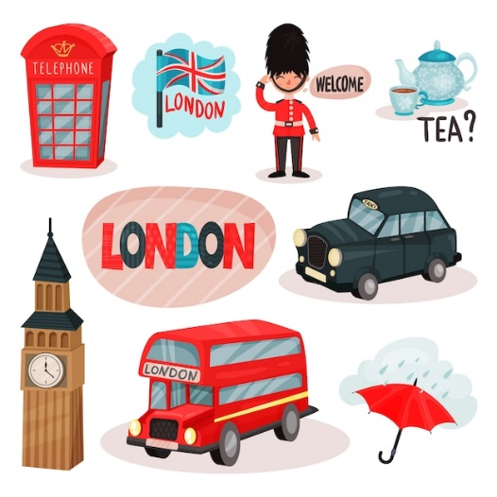
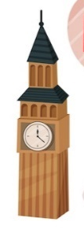

Activity 2. KNOWLEDGE FORMATION (15'- PW, IW)
* Aim:
To prepare students for the listening by introducing two key phrases visually.
* Content:
* Product: Ss learn how to use them.
* Implementation: Teacher’s instructions…
Teacher’s & Student’s activities | Content
Task 1: Work in groups. Match the phrases to the pictures (p. 131)  * Teacher asks students work in groups to read the phrases and match them to the pictures.  ** Students discuss with partners.  *** Teacher elicits as many learnt vocabularies as possible and asks one or two students to re-describe the pictures to the class.  **** Teacher gives feedback and introduces the topic of the listening task: A tour around London. | Task 1: Work in groups. Match the phrases to the pictures (p. 131)  Answer key:  1. Changing of the Guard  2. Buckingham Palace
Activity 3. PRACTICE (15’-IW, PW, GW)
* Aim:
To help students develop their skill of listening for specific information, in this case: times.
To help students further develop their listening skill for specific information.
To help students summarise the content of the listening in notes.
To teach students how to write a diary entry about a tour they have taken.
* Product: Students’ answers.
* Implementation:
Teacher’s Student’s activities | Content
Task 2: A tour guide is talking about the schedule for a day trip in London. Listen and fill in the times. (p. 131)  * Teacher helps students revise the use of time in the listening and note taking skills by saying 3 - 4 different times for students to write down.  ** Teacher has students read the questions quickly. This helps students get some ideas of what they are going to listen to as well as determine the information they need for answering the questions.  *** Teacher has students exchange answers in pairs, invites some pairs to read their answers and confirm the correct ones  **** Teacher confirms the answers and gives feedback.  Task 3: Listen again and complete each sentence with ONE word. (p. 131)  * Teacher has students read the questions and determine what information they need for answering the questions, reminds them that the questions ask for one-word answers.  ** Teacher plays the recording again twice for students to listen and complete the sentences.  *** Teacher has students exchange answers in pairs, invites some pairs to say their answers and confirm the correct ones.  **** Teacher plays the recording again if needed, stopping at each place where the answers appear. | Task 2: A tour guide is talking about the schedule for a day trip in London. Listen and fill in the times. (p. 131)  Answer key:  1. 11:30 a.m.  2. 1:00 p.m.  3. 3:15 p.m.  4. 5:00 p.m.  Task 3: Listen again and complete each sentence with ONE word. (p. 131)  Answer key:  1. Queen  2. garden  3. Clock  4. photos  5. attractions
Task 4: Work in pairs. Fill in the table with information about the London tour. (p. 131)  * Teacher asks students to work in pairs, lets them read the table and decide what information they need to complete the table.  ** Students do the task within 4-5 minutes.  *** Teacher invites some pairs to share their answers with the class  **** Teacher gives feedback and provides suggested answers. | Task 4: Work in pairs. Fill in the table with information about the London tour. (p. 131)    Suggested answers:  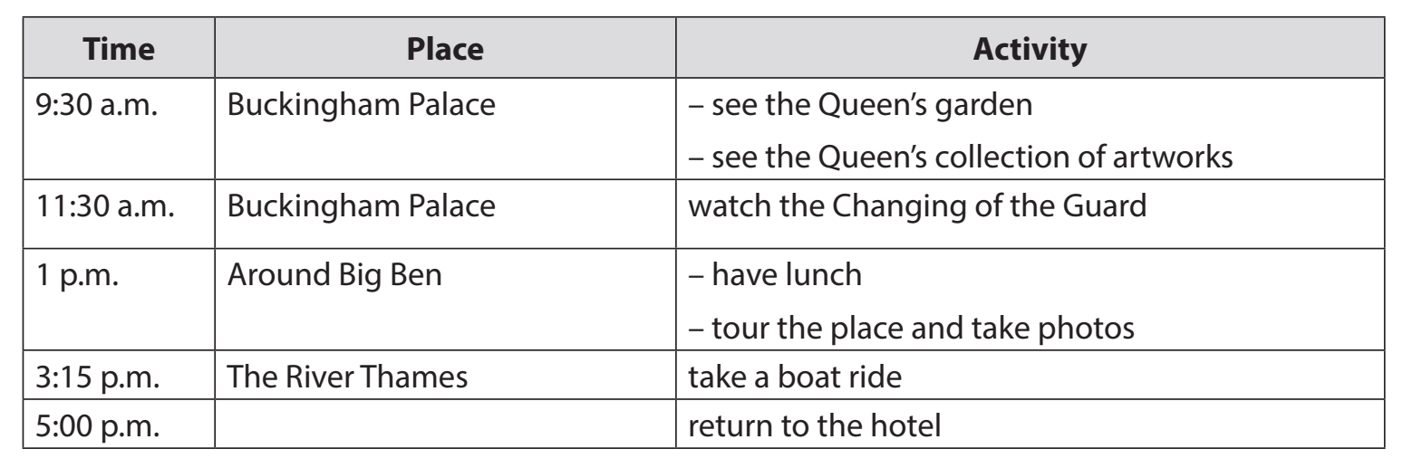
Task 5: Imagine that you took the tour of London. Write a diary entry of about 70 words about your tour, based on the table in 4 or use your imagination. (p. 131)  * Teacher explains to students what a diary entry is: It is a description of what you do during a tour and how you feel about it.  ** Students refer to the table in 4 for information. They can write about everything or just choose the activities they like most.  *** Teacher allows students to peer check first.  **** Teacher goes around to help (if necessary). | Task 5: Imagine that you took the tour of London. Write a diary entry of about 70 words about your tour, based on the table in 4 or use your imagination. (p. 131)  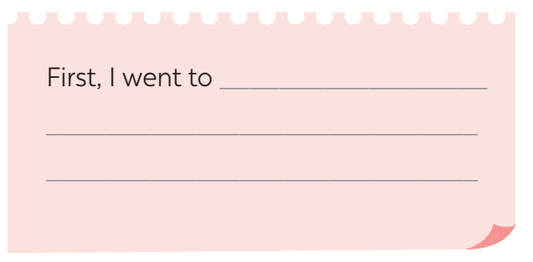  Suggested answers:  The tour of London began at 9:30 a.m. First, we went to Buckingham Palace. We visited the Queen’s Garden and saw her collection of artworks. At 11:30 a.m. we watched the Changing of the Guard. We then went to Big Ben. We took a lot of photos there. At 3:15 p.m., we took a boat ride on the River Thames. We saw many historic attractions along the river. I enjoyed the tour very much.
Activity 4. APPLICATION (7’-IW, PW, GW)
* Aim:
To peer check, cross check and final check students’ writing.
* Content:
* Product: Students’ answer.
* Implementation: Teacher’s instructions
Giving peer-reflection & evaluation
* Teacher asks students to work in groups of four and swap the entries to their group members.
** Students can give comment to others’ work.
*** Students then give comments to each other.
**** Teacher then gives feedback as a class discussion.
* Wrap up  - Teacher asks students to talk about what they have learnt in the lesson.  * Homework:  - To allow students finalize their paragraph after being checked by friends and the teacher. | * Wrap up  - Teacher asks students to summarise what they have learnt in the lesson.  - Teacher has them say out loud the articles.  * Homework:  - Rewrite the diary on your notebook.  - Prepare for the next lesson (Unit 3-Lesson 7: Looking back and Project)

Planning date:
Teaching date:
PERIOD 100
UNIT 12: ENGLISH-SPEAKING COUNTRIES
LESSON 7: LOOKING BACK & PROJECT

I. OBJECTIVES: By the end of this unit, students will be able to gain the following things:
1. Knowledge:
- Review the vocabulary and grammar of Unit 12
- Apply what they have learnt (vocabulary and grammar) into practice through a project
a. Vocabulary: vocabulary on the topic “English-speaking countries”.
b. Grammar:
2. Competence:
a) General competencies:
- Students will be able to know more words and phrases about English speaking countries.
- Be collaborative and supportive in pair work and teamwork
- Actively join in class activities
b) Specific competencies:
- Group work and independent working, pair work, linguistic competence, cooperative learning and communicative competence.
- Sts can introduce themselves or one another fluently.
3. Qualities: The love of country; The awareness about importance of speaking English; Be ready to talk about English speaking countries.
- Develop self-study skills.
II. PREPARATIONS
Teacher: Grade 7 text book, laptop, TV, pictures and realia, Computer connected to the Internet, Sach mem.vn
Students: Text books, pencils, pics, blank papers, realia,….
III. PROCEDURE:
In each activity, each step will be represented as following:
* Task delivering
** Task performance
*** Report and discussion
**** Judgement
Activity 1. WARM UP (5’-IW, GW)
* Aim:
- To revise the vocabulary related to the topic and lead in the next part of the lesson.
* Content: Video watching:
* Product: Having a chance to speak English and focus on the topic of the lesson.
* Implementation: Teacher’s instructions…
Teacher’s & Student’s activities | Content
Video watching:  How many English-speaking countries are there? What are they?  * Teacher lets students watch a video and ask them the questions:  - How many English-speaking countries are there in the video?  - What are they?  ** Students watch the video, note down the names and the number of English-speaking countries.  *** Teacher and students discuss the answers.  **** Teacher confirms the answers as a class. | Video watching:  How many English-speaking countries are there? What are they?  Video link: https://ejoy-english.com/go/intl/vi/video/6-english-speaking-countries/60729  Answer key:  1. There are 6 English-speaking countries in the video.  2. They are:  - The Philippines  - Australia  - Republic of Ireland  - Canada  - The USA  The UK
Activity 2. KNOWLEDGE FORMATION (10'- PW, IW)
* Aim:
To help students revise the vocabulary (nouns showing things and places) they have learnt in the unit.
* Content:
* Product: Ss learn how to use them.
* Implementation: Teacher’s instructions…
Teacher’s & Student’s activities | Content
VOCABULARY  Task 1: Look at the pictures and write the correct words or phrases to complete the sentences. (p. 132)  * Teacher asks students to work in pairs, has students read the sentences and see if they can find the equivalent words illustrated by the pictures.  ** Students do the task in pairs.  *** Students exchange their answers with their partners.  **** Teacher gives feedback as a class discussion. | VOCABULARY  Task 1: Look at the pictures and write the correct words or phrases to complete the sentences. (p. 132)  Answer key:  1. island  2. castle  3. boat ride  4. tattoos  5. coastline
Activity 3. PRACTICE (15’-IW, PW, GW)
* Aim:
To help students revise more key vocabulary they have learnt in the unit.
To help students revise the use of articles.
To help students recognise mistakes in the use of the articles and correct them.
* Product: Students’ answers.
* Implementation:
Teacher’s Student’s activities | Content
VOCABULARY  Task 2: Choose the best answer A, B, or C to complete each sentence. (p. 132)  * Teacher asks students to to complete the task individually.  ** Students do the task individually complete the sentences.  *** Students exchange their textbooks with their partners.  **** Teacher gives feedback as a class discussion.  GRAMMAR  Task 3: Complete the sentences with "a / an" or "the". (p. 132)  * Teacher encourages students to complete the task individually.  ** Students complete the passage with "a / an" or "the".  *** Students exchange their textbooks with their partners.  **** Teacher gives feedback as a class discussion.  Task 4: Underline and correct the article mistakes in the sentences below. (p. 132)  * Teacher asks students to do this exercise in pairs.  ** Students read each sentence carefully and discuss to find out which article is incorrect, then correct it.  *** Teacher then asks them to check their answers with a partner before discussing the answers as a class.  **** Teacher confirms the answers and explains if necessary. | VOCABULARY  Task 2: Choose the best answer A, B, or C to complete each sentence. (p. 132)  Answer key:  1. A  2. B  3. B  4. C  5. A  GRAMMAR  Task 3: Complete the sentences with "a / an" or "the". (p. 132)  Answer key:  1. the – the  2. A – a  3. the – the  4. a – the  5. An – an  Task 4: Underline and correct the article mistakes in the sentences below. (p. 132)  Answer key:  1. Ottawa is a capital of Canada. → the  2. He’s the Englishman. He lives in Oxford. → an  3. When people travel, they use an map to find their ways round. → a  4. Can you see a Big Ben from where you are standing? → the  5. Canadians love ice hockey, the winter sport. → a
Activity 4. APPLICATION (12’-IW, PW, GW)
* Aim:
To guide students how to find information for a poster introducing a place in an English-speaking country.
* Content:
* Product: Students’ answer.
* Implementation: Teacher’s instructions
Posters exhibition:  * Teacher has students work in groups and gives instructions to students as follow:  - Discuss and choose a place in an English-speaking country.  - Find information about it, including:  - its name  - its location  - its attractions  ** Students do the project in groups.  *** Students vote for the best poster.  **** Teacher gives feedback. | Posters exhibition:  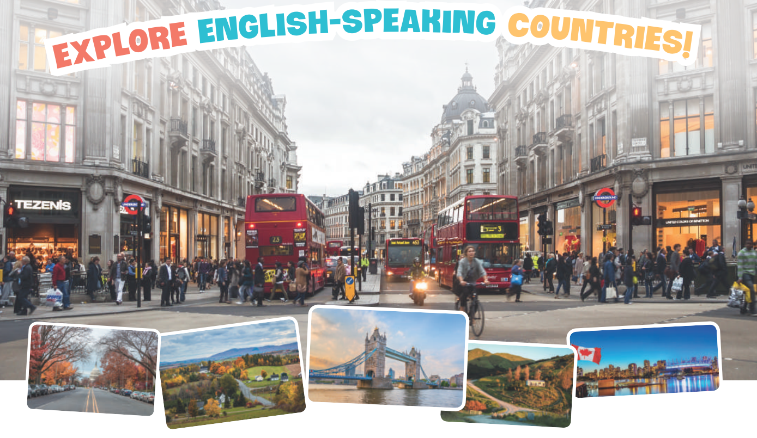
* Wrap up  - Teacher asks students to talk about what they have learnt in the lesson.  * Homework:  - To allow students finalize their paragraph after being checked by friends and the teacher. | * Wrap up  - Teacher asks students to summarise what they have learnt in the lesson.  - Teacher has them say out loud the articles.  * Homework:  - To prepare for the next lesson.

Planning date:
Teaching date:
PERIOD 101
REVIEW 4
LANGUAGE

I. OBJECTIVES:
By the end of this review, Ss will have revised the language they have learnt and the skills they have practised in Units 10 -12.
1. Knowledge:
- To revise the language and skills they have learnt in Unit 10-11-12;
+ Vocabulary: Ss revise the words related to types of energy sources; the future means of transport; and words related to the people and places in English-speaking countries.
+ Grammar: Revise the present continuous; how to ask for explanations; the future simple to talk about future activities and make predictions; how to use possessive pronouns correctly; Revise how to use articles correctly; how to express amazement.
+ Pronunciation: Pronounce three-syllable words with correct stress; say sentences with correct stress, ask questions with the correct rising and falling intonation.
2. Competence:
a) General competencies:
- Develop communication skills and cultural awareness’ Be collaborative and supportive in pair work and teamwork; Actively join in class activities.
b) Specific competencies:
- Group work and independent working, pair work, linguistic competence, cooperative learning and communicative competence.
- Ability of using the present continuous, the future simple.
- Raise students’ awareness of the need to save energy at home.
3. Qualities: - Raise students’ awareness of the need to save energy at home; Have the good attitude to working in groups, individual work, pair work; cooperative learning. Develop self-study skills.
II. PREPARATIONS
Teacher: Grade 7 text book, laptop, TV, pictures and realia, Computer connected to the Internet. Sach mem.vn
Students: Text books, pencils, pics, blank papers, realia,….
III. PROCEDURE:
In each activity, each step will be represented as following:
* Task delivering
** Task performance
*** Report and discussion
**** Judgement
Activity 1. WARM UP (5’-IW, GW)
* Aim: Introduction
- By the end of this review, students will have revised the language they have learnt and the skills they have practiced in Units 10 – 12.
- Ss revise what they have learnt so far in terms of language and skills.
- Summarize their answers in notes and write them in a top corner of the board. Briefly revise some important / difficult ones before starting the review.
* Content: Having some warm-up activities to create a friendly and relaxed atmosphere to inspire Ss to warm up to the new lesson.
* Product: Having a chance to speak English; Revision.
* Implementation: Teacher’s instructions…...
Teacher’s & Student’s activities | Content
+ Greeting  + Revision on the old lessons  * Teacher divides class into 3 big groups to draw a mindmap related to the knowledge they have learnt in Unit 7, 8, 9.  ** Ss do the task in group.  *** Teacher calls on some students to present their answer based on the mindmap.  **** Other Ss comment and teacher con-firms. | Mind map  
Activity 2. KNOWLEDGE FORMATION (10'- PW, IW)
A. LANGUAGE:
* Pronunciation
* Aim: To help Ss review the pronunciation of the sounds learnt in Units 10 - 12.
* Content: Mark (') the stressed syllables in the underlined words. Then listen, check, and repeat.
* Product: Answer keys
* Implementation: Teacher’s instructions…..
Teacher’s & Student’s activities | Content
* Teacher reminds Ss how to stress on two – and three – syllable words. Then, ask Ss to read the underlined words in the sentences and mark the stress syllables.  ** Ss do the task individually.  *** Teacher calls on some Ss to give their answers, then plays the recording for Ss to listen and check their answers.  **** Teacher confirms and plays the recording again for Ss to listen and repeat in chorus and then individually. | VOCABULARY  Task 1: Mark (') the stressed syllables in the underlined words. Then listen, check, and repeat. (Ex 1, p. 134)  Answer keys:  1. 'Driverless trains will be 'popular.  2. Niagara Falls is Canada’s most famous  ‘natural at’traction.  3. We can save 'energy by re'cycling.  4. All plants and ‘animals need ‘energy  5. He’s reading Guidance for Visitors to  Scotland.
Activity 3. PRACTICE (15’-IW, PW, GW)
Vocabulary & Grammar
* Aim:
- To help Ss recognize the words through their definitions Units 10 - 11 - 12.
- To help Ss revise some key adjectives from Units 10 - 12 and use them in context.
- To help students review the use of the articles a/an and the.
- To help Ss revise the use of the present continuous and the future simple
* Content:
- Write the words in the box next to their definitions.
- Complete the sentences with the words below.
- Use the correct tense and form of each verb in brackets to complete the sentence.
* Product: Answer key
* Implementation:
* Teacher has Ss do the task independently to do matching.  ** Ss do the task individually, teacher reminds them highlight the key words to help them with the matching.  *** Teacher calls on some Ss to check.  **** Teacher confirms the correct answers. | Task 2: Write the words in the box next to their definitions. (Ex. 2, p. 134)  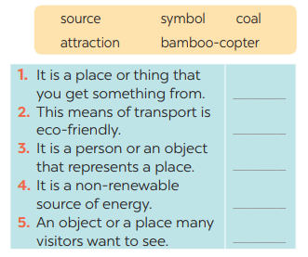  Answer keys:  1. sunlight  2. bamboo-copter  3. tour  4. coal  5. attraction
3. Complete the sentences with the words and phrases below.  * Teacher asks Ss to read the adjectives in the box to do the exercise.  ** Ss works independently to do the task.  *** Teacher calls on some Ss to check.  **** Teacher confirms the correct answers. | Task 3: Complete the sentences with the words below. (Ex. 3, p. 134)  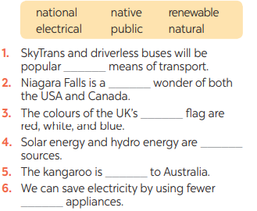  Answer keys:  1. public  2. natural  3. national  4. renewable  5. native  6. electrical
* Teacher asks Ss to read the sentences first and underline the signals to help them decide if the verbs are used in the present continuous or future simple.  ** Ss do the task individually.  *** Teacher calls on some Ss to check.  **** Teacher confirms. | GRAMMAR:  Task 4: Use the correct tense and form of each verb in brackets to complete the sentence. (Ex. 4, p. 134)  Answer keys:  1. is doing  2. will visit  3. is building  4. will use  5. will have
Activity 4. APPLICATION (10’-IW, PW, GW)
Grammar
* Aim:
- To help Ss identify the wrong use of the articles and correct them.
* Content: Find and cross (––) ONE incorrect article in each sentence and write the correct one.
* Product: Answer key
* Implementation:
Teacher’s & Student’s activities | Content
* Teacher asks Ss to read the sentences first and underline all the articles in each sentence, then look at each article and the word it goes with and decide if it is used correctly.  ** Ss do the task individually.  *** Teacher calls on some Ss to check.  **** Teacher confirms. | Task 5: Find and cross (––) ONE incorrect article in each sentence and write the correct one. (Ex. 5, p. 134)  Answer key:  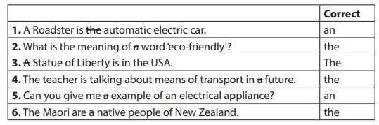
Activity 5. WRAP-UP & HOME WORK (2’)
* Aim: To consolidate what students have learnt in the lesson.; To prepare vocabulary for the next lesson.
* Content: Home assignment.
* Product: Take home assignment.
* Implementation:
- Ask Ss what they have learnt so far. Have them recall the important grammar points, Vocabulary; Pronunciation
* HOME WORK
- Read again the conversation
- Do more exercises in workbook.
- Prepare for Review 4 – Skills.

Planning date:
Teaching date:
PERIOD 102
REVIEW 4
SKILLS

I. OBJECTIVES: By the end of this review, Ss will have revised the language they have learnt and the skills they have practised in Units 10 - 12.
1. Knowledge: - To revise the skills they have learnt in Unit 10 – 12.
- Practise reading for general and specific information about a place in an English-speaking country (Alaska).
- Practise talking about energy-saving activities.
- Practise listening for specific information about a mean of transport (the flying bike)
- Practise writing about the future means of transport.
+ Vocabulary: Ss revise the words related to types of energy sources; the future means of transport; and words related to the people and places in English-speaking countries.
+ Grammar: Revise the present continuous; how to ask for explanations; the future simple to talk about future activities and make predictions; how to use possessive pronouns correctly; Revise how to use articles correctly; how to express amazement.
+ Pronunciation: Pronounce three-syllable words with correct stress; say sentences with correct stress, ask questions with the correct rising and falling intonation.
2. Competence:
a) General competencies:
Develop communication skills and cultural awareness; Be collaborative and supportive in pair work and teamwork; Actively join in class activities
b) Specific competencies:
a) General competencies:
- Develop communication skills and cultural awareness’ Be collaborative and supportive in pair work and teamwork; Actively join in class activities.
b) Specific competencies:
- Group work and independent working, pair work, linguistic competence, cooperative learning and communicative competence.
- Ability of using the present continuous, the future simple.
- Raise students’ awareness of the need to save energy at home.
3. Qualities: - Raise students’ awareness of the need to save energy at home; Have the good attitude to working in groups, individual work, pair work; cooperative learning. Develop self-study skills.
II. PREPARATIONS
Teacher: Grade 7 text book, laptop, TV, pictures and realia, Computer connected to the Internet. Sach mem.vn
Students: Text books, pencils, pics, blank papers, realia,….
III. PROCEDURE:
In each activity, each step will be represented as following:
* Task delivering
** Task performance
*** Report and discussion
**** Judgement
Activity 1. WARM UP (5’-IW, GW)
* Aims:
- By the end of this review, students will have revised the language they have learnt and the skills they have practiced in Units 10-12.
- Ss revise what they have learnt so far in terms of 4 skills; summarize their answers and add some more information if necessary.
*Content: Having some warm-up activities to create a friendly and relaxed atmosphere to inspire Ss to warm up to the new lesson.
* Product: Chatting
* Implementation: Teacher’s instructions….
Teacher’s & Student’s activities | Content
+ Greeting  * Teacher writes on the board “Alaska” and asks Ss some questions to lead into the passage they are going to read.  ** Ss do the task individually.  *** Teacher calls on some Ss to answer the questions.  **** Teacher can or can’t confirm. | Chatting:  ALASKA
Activity 2. KNOWLEDGE FORMATION (15'- PW, IW)
* Aim:
- To develop Ss’ knowledge of the vocabulary.
- To help Ss practise reading for specific information through multiple choice questions.
* Content:
- Read the passage. Find a word and a phrase from the passage and write them under their correct pictures.
- Choose the correct answer A, B, or C to complete each sentence.
* Product: Answer key
* Implementation: Teacher’s instructions…...
Teacher’s & Student’s activities | Content
* Teacher asks Ss to look at the pictures first, then quickly read the passage and find word/ phrase for each one.  ** Ss do the task individually.  *** Some Ss answer.  **** Teacher confirms.  * Teacher gives Ss some time to read all the passage carefully, then asks them to do Ex 1b.  ** Ss do the task independently.  *** Ss give answers and explain their ideas.  **** Teacher confirms. | READING  Task 1: Read the passage. Find a word and a phrase from the passage and write them under their correct pictures. (Ex. 1a, p. 135)  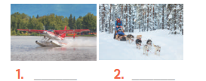  Answer key:  1. float plane  2. dogsled  Task 2: Choose the correct answer A, B, or C to complete each sentence. (Ex. 1b, p. 135)  Answer key:  1. C  2. A  3. B  4. A
Activity 3. PRACTICE (15’-IW, PW, GW)
* Aim:
- To help Ss revise and talk about energy-saving activities.
- To help Ss practise listening for specific information.
* Content:
- Read the list of activities and discuss which ones are energy-saving and which ones are not. Explain your answer.
- Listen and complete each sentence with ONE word.
* Product:
- Suggested answers & answer key
* Implementation: Teacher’s instructions…...
* Teacher asks Ss to work in groups of 4 to discuss the list of activities and gives the reasons for each.  ** Ss do the task in group.  *** Some groups report their answers, other listen, and comment.  **** Teacher confirms and correct their grammar, pronunciation and spelling. | SPEAKING  Task 3: Read the list of activities and discuss which ones are energy-saving and which ones are not. Explain your answer. (Ex. 2, p. 135)  Suggested answers:  Energy-saving: 1, 3, 4, 5  Not energy-saving: 2 and 6  The focus is on how a student explains his / her answer.
* Teacher asks Ss to read all the questions first, then try to guess the needed information to fill in the blanks. After that, teacher plays the recording twice for Ss to listen  ** Ss do the task independently.  *** Some Ss give their answers.  **** Teacher plays the recording again and confirms the correct answers.  Audio script- Track 89  Next month, we will hold a meeting to introduce our new product, the flying bike. Most of our customers will be school children and their parents. Here are some of the questions they may ask you.  1. There are special lanes for bicycles on land, how about in the air? If you don’t have lanes for them, the bicycles will crash into each other. | LISTENING  Task 4: Listen and complete each sentence with ONE word. (Ex. 3, p. 135)  Answer key:  1. flying  2. parents  3. lanes  4. traffic  5. land
Activity 4. APPLICATION (7’-IW, PW, GW)
* Aim:
- To help Ss practise writing a paragraph describing a future means of transport.
* Content:
- Choose one of the future means of transport below. Write a paragraph of about 70 words about it.
* Product: Suggested answers.
* Implementation:
Teacher’s & Student’s activities | Content
* Teacher asks Ss to look at the picture and choose what means of transport for their writing. Then, teacher has Ss read the suggested information they can include in their description.  ** Ss do the task individually in 6-8 minutes.  *** Some Ss read their writing.  **** Teacher checks grammar, vocabulary, spelling if needed.  * Home assignment  - T assigns the homework.  - Ss copy their homework.  - T explains it carefully | WRITING  Task 5: Choose one of the future means of transport below. Write a paragraph of about 70 words about it. (Ex. 4, p. 135)  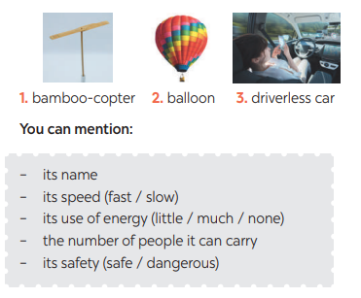  Suggested answer:  The bamboo-copter will be a popular means of transport in the future. It’s not very fast, so it’s safe to ride. It’s cheap, and it doesn’t use much energy. Most people can afford it. It’s also convenient because you can go anywhere: in a busy city, to the sea, or to the mountains. The copter is small and can carry only one person, so it doesn’t take up much space. I love it.
Activity 5. WRAP-UP & HOME WORK (2’)
* Aim: To consolidate what students have learnt in the lesson.; To prepare vocabulary for the next lesson.
* Content: Home assignment.
* Product: Take home assignment.
* Implementation:
- Ask Ss what they have learnt so far. Have them recall the important grammar points, Vocabulary; Pronunciation
* HOME WORK
- Read again the conversation
- Do more exercises in workbook.
- Prepare for the next lesson.

Planning date:
Teaching date:
PERIOD 103
SECOND END-TERM TEST
Planning date:
Teaching date:
PERIOD 104 + 105
SPEAKING TEST

