School: Kim Son Secondary School
Teacher: Nguyen Thi Thu Hang
Week: 05
ENGLISH 7

Unit 7 – Traffic
- Look at the road signs. Choose the best answer or Write the meanings of the road sign.
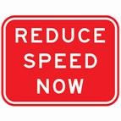 | - You can reduce your speed.  - You have to go fast.  - You must drive slowly. | 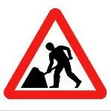 | - Be careful. Road works ahead.  - Watch out. There are workers.  - Look out for working children.
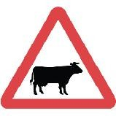 | - There are wild animals ahead.  - There are cattle ahead.  - You can buy cattle meat here. | 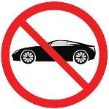 | - Cars and buses can pass.  - Cars cannot be sold here.  - Cars are not allowed.
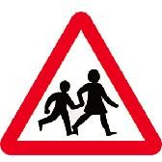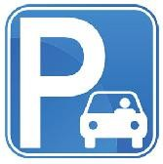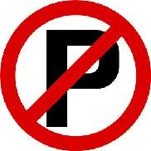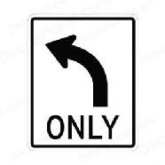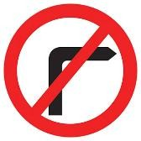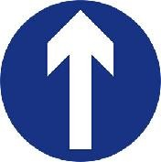


…………………………………………………………………………………………………..
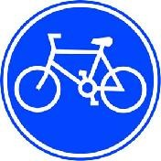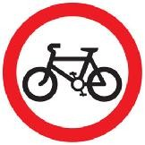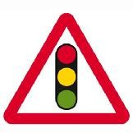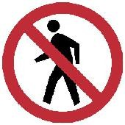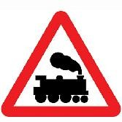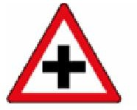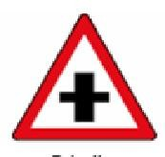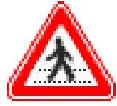

…………………………………………………………………………………………………..

Find the word which has a different sound in the part underlined.
  - A. brainstorm B. captain C. sailing D. railway
  - A. traffic B. station C. safety D. plane
  - A. enter B. vehicle C. helicopter D. mention
  - A. hey B. obey C. grey D. honey
  - A. ahead B. healthy C. seatbelt D. bread
  - A. traffic B. pavement C. plane D. station
  - A. recycle B. vehicle C. helicopter D. reverse
  - A. railway B. mail C. sail D. captain
  - A. sign B. mistake C. triangle D. drive
  - A. nearest B. head C. bread D. health
- Choose the best option to complete the sentence.
- Minh used to his homework late in the evening. ( does/ do / doing / did)
- If people _the rules, there are no more accidents. ( follow / take care of / obey / remember)
- You should _ right and left when you go across the roads.( see / look / be / take)
- Hurry up or we can’t _ the last bus home. ( keep / follow / go / catch)
- Public _ in my town is good and cheap. ( transport / tour / journey / travel)
- _is not very far from here to the city centre. ( That / This / It / There)
- When there is a traffic jam, it _me a very long time to go home.( costs/ takes / lasts / spends)
- Mai’s dad usually drives her to school __her school is very far from her house.( but / though/ because / or)
- Traffic accidents can be prevented if people _ the rules ( remember / obey / go after / take care of)
- Hurry up, or we'll _ the last bus. (lose / avoid / miss / drop)
- Does your bike ever _ down on the way to school? ( break / take / do / turn)
- Give a _ before you turn left or right. ( sign / turn / sound / signal)

Fill in each blank with ONE suitable preposition.
  - I'm reading a book ……………..history of China. 2. Is it far …………….your house ……… school?
3. Is Tokyo the biggest city ……………..the world. 4. John's worried his final exam.
5. What's HCM city famous ………………….? 6. Her sister is working a computer company.
- What time does the library close? It closes ……………about half four.
- We look …………the new words in the dictionary. 9. What is your date birth? - November eighth.
- Farmers are very hard - working. They work ……………. morning night on their farms.
- Mr. Minh is not at home now. He is work.
- Give the correct form of the verbs in brackets to complete the following sentences.
  - What ………………………you (do) ……………….at the moment? I (watch) TV.
  - We (be) students in four years.
  - A little girl can't spend all her time (listen) to stories.

  - We (play) …………………soccer this afternoon. Would you like (join) ?
  - You can borrow my umbrella. I (not/ use) it at the moment.
  - Look! The plane (fly) towards the airport.
  - Nam (not visit) the museum with his class last Sunday because he had a cold.
  - We (have) ……………… a birthday party last week and a lot of people (join)…………………………
- Put these expressions in the gaps to complete the sentences
road users | railway station | driving license | zebra crossing
means of transport | train ticket | traffic jam | speed limit
- At some stations you can buy a from the machine.
- Slow down a bit. There's a 50 km on this road.
- You must get a _ before you can drive a car.
- The camel is the most common in the desert of Egypt and some other countries.
- Avoid the rush hour and you won't get stuck in a .
- He is driving so fast: he may endanger other .
- This morning a lorry broke down near the _ _.
- A new has been built in the suburbs of our city.
- Fill in each blank with ONE suitable word.
Who are the best drivers? Which drivers are safest on the roads? According to a recent survey, young
and inexperienced drivers are the most likely to have ……. accident. Older drivers …….. more careful. Young men have the worst accident records of all. They often choose faster cars with bigger engines. One of the ………. interesting facts in the survey is that passengers have an effect on the driver young male
drivers have their friends in the car, driving becomes worse. When their wife or girlfriend is in the
car, however, their driving is better. But this is not true ………. women. Their driving is more dangerous when their husband ……. boyfriend is in the car. However, if their small children ………. riding in the car, they drive more slowly …… safely.
- Choose the best answer to complete the passage.
When you are in Hong Kong, you can go about by taxi, by tram, by bus, or (1) (in / by / on /with ) underground. I myself prefer the underground (2) (because / when / so / but) it is fast, easy and cheap. There are (3) (some / a lot / many / few )trams and buses in Hong Kong, and one cannot drive along the road (4) (quick / quicker / quickly / quickest) and without many stops. The underground is therefore usually quicker (5) (as / than / so / like ) taxis or buses. If you do not know Hong Kong very well, it is very difficult (6) (finding / to find/ found / to finding) the bus you want. You can take a taxi, but it is (7) (more / much /as / too) expensive than the underground or a bus. On the underground you find god maps that tell you the names of the stations and show you (8) (who / when / what / how )to get to them so that it is easy to find your way.

Rewrite the following sentences so that their meaning stays the same, using the words give.
  - The distance from my house to school is about 500 metres. (It)
  - My father went to work by car some years ago, but now he goes by bus. (used to)
  - The distance from Ha Noi to Can Tho is about 1,877 kilometres. (It)
  - What is the distance between Hue and Da Nang? (how)
  - There wasn't much traffic when I was small. (used to)
  - My uncle drove carelessly some years ago, but now he doesn't. (used to)
  - The distance between Ho Chi Minh City and Vung Tau is about 120 km. (It)
- Make questions for the underlined parts.
  - Most of my classmates go to school by bicycle.
  - It is about three kilometres from my house to the nearest town.
  - The students are leaning road signs in the schoolyard
  - There are often traffic jams in the city centre in the rush hour.
  - My father used to go fishing in the pond near the woods.
  - Trung usually rides his motorbike very carefully.
- Write the sentences using the words and phrases given.
- We/ used/ school / foot.

- It /about / 30 km/ my town/ Ha Long Bay/.
- My family/ used/ go / holiday / seaside / summer/.
- How/ long / it / take/ you/ Ha Noi / Sa Pa/?
- There / used / be / a factory / town centre / but/ it / move/ the/ suburbs/.
- You/ must / learn / about / road safety/ before/ riding/ your/ bike/ road/.

Unit 8 - Films

Adj: -ing, -ed
- This is an movie. I was afraid when watching it. FRIGHTEN
- I was when I saw him dress totally in black.
- It is_ to meet you here. SURPRISE
- My daughter felt__ _at my gift on her birthday.
- We are very__ about the upcoming trip on Sunday. EXCITE
- How_ this book is!
- You look_ . What has made you scared? Don’t worry! TERRIFY
- This is the most game in the park.
- He is a _man. He is lazy and drunk all day. DISAPPOINT
- We are completely_ because of failing the exam.
- Are you in our new publication? INTEREST
- This is the most poem I have ever read.
- She felt_ when hearing that she was turned down for the job. DEPRESS

- Failing the interview is_ .

- What an_ actor! He makes the movie wonderful. AMAZE
- Were you_ _when she appeared suddenly?
- I am_ with this work. It is the same everyday. BORE
- How__ she is! She is always talking about silly things.
- Are you with the result? SATISFY
- The work is and I am very happy.

Adj/ adv:
- She smiled_ when she met him again. HAPPY
- You are_ because the train has just left. UNLUCKY
- She is a_ student. She learns very__ . HARD
- She can type very_ . QUICK
- My brother walks to avoid making noise. QUIET
- My sister can speak English_ . FLUENT

Comparative of adj/ adv:
- She is than me. LAZY

2. Anna runs than John. |  | SLOW
3. She works__ than everyone. |  | HARD
4. Noone can run than Jack. |  | FAST
5. My brother draws_ than me. |  | GOOD
6. She is at English than her sister. |  | GOOD
Choose the best answer:  - She is old climb the mountain.  A. very/ to B. enough/ to | C. too/ to |  | D. so/ to
- It is not_ to pass the red traffic light.
  - dangerous B. safe C. safety D. danger
- There are many_ on the street: cars, buses, bikes, motorbikes…
A. vehicles B. transport C. engines D. machines
- She spent all day with her children.
  - play B. to play C. played D. playing
- The central square is . It is full of people and noise.
  - quiet B. peaceful C. crowded D. calm
- Your behaviour is_ . You should not be rude.
A. disappointing B. disappointed C. disappoint D. disappoints
- If we walk, we should go on the_ .
  - street B. pavement C. traffic light D. road
- “One-way street”, “No parking” are .
  - road signs B. means of transport C. traffic rules D. mistakes
- He sings__ _. Nobody wants to listen to his voice.
  - bad B. badly C. well D. good
- He runs than me.
A. more faster B. more fastly C. more fast D. faster Fill in each gap with one suitable word:
I live (1) Hanoi. It is (2)_ busy city. The streets (3) crowded and there are traffic jams in the rush hour. I am sometimes late for school because of the traffic jams. Some people don’t
(4) _the traffic rules. They pass the red traffic light, wear no helmets…Therefore, sometimes there (5) accidents.

Word form:
- The children were_ _by the stories about ghosts. FRIGHTEN
- It is_ to use gun without permission. LEGAL
- Be ! A car is coming! CARE

- Have you got_ license? DRIVE
- Stop in front of the zebra _when the traffic light turns into red. CROSS Put question for the underlined part of each sentence:
- It is 10 kilometers from here to ACB bank.
_
- I have known Marie for nine years.
_
- Yes, they used to be friends at the university.
_
- Sarah left two hours ago.
_
- She is watching Tom and Jerry.
_

EXTRAS

Choose the best answer:
- _this movie is entertaining, not many people like it.
  - Because B. Although C. Because of D. Despite
- _getting up early, I still missed the bus.
  - Despite of B. Although C. In spite of D. Because of
- I decided to quit this job _the low salary.
  - because of B. despite C. because D. although
- They canceled the match it rained heavily.
  - because of B. because C. although D. in spite of
- _the difficulty, they tried to finish all their tasks.
  - because of B. because C. although D. in spite of
- Are you a_ _runner? No. I run_ .
  - fast/ slow B. fastly/ slowly C. fast/ slowly D. fast/ slow
- How do you think about my new book? – I find it__ _.
  - excited B. excite C. excitingly D. exciting
- This is a movie. It makes me laugh a lot.
  - hilarious B. boring C. disappointing D. frightening
- This movie is about the war between the planets in the space. It is a_ movie.
  - romantic B. comedy C. documentary D. sci-fi
- Please get _the bus. We have finished our journey.
  - on B. of C. off D. up

Rewrite sentences:

    - Although I have a lot of money, I am not very satistied. DESPITE
_ _
    - Although it rained, they still go fishing. IN SPITE OF
_
    - Although she works hard, she doesn’t get good results. DESPITE
_
    - Although he is a singer, he sings badly. IN SPITE OF
_
    - Although the exercise is difficult, she can do it easily. DESPITE
_ Cloze test:
There are many (1) of films: romance, comedy, science fiction, documentary, horror, action… My favourite is romantic films, for (2)_ _, Titanic, The Notebook, Notting Hill… They are meaningful about life and love.
Sometimes they are (3) and make me cry. I am also interested (4) docmentaries. They give me interesting knowledge.
1. A. types | B. movies | C. forms | D. watches
2. A. such as | B. character | C. example | D. actor
3. A. funny | B. gripping | C. strange | D. moving
4. A. on | B. in | C. of | D. with

