Unit 7. pullution
A. VOCABULARY
News words | Meaning | Picture | Example
Aquatic  /əˈkwætɪk/  (adj) | Dưới nước | 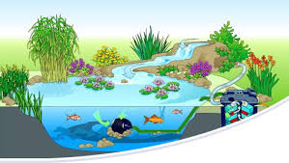 | The aquatic ecosystem is threatened by water pollution.  Hệ sinh thái dưới nước đang bị đe dọa bởi ô nhiễm nước.
Chemical  /ˈkemɪkl/  (n) | Chất hóa học | 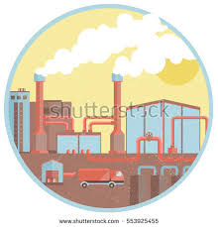 | Chemical substances from factories are harmful to the environment.  Những chất hóa học từ nhà máy có hại đối với môi trường.
Contaminant  /kənˈtæmɪnənt  (n) | Chất gây ô nhiễm | 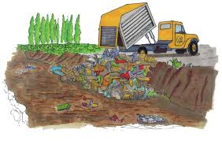 | They are trying to remove contaminants from the lake.  Họ đang cố gắng loại bỏ những chất gây ô nhiễm ra khỏi hồ.
Damage  /ˈdæmɪdʒ/  (v,n) | Phá hủy | 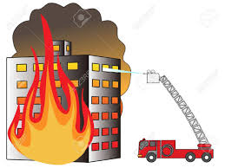 | The fire badly damaged the building.  Ngọn lửa đá phá hủy trầm trọng ngôi nhà.
Dead  /ded/  (adj) | Chết | 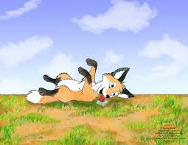 | Some animals escape danger by playing dead.  Một vài loài động vật trốn thoát nguy hiểm bằng cách giả chết.
Dirty  /ˈdɜːrti/  (adj) | Bẩn | 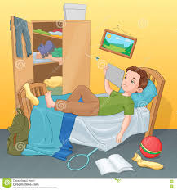 | Everything in his room was so dirty.  Mọi thứ trong phòng của anh ấy đều bẩn.
Dump  /dʌmp/  (v) | Đổ rác, vứt bỏ | 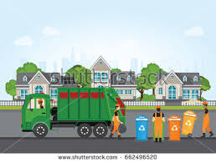 | People mustn’t dump waste into the sea.  Mọi người không được đổ rác xuống biển.
Environmental  /ɪnˌvaɪrənˈmentl/  (adj) | Thuộc về môi trường | 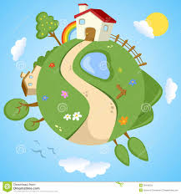 | We are facing many environmental problems these days.  Ngày nay chúng ta đang đối mặt với nhiều vấn đề môi trường.
Groundwater  /ˈgraʊndwɔːtər/ (n) | Nước ngầm | 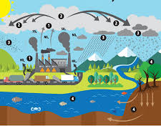 | People dig well to use groundwater.  Mọi người đào giếng để sử dụng nguồn nước ngầm.
Herbicide  /ˈhɜːrbɪsaɪd/  (n) | Thuốc diệt cỏ |  | Herbicide can pollute the groundwater.  Thuốc diệt cỏ có thể gây ra ô nhiễm nguồn nước ngầm.
Industrial  /ɪnˈdʌstriəl/  (adj) | Thuộc về công nghiệp | 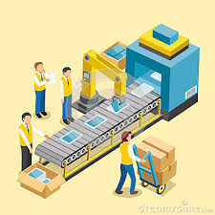 | Industrial chemicals cause air, water and land pollution.  Những chất hóa học công nghiệp gây ra ô nhiễm không khí, nước và đất.
Litter  /ˈlɪtər/  (n,v) | Đổ rác, làm bừa bộn | 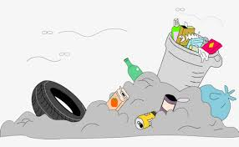 | The street are littered with rubbish.  Những con đường bị đổ đầy rác.
Poison  /ˈpɔɪzn/  (n) | Chất độc | 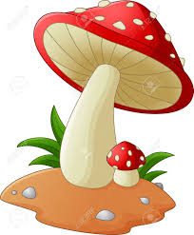 | Some kinds of mushrooms contain poison.  Một vài loại nấm có chứa chất độc.
Radioactive  /ˌreɪdioʊˈæktɪv/  (adj) | Phóng xạ | 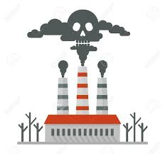 | Radioactive pollution is not a pollution of our city.  Ô nhiễm phóng xạ không phải là vấn đề của thành phố chúng tôi.
Stream  /striːm/  (n) | Dòng suối | 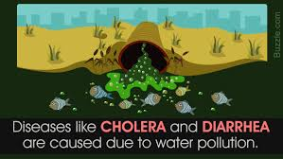 | Some mountain streams are polluted by acid rain.  Một vài dòng suối trên núi đá bị ô nhiễm bởi mưa a-xít.
Thermal  /ˈθɜːrml/  (adj) | Nhiệt | 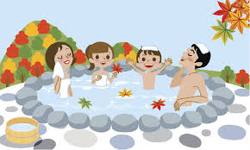 | Are there any thermal springs in your country?  Có suối nước nóng ở đất nước bạn không?
Visual  /ˈvɪʒuəl/  (adj) | Thuộc về thị giác | 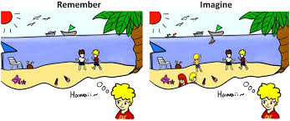 | Jane has a good visual memory.  Jane có một trí nhớ hình ảnh tốt.

B. GRAMMAR
1. ĐỊNH NGHĨA CÂU ĐIỀU KIỆN.
Định nghĩa | Ví dụ
Câu điều kiện gồm có hai phần: mệnh đề chỉ điều kiện (if-clause) và mệnh đề chỉ kết quả (result clause) | If the weather is fine, I will go campingwith my friends tomorrow.  (Nếu thời tiết đẹp thì ngày mai tôi đi sẽ đi cắm trại với bạn của tôi.)  -> “If the weather is fine” là mệnh đề chỉ điều kiện: “I will go camping with my friends tomorrow” là mệnh đề chỉ kết quả (mệnh đề chính)
Mệnh đề IF và mệnh đề chính có thể đứng trước hay sau đều được. | I will go camping with my friends tomorrow if the weather is fine.

II. ÔN TẬP CÂU ĐIỀU KIỆN LOẠI 1 (CONDITIONAL SENENCES TYPE 1)
Chức năng | Dùng để diễn tả điều kiện có thể xảy ra ở hiện tại hoặc tương lai.
Cấu trúc | If + S+ V _{(s/es)} + (bổ ngữ) S will +V _{nguyên mẫu} + (bổ ngữ)  (thì hiện tại đơn) (thì tương mai đơn)  -> Mệnh đề IF dùng thì hiện tại đơn, mệnh đề chính dùng thì tương lai.
Ví dụ | If I have enough money, I will buy a new computer. (Nếu tôi có đủ tiền thì tôi sẽ mua một chiếc máy tính mới.)  - If you work hard, you will make a lot of money. (Nếu bạn làm việc chăm chỉ thì bạn sẽ kiếm được nhiều tiền.)
Lưu ý | - Unless= If not  - If= Unless + not  Ví dụ:  - If he doesn’t do his homework, his mother will complain.  -> Unless he does homework, his mother will complain.  - If you don’t send to the hospital, she will die.  -> Unless you send her to the hospital, she will die.  Có thể dùng các động từ must, have to, can, may, should thay cho will trong mệnh đề chính.  Ví dụ:  Is It rains heavily, you can stay here. (Nếu trời mưa bạn có thể ở lại đây.)  - If you want to see that film, you must buy a ticket. (Nếu bạn muốn xem bộ phim đó thì bạn phải mua vé.)

BÀI TẬP VẬN DUNG CƠ BẢN
Bài 1. Khoanh tròn phương án đúng để hoàn thành các câu sau.
1. If the weather is fine, we (goes/ will go) camping tomorrow.
2. My parents will give me a gift if I (will pass/ pass) the final exam.
3. If you are polite to others, they (will be/ are nice to you).
4. Unless James (studies/ will study) hard, he will fail the exam.
5. My parents won’t allow me to go out if I (don’t finish/ won’t finish) my homework.
6. If the cable TV (doesn’t/ won’t) work, we will rent a DVD.
7. If you don’t want to stay at home, you (go/ can go) with me to the supermarket.
8. If you (will be/ are) a good listener, you will gain many friends.
9. James won’t attend the meeting if he (won’t/doesn’t) want to.
10. You can’t have this job unless you (have/will have) long working experience.
11. What (you will do/ will you do) if it snows tomorrow?
12. You (will be/ are) able to understand it you practice every day.
13. We will eat out today if there (will be/ is) nothing left in the fridge.
14. If it (will be/ is) too cold outside, we will stay home.
15. If she (isn’t/ won’t) careful, she will make many mistakes.
Bài 2. Hoàn thành các câu sau sử dụng dạng đúng của động từ trong ngoặc.
1. The manager (be) ________________ very angry if I am late for work.
2. You will have to work very hard if you (take)______ this course.
3. I (go) ________ to see the doctor if I don’t feel well tomorrow.
4. They can’t hear you unless you (speak) ______ louder.
5. If Peter (forget) _____________ to write his essay, the teacher (give) _____________ him a low mark.
6. If they (win) ___________ this match, they will ne the champions.
7. We (have) _________ plenty of time if we (arrive) ______ there early.
8. The zookeeper (punish) ____________ you if you (feed) ___________ the animal.
9. What ________ (Jane/ say) if Jim (tell0 _______ her the truth.
10. The boys (shiver) _____________ with cold if they (swim) ________ in this lake.
11. The door (not lock) ____________- unless you (press) ____ the green button.
12. Jim won’t be late if he (take) _______________ the bus at 6 o’clock .
13. Mary isn’t home, but if you (want) _____ to leave her a message, I (give) ________ it to her.
14. If jack (clean) ________ the floor, I (do) __________ the washing.
15. the children (be) _____ happy if you (give) _______ them some sweets.
Bài 3.Nối cột A với cột B để tạo thành câu hoàn chỉnh.
A | B
1. If people keep dumping rubbish into the lake, | a. the groundwater will be poisoned.
2. If the farmers overuse pesticide, | b. if our surrounding environment is polluted
3. Soil erosion won’t happen in an area, | c. they will disappear in the future.
4. if we don’t converse the rainforests, | d. unless we join hands to protect it.
5. Our health will be badly affected | e. the aquatic life will be afflicted.
6. Our environment will be damaged | f. floods will be more and more severe.
7. Is we don’t protect the frontier forests, | g. if people use more public transportation.
8. The amount of carbon dioxide in the atmosphere will be reduced | h. if people practice sustainable agricultural mad use.
1. ____ 2. __________ 3. _______ 4. ____________
5. ____ 6. __________ 7. _______ 8. ____________
Bài 4. Dựa vào từ cho sẵn, viết câu hoàn chỉnh.
1. If/people/ not/ stop/ dumping/ waste/ into/ rivers/,/pollution/ increase/.
_____________________________________________________________________________
2. If/ polar/ ice caps/ melt/ ,/huge landmasses/ be/ under/ water.
_____________________________________________________________________________
3. If the air/ in/ city/ be/polluted/ ,it/can/ cause/ people’s/ respiratory/ problems.
_____________________________________________________________________________
4. If/smog/ be/ frequently/ formed/ in/ city/,/it/ cause/ difficulty/ in/ breathing/ headache/ even/ lung cancer.
_____________________________________________________________________________
5. If/ carbon monoxide/ concentrate/ in/ great/ amounts/, /it/ be/ harmful/.
_____________________________________________________________________________
6. The climate/ change/ if/ more trees/ be/ cut/ down/ for/ hardwood/.
_____________________________________________________________________________
7. If/ we/ not/ control/ pollution/ soon/,/it/ be/ too/ late/.
_____________________________________________________________________________
8. If/we/ not/ protect/ frontier/,/we/ suffer/ many/ from/ natural/ disasters.
_____________________________________________________________________________
Bài 5. Viết lại câu với “” if/unless” sao cho nghĩa của câu không thay đổi.
1. I can’t finish this task you don’t give me a hand.
-> _____________________________________________________________________________
2. You will run out of money if you don’t stop wasting it.
-> _____________________________________________________________________________
3. Don’t call me unless it is an emergency.
-> _____________________________________________________________________________
4. James will not pass the test unless he studies harder.
-> _____________________________________________________________________________
5. If Jane finishes her work before 6 pm, she will dine out with her friends.
-> _____________________________________________________________________________
6. My brother won’t go travelling this summer if he doesn’t find a companion.
-> _____________________________________________________________________________
7. It is not easy to do these exercises unless you listen attentively to the teacher.
-> _____________________________________________________________________________
8. If Jim doesn’t submit his essay before Tuesday, he will be punished by the teacher.
-> _____________________________________________________________________________
III. CÂU ĐIỀU KIỆN LOẠI 2 (CONDITIONAL SENTENCES TYPE 2)
Chức năng | - Dùng để diễn tả điều kiện không thể xảy ra ở hiện tại hoặc tương lai, điều kiện chỉ là một giả thiết, mọt ước muốn trái ngược với thực trạng hiện tại.  - Dùng để đưa ra lời khuyên.
Cấu trúc | If+ S+ V-ed + (bổ ngữ), S+ would + V nguyên mẫu + (bổ ngữ).  (thì quá khứ đơn)  -> Mệnh đề IF dùng thì quá khứ đơn, mệnh đề chính dùng động từ khuyết thiếu “would +V”
Ví dụ | If we were a bird, I wou;d be very happy.  (Nếu tôi là một con chim tôi sẽ rất hạnh phúc)  -> Tôi không thể là chim được.  If I had a million USD, I would buy that cả. (Nếu tôi có một triệu đo la, tôi sẽ mua chiếc xe đó.)  -> hiện tại không có.
Lưu ý | - Trong câu điều kiện loại 2, ở mệnh đề ‘IF’, với chủ ngữ “ I/he/she/it” ta có thể dùng “were ” hoặc “was” đều được.  - Ta cũng có thể dùng “could” hoặc “might” trong mệnh đề chính.  WOULD= sẽ (dạng quá khứ của WILL)  COULD = có thể (dạng quá khứ của CAN)  MIGHT = có thể (dạng quá khứ của MAY)

BÀI TẬP VẬN DỤNG CƠ BẢN
Bài 6. Khoanh tròn vảo phương án đúng.
1. I (would buy/ bought) a new house if I had enough money.
2. If he (would try/ tried) his best, he might be successful.
3. If I (lived/ would live) in Japan, I could speak Japanese well.
4. If someone gave you a dress, which color (would you want/ you would want) it to be?
5. I would repaired the roof myself if I (would have/ had) a longer ladder.
6. You would be more comfortable now if you (didn’t/ wouldn’t) wear high heels.
7. I (wouldn’t/didn’t) buy things on the Internet if I were you.
8. If you (met/ would meet) your favorite author Mark Twain, what wouldn’t you ask him?
9. His parents would be very proud if he (wouldn’t be/ weren’t) so naughty.
10. If Jane had more money, she (would treat/ treated) herself to a decent meal.
11. If you were a billionaire, what (would you do/ did you do)/
12. If Kate owned a computer, she (would spend/ spent) most of her free time on it.
13. If I (would know/ knew) his address, I would give it to you.
14. She would look much better if her hair (didn’t look/ wouldn’t look) so unkempt.
15. If I were in your situation, I (would/ will) let the nature take its course.
Bài 7. Hoàn thành các câu sau, sử dụng dạng đúng của động từ trong ngoặc.
1. More tourists would come to our country if we (provide) ______________ better services.
2. If I studies abroad, _____________ (we/keep) in touch with each other?
3. If someone (give) ______________ you a camera, what would you do with it?
4. If I (win) _________________ a big prize in a lottery, I (donate) _______________ apart of it and (spend) _______________ the rest for myself.
5. What ___________ (you/do) if you found a wallet in the street?
6. I could watch foreign TV program without subtitles if I (know) _________ English.
7. He might be obese if he (not stop) __________________ taking in fat and sugar.
8. If he knew that it was dangerous, he (not do) _______________ it.
9. If you (see) ________________ someone drowning, ________________ (you/save) him?
10. She (be) __________________ happier if her parents (not get) ________________ divorced.
11. If you (sleep) _____________ under a mosquito net you (not be) _______________ bitten so often.
12. I (get) _________________ a job easily if I (have) ______________________ a degree.
13. If whe (have) _________ another hair style, she (look) ___________ younger.
14. if the weather (not be) _______________________ severe, out crops (grow) _______________ faster.
15. I (keep) _____________ a horse if I could afford it.
Bài 8. Viết câu điều kiện loại 2 cho các trường hợp sau.
0/ They don’t have enough money. They cannot buy a new car.
->If they had enough money, they could buy a new car.
1. There isn’t a library in my neighborhood. I cannot borrow books.
__________________________________________________________________________________
2. My health is not good. I don’t play extreme sports.
__________________________________________________________________________________
3. We cannot go for a picnic because it is pouring with rain.
__________________________________________________________________________________
4. I don’t have much free time. I cannot come to your party.
__________________________________________________________________________________
5. Jim doesn’t have any siblings. He feels lonely sometimes.
__________________________________________________________________________________
6. My father is very busy at work. He rarely has time for me.
__________________________________________________________________________________
7. This camera is expensive. I can’t buy it.
__________________________________________________________________________________
8. You don’t try your best. Your result will not be good.
__________________________________________________________________________________
BÀI TẬP TỔNG HỢP NÂNG CAO.
Bài 9. Hoàn thành các câu sau, cho dạng đúng của động từ trong ngoặc.
1. We (be) ____________ happy if air pollution were the only problem.
2. They would be disappointed if you (not go) _____________ to their party.
3. If we (use) _______ this kind of light bulb, we can save energy.
4. Peter should go to sleep early if he (not want) ____________ to be tired the next morning.
5. If you (take) _______________ more exercises, you would be more resistant to diseases.
6. You may have car accident unless you (drive) ________________ more carefully.
7. If I travel to London, I (visit) ____________ its museum.
8. If they offer me the job, I think I (accept) _________________ it.
9. Many people (be) ____________ out of work if the local factory closed down.
10. What (happen) _________________ if that red button was pressed?
11. I’d be absolutely astonished if Mary and James (get) _____________ married.
12. They won’t let you in unless you (show) _____________them your identity card.
13. My best friend gave me this book. She (be) ________________ very upset if I lost it.
14. Would you mind if I (turn) ________________ up the radio.
15. I’m sure she (forgive) ______________ you if you sincerely apologize to her.
Bài 10. Đánh dấu trước câu đúng, đánh dấu x trước câu sai và viết lại cho đúng.
______ 1. Pollution can be reduced if we joined hands to prevent it.
_________________________________________________________________
______ 2. If farmers would make use of pesticide more wisely, the soil would not be poisoned.
_________________________________________________________________
______ 3. I won’t believe it unless you showed me the evidence.
_________________________________________________________________
_____ 4. Unless you don’t tell me the truth, I won’t help you.
_________________________________________________________________
_____ 5. If James is more outgoing, he would have more friends.
_________________________________________________________________
_____ 6. I think the show would be successful if he were one of the organizers.
_________________________________________________________________
______ 7. If you paid more attention to what I said, you didn’t make so many mistakes.
_________________________________________________________________
______ 8. If children are taught about environmental issues, they might change their attitudes towards pollution.
_________________________________________________________________
______ 9. You would be punished if you park your car here.
_________________________________________________________________
_____ 10. If you could win the competition, we will have a celebration.
_________________________________________________________________
Bài 11. Hoàn thành các câu sau, chọn và cho dạng đúng của các độn từ cho sẵn.
happen | Reduce | save | suffer | Cause
throw | Take | be | change | See
1. If we use less vehicles, we _________ the amount of carbon dioxide into the air.
2. If you __________ the president, what you do to prevent air pollution.
3. If there were no fresh water left, what ____?
4. If people (not) ________________ rubbish in the street, it would look better.
5. if there wasn’t so much light in the cities at night, we __________ the starts more clearly.
6. If the water is contaminated, people ________ from many diseases.
7. If chemicals from factories are dumped into rivers and lakes, they ______ water pollution.
8. If people want to protect their planet, they should ________ their habit of using plastic bag for convenience.
9. If we recycle paper, we ________ 1000 trees a day.
10. If people were more aware of the negative consequences of pollution, they might ______ actions to prevent it.
Bài 12. Khoanh tròn phương án đúng.
Consequences of water pollution
Water pollution is a matter of concern nowadays because of its negative effects on the environment and human. The first problem is that water pollution kills (1) ________ organism. Dead fish, crabs, birds and sea gulls, dolphins, and many other animals have been killed by (2) ____________ in their habitat. Moreover, pollution (3) _______ the natural food chain as well. Pollutants such as lead and cadmium are eaten by tiny animals. Later, these animals are consumed by fish and shellfish, and the food chain continues to be disrupted at all high levels. Eventually, humans are (4) ___________ by this process as well. People can get (5) ______ such as hepatitis by eating seafood that has been (6) ______________. In many poor nations, there is always outbreak of cholera and diseases as a (7) ______ of poor drinking water treatment from contaminated water. (8) ________ people don’t prevent pollution, not only the environment but also their health will be put at risk.
1. A. aquatic B. atmosphere C. underground D. soil
2. A. pollutes B. Pollution C. polluted D. pollutants
3. A. changes B. disrupts C. pollutes D. clears
4. A. affect B. affected C. affecting D. effect
5. A. illness B. sickness C. diseases D. healthiness
6. A. cleaned B. poisoned C. processes D. prepared
7. A. outcome B. effect C. way D. result
8. A. If B. Unless C. When D. In case
Bài 13. Đọc đoạn văn sau và trả lời câu hỏi.
Light pollution
Most of us are familiar with air, water, and land pollution, but did you know that light can also be a pollutant? Not many people know about this kind of pollution. Light pollution is the inappropriate or excessive use of artificial light and it can have serious environmental consequences for humans, wildlife, and our climate. Light pollution is a side effect of industrial civilization. Its sources include building exterior and interior lighting, advertising, commercial properties, offices, factories, streetlights, and illuminates sporting venues.
The fact is that much outdoor lighting used at night is inefficient, overly bright and, in many cases, completely unnecessary. This light, and the electricity used to create it, is being wasted by spilling into the sky, rather than focusing on the actual objects and areas that people want illuminated. For three billion years, life on Earth in a rhythm of light and dark that was created solely by the illumination of the Sun, Moon, and Stars. Now, artificial lights overpower the darkness and our cities glow at night. It disrupts the natural day-night pattern and shifts the delicate balance of our environment. Light pollution has negative impacts. It increases energy consumption, disrupts the ecosystem and wildlife and harms human health. Fortunately, concern about light pollution is rising dramatically. A growing number of sciences, homeowners, environmental groups and civic leaders are taking actions to restore the natural night.
1. What source of light does not contribute to light pollution?
A. moonlight B. streetlight
C. offices D. advertising
2. What is NOT true about light pollution according to the passage?
A. People are so familiar with it.
B. Is has many bad effects on humans and the environment.
C. It is the inappropriate or excessive use of natural light.
D. It is a side effect of industrial civilization.
3. What disrupts the natural day-night pattern as mentioned in the passage?
A. artificial light B. darkness
C. our city D. night
4. Which is NOT mentioned as the negative impact of light pollution?
A. increasing the use of energy
B. disrupting the ecosystem.
C. badly affect human health
D. balancing the ecosystem

