Full name: ………………………………………..  Class: ……………………………………………… | ENGLISH LANGUAGE TEST  Time: 15 minutes
I. READING AND WRITING
Task 1. Look and write. There is one example.

Example:
bodomer → b e d r o o m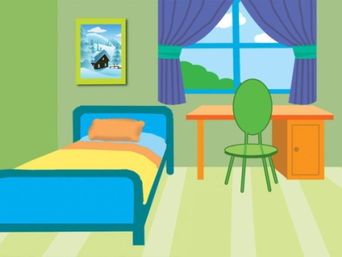
1. kechnit → k _ _ _ _ _ _ | 2. bomahtro → b _ _ _ _ _ _ _ | 3. gednar → g _ _ _ _ _
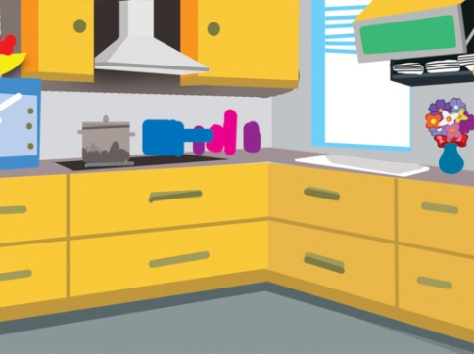 | 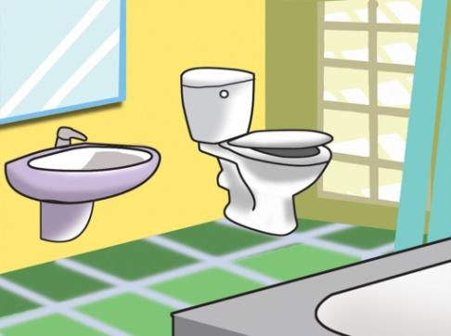 | 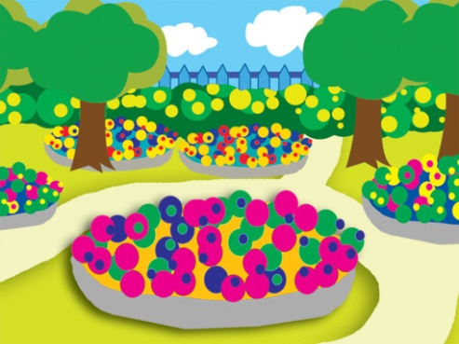
4. pdno → p _ _ _ | 5. gilvin room → l _ _ _ _ _ room
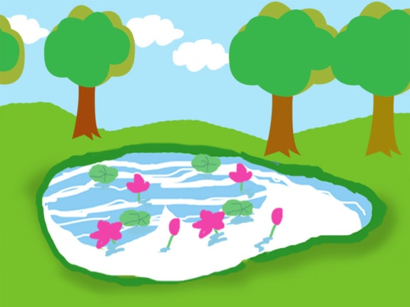 | 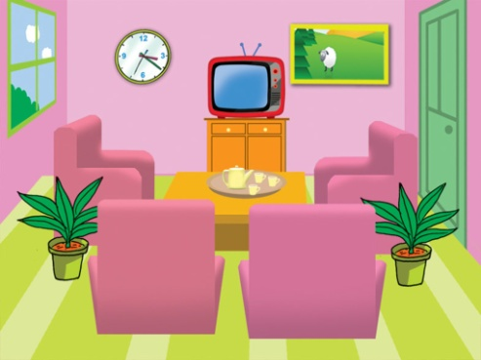

Task 2. Look and read. Tick  or cross  the box. There are two examples.

Examples:
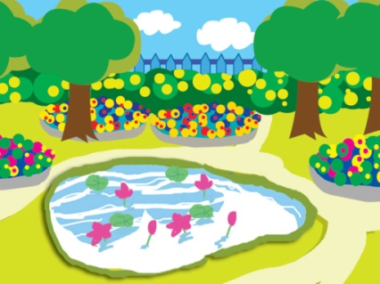  A. There’s a pond. |   B. There’s a gate in front of the house.

  1.  This is a house. |   2. There is a garden in front of the house. |  |   3. There isn’t a pond behind the house.
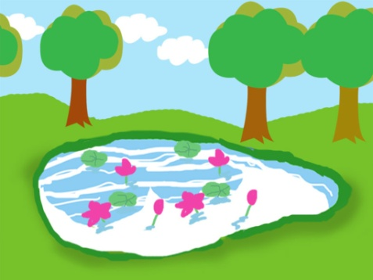  4. There’s a pond in the garden. |  |   5. The gate is blue.

Task 3. Read and complete. There is one example (0).

house | isn’t | it | garden | nice | there
A: This is my (0) house.
B: Wow. It’s very (1) ________!
A: Yes, (2) ________ is. And this is my bedroom.
B: It’s so big! Is there a (3) ________?
A: Yes, (4)________ is. Come and see it.
B: Is there a pond in the garden?
A: No, there (5)________.

– The end –
manual page break

Đáp án
I. READING AND WRITING
Task 1. Look and write. There is one example.
Key: 1. kitchen 2. bathroom 3. garden 4. pond 5. living room
Task 2. Look and read. Tick or cross the box. There are two examples.
Key: 1. 2. 3. 4. 5.
Task 3. Read and complete. There is one example (0).
Key: 1. nice 2. it 3. garden 4. there 5. isn’t

