Full name: ………………………………………..  Class: ……………………………………………… | ENGLISH LANGUAGE TEST  Time: 15 minutes
I. READING AND WRITING
Task 1A. Look and write. There is one example.

Example:
mafrer → f a r m e r | 
1. taechre → _ _ _ _ _ _ _ | 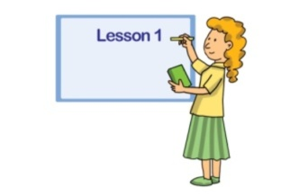
2. trodoc → _ _ _ _ _ _ | 
3. dirvre → _ _ _ _ _ _ | 
4. rusen → _ _ _ _ _ | 
5. rowker→ _ _ _ _ _ _ | 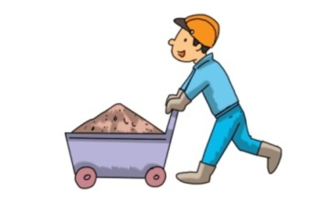

Task 2. Order the words. There is one example.

Example: father / what / do / does / your
What does your father do?
1. is / factory / a / my / worker / uncle
____________________________________.
2. a / in / car / he / works / factory
____________________________________.
3. do / mother / your / does / what
____________________________________?
4. work / she / does / where
____________________________________?
5. brother / your / what / do / does
____________________________________?

Task 3A. Read and circle the correct answers. There is one example (0).

My name is Lam. There are four people in my family. My parents, my sister and me. My dad is a doctor. He works in St. Paul Hospital. My mum is a teacher. She teaches English at Kim Lien Primary School. My sister is a student of Thang Long University. I am a pupil at my mum’s school. I love my family.
0. There are ________ people in Lam’s family.
A. three
B. four
C. five
1. His father is a _________.
A. teacher
B. doctor
C. student
2. He works in __________ Hospital.
A. Kim Lien
B. Thang Long
C. St. Paul
3. His mother teaches English at a ________.
A. primary school
B. secondary school
C. university
4. His sister is a _________ .
A. teacher
B. student
C. pupil
5. Lam studies at his ________.
A. mother’s school
B. father’s school
C. parents’ school
– The end –
manual page break

Đáp án
I. READING AND WRITING
Task 1A. Look and write. There is one example.
Key: 1. teacher 2. doctor 3. driver 4. nurse 5. worker
Task 2. Order the words. There is one example.
Key:
1. My uncle is a factory worker.
2. He works in a car factory.
3. What does your mother do?
4. Where does she work?
5. What does your brother do?
Task 3A. Read and circle the correct answers. There is one example (0).
Key: 1. B 2. C 3. A 4. B 5. A

