Full name: ………………………………………..  Class: ……………………………………………… | ENGLISH LANGUAGE TEST  Time: 15 minutes
I. WRITING
Task 1. Look at the pictures. Read and write one word for each gap. There is one example.

Example:
Don’t touch the stove. | 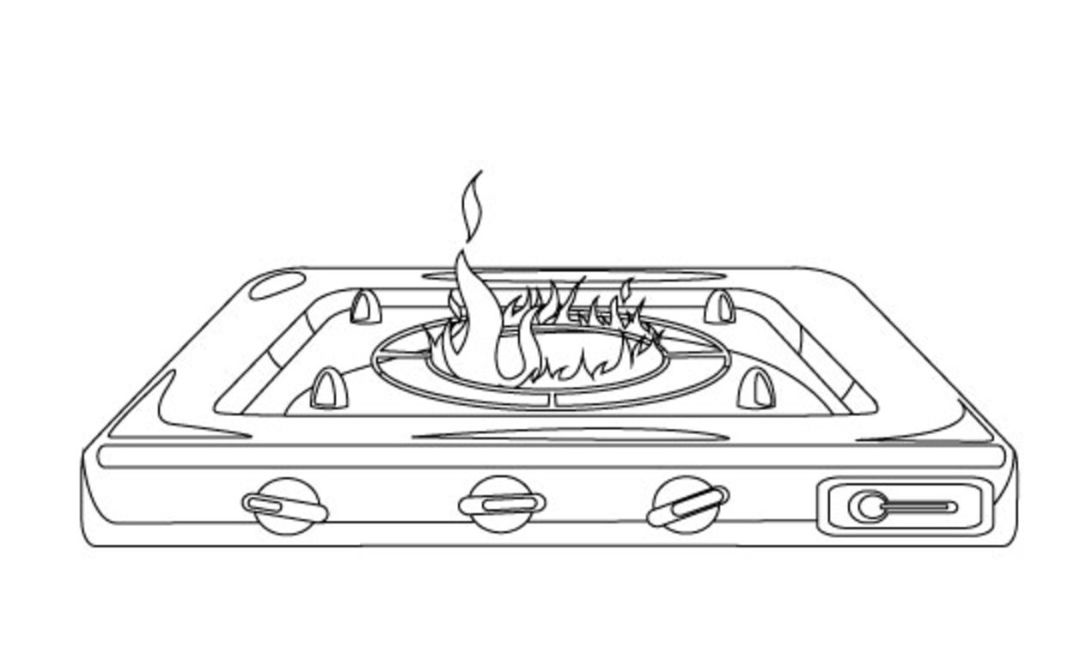
1. Don’t _______________ the stairs. |  | 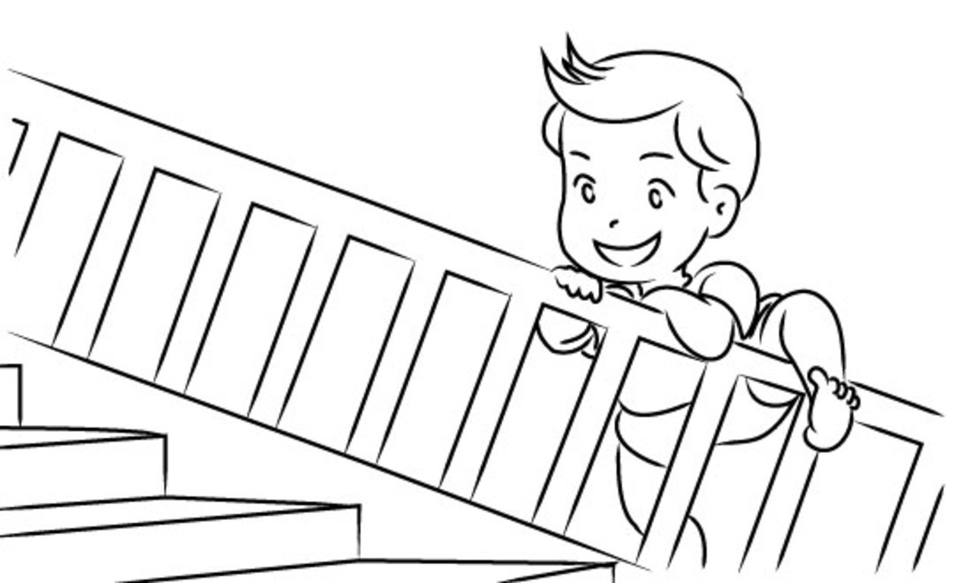
2. You shouldn’t play with ______________. |  | 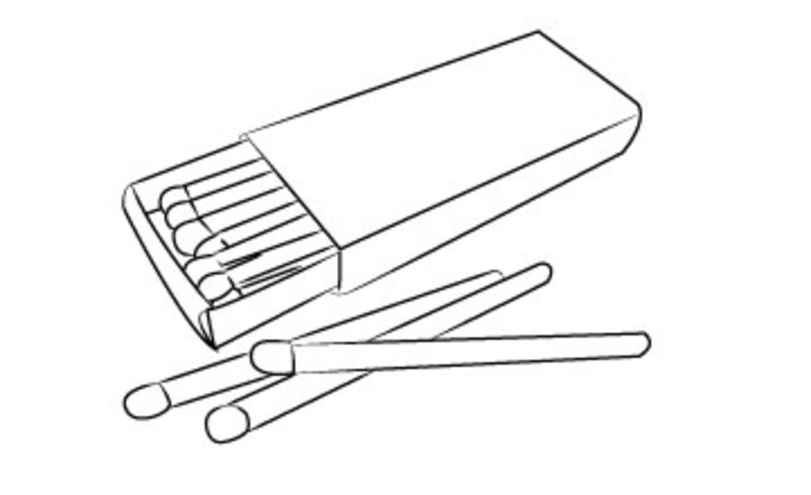
3. Young babies are easy to ________________ off the bed or the sofa. |  | 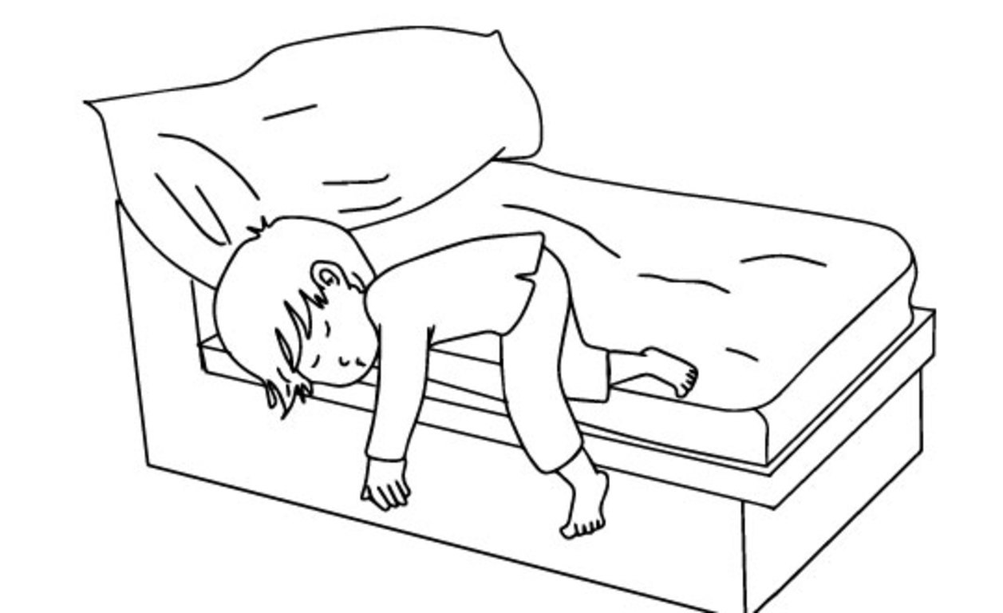
4. The knife is very sharp, you may __________ yourself. |  | 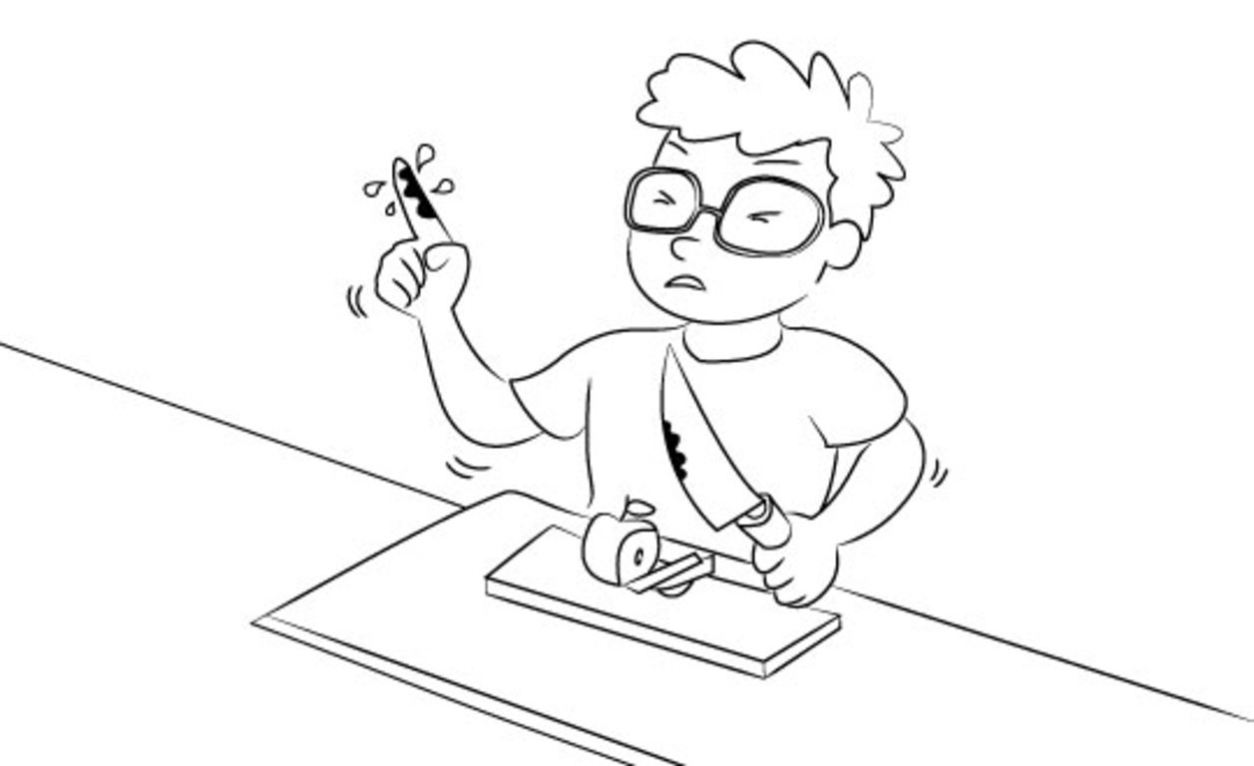
5. The stove is very hot, you may get a __________ . |  | 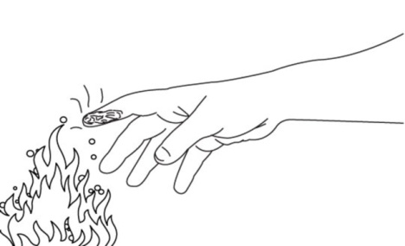

Task 2. Order the words. There is one example.

Example: bike / off / his / he / fall / may
He may fall off his bike.
1. too / I / ride / shouldn’t / why / fast
________________________________________________?
2. you / the / what / doing / stove / are / with
________________________________________________?
3. do / I / that / won’t / ok / again
_______,________________________________________.
4. shouldn’t / why / I / touch / knife / the
________________________________________________?
5. with / the / play / don’t / cat
________________________________________________.

Task 3. Read the questions. Write safety tips for children. There is one example (0).

0. Why shouldn’t children climb trees?
1. Why shouldn’t children play with a knife?
2. Why shouldn’t children play with matches?
3. Why shouldn’t children ride their bike too fast?
4. Why shouldn’t children go out alone?
5. Why shouldn’t children play on the balcony?

0. Children shouldn’t climb trees because they may fall down and break their arms or legs.
1. They shouldn’t play with a knife because ________________________________________.
2. They shouldn’t play with matches because_______________________________________.
3. They shouldn’t ride their bike too fast because____________________________________.
4. They shouldn’t go out alone because ___________________________________________.
5. They shouldn’t play on the balcony because______________________________________.
– The end –
manual page break

Đáp án
I. WRITING
Task 1. Look at the pictures. Read and write one word for each gap. There is one example.
Key: 1. climb 2. matches 3. roll 4. cut 5. burn
Task 2. Order the words. There is one example.
Key:
1. Why shouldn’t I ride too fast?
2. What are you doing with the stove?
3. Ok, I won’t do that again.
4. Why shouldn’t I touch the knife?
5. Don’t play with the cat.
Task 3. Read the questions. Write safety tips for children. There is one example (0).
Student’s answers vary with correct grammar.

